Current version (timestamped by central):
23:51 Sun, 13 Sep 2026
(check this GitHub repo for future updates)

Documentation is laid out herein in visually top-down order of what is first encountered at the top of the AO3 work and moving downward (rather than general highest level parsing to more specific lowest level), though some of it is in hidden HTML or otherwise conditional and hence might not be immediately obvious at a casual glance; at the end of the document you will find a Q.R.L. (Quick Reference List) of the CSS sequenced by standard first-through-last lines (which does mostly follow the order of the HTML elements, but necessarily not always).
Although teh original April Fools' Day work is a gag, and I wrote “teh” in place of all of teh “the”s just to mess with readers that little extra bit, I won't write “teh” anywhere in this documentation... other than this one paragraph (and any instances quoted directly from the work).
This is for anyone scratching their heads in general over the gnarled and arguably Byzantine almost-spaghetti code, but specifically prompted for Pascal/tbvns and nerdzeword re. Coding & Crossovers Discord server request for breakdown (# coding-talk channel, 12:51 Fri 29 May 2026) of magic used in the AO3 work
̶̢̡̢̨̨̢̛͓̖͈̥̯̗͉̣͍̤̱̟͚͓̠̱̤̻̝͈̗͉̰͚̣͉̜̻̙͉̜͕̪̠̪̺̹̦̦̞̼̥͈̭̜̘͍̥̪̯̘̳͚̦̩̭͉̬̲̝̲̹̥̞̯͕̠̥̯̖͙͔̺̹̹̠̪͎̰̬̗̣̹̼̞̘̦̲̠̻͎͈͙̀̎̋́̆͒̽̃̀̊͊̿̅̄́̈́̇̆̾̔͂̿̏͛́̽͆̄͒̀͗̐̂́̉̀͗͑̀͋̌͐̓̿͒̈̑̉͒̔͂̄̇̅̍͛̃̑̏͊̾͐̈̽̊̄̐͒̋̃̆́́̆́̇̈͐̈́̑͐̑̅͌͗̈́̓͘̚̕͘͜͝͠͠͠͠͠ Foolproof, and just teh fool to prove it!.

CONTENTS
(CTRL+CLICK)
PREFACE PER CAVEAT
Generic work skin stuff
Curtain drop
Metadata-block's click-blocking image
n/4 title
(True title line-through, “LOL, wut”, 0.7° tilt and missing cursor, and .title replacement)
n/6 banter
Reverse byline
byline:hover and a:hover
Colors... colors everywhere
.summary snippet's images
Headnote color note w/ style off, & Dark Mode 6000
Transylvania-6 5000
Keynote detail marker, w/ bonus image
Gumba
Unicorns
Gumba-greeting
Not-chapter headnote
.popup
Rule of three
Red Dot Special
Weasel
TABLE OF JACKS
Red-blue .dim3
.wiiiiide
ASCII art — in color
Chuck Norris
Dee Dee
Escher fractal
(Tooltip II and Voronoi diagram, much?)
Kudos
SONIC!
CHAPTER FOOTnote's Snoopy's Easter Eggs
WORK ENDnote's fading paragraph
XKCD, etc.
Season's farewell
Mule
.clear
Line-by-line enumerated Quick Ref. List

PREFACE PER CAVEAT
↑ CONTENTS (CTRL+CLICK)

NB: The effects shown and described below, and demonstrated on AO3, vary some between different desktop browsers, and more so between devices (desktop vs. iPhone vs. Android, for example).
I tested in a desktop tower WIN 11 environment on a 1920px monitor in {Chrome, Firefox, MS Edge, Opera, and TOR}, and on iPhone Safari and Android Chrome.
Your mileage might vary.

As with all works, the work skin doesn't account for all of the possible site skins that users might apply. This would be an impossible task.
It is designed solely for default view, or similar themes; it's functional in Reversi (dark mode), though less legible (there's a fair bit of color used, which affects some of the texts and all of the links and buttons).
A couple of the special effects occur in the #feedback section, hence require my AO3: return tailored kudos' and styled comments' visibility userscript (or similar) in order to return that section automatically to within the #workskin's reach, or for you to open DevTools and move it to there manually. EDIT: AO3 changed some things today (cf. Curtain drop below, for details: I committed this doc to GitHub in the morning CDT, by lunchtime Reddit and a couple of Discord servers were abuzz, and by evening I found several things badly borked [including this script]), and one of those affected this script's ability to move the #feedback to a useful spot; the fix was easy, so the script is functional again, but I make no guarantees for the future. Accordingly, you might want to check out feind's response of Remove Header & Footer (which I discovered works well on href="#main" and href="#feedback", too, though I got distracted from pursuing a further workaround for the ul.work.navigation.actions and the [metadata block] .wrapper by some paragraph rotation effects [when deleting in DevTools] caused by lines 1402-1432, as explained at the end of the .popup section). 12 Jun: fuhgeddaboudit, I fixed it (the overflow problem, and consequentially the sticky problem). For site skin or Stylus, use:

#work-skin.wrapper {
overflow-y: visible !important;
}
and/or just grab my AO3: return overflow-y visibility userscript (note that this script's name is not the earlier one's... because it's not the same script) and/or spin by my write-up on AO3, Userscript and CSS, as you prefer, to return overflow and sticky effects client-side.
Many site skins rearrange all sorts of thing (where the header and footer are, width [and even presence/absence] of different elements, background images for these and around the reading material of the work, background colors and images added to the reading material itself, rainbow text-clip, etc.). I strongly advise turning off your site skin before trying to read the ̶̢̡̢̨̨̢̛͓̖͈̥̯̗͉̣͍̤̱̟͚͓̠̱̤̻̝͈̗͉̰͚̣͉̜̻̙͉̜͕̪̠̪̺̹̦̦̞̼̥͈̭̜̘͍̥̪̯̘̳͚̦̩̭͉̬̲̝̲̹̥̞̯͕̠̥̯̖͙͔̺̹̹̠̪͎̰̬̗̣̹̼̞̘̦̲̠̻͎͈͙̀̎̋́̆͒̽̃̀̊͊̿̅̄́̈́̇̆̾̔͂̿̏͛́̽͆̄͒̀͗̐̂́̉̀͗͑̀͋̌͐̓̿͒̈̑̉͒̔͂̄̇̅̍͛̃̑̏͊̾͐̈̽̊̄̐͒̋̃̆́́̆́̇̈͐̈́̑͐̑̅͌͗̈́̓͘̚̕͘͜͝͠͠͠͠͠ Foolproof, and just teh fool to prove it! work, but... you do you, boo.

NB: Complete source here, wherein some of the REM notes (as inactive class content injection) include some tables built into the CSS, covering the results of combinations of {different HTML elements, different rules being applied/deactivated, and certain URL paths}.
Some of the rules are turned off (e.g.: #workskin .some_class_name_OFF). These were tests that I chose to keep in place for fun or reference. Some failed, some were interesting but not what I wanted, probably some clashed with other effects.
Some assets (notably, though not solely, the Sonic .gifs and sound effect) are currently located in my GitHub repository (except for GumbaBunny's material that I snuck into this work as a surprise present to them), some still in my Pinterest folder, and maybe one or two bits available for public use — my own pieces are all also backed-up offline though, of course.

Generic work skin stuff
↑ CONTENTS (CTRL+CLICK)

In the work skin, there are three “rules” present before we see the first of the actual rules, but they're only a couple of standard notes that I include in all of my work skins, present for anyone poking around under the hood (the first is about things to avoid in order not to cause the rules to case functioning, the second explains much the same about making notes, and the third simply acts as to introduce the work-specific rules [there's a similar one at the end of the work-specific rules, making a clear break between those and all of the default rules that I include in every work skin, those defaults being there to style links, provide highlighting, etc.]).
- The work skin is 3,486 lines in toto (including the white space between one rule or stack and the next). Those first three rules are lines 1-28 (29, counting that white space).
- The actual work-specific rules and their notes are lines 30-2769.
- The note demarcating the work-specific rules' end is in lines 2771-2778.
- All remaining lines 2780-3488 are mostly the default rules (one non-default is added at the end, covered in the rules below) and their notes.
  - If you dig through them, then you'll find a whole lot that weren't used in this AO3 work, but there are a few rule stacks (in lines 2806-2855) that play into the links. The first stack is general for all links, the second places a magnifying glass before search links, the third places an upward-rightward double arrow after offsite-links, and the fourth is necessary for some purpose that I don't recall (and in all cases: the pseudo-elements having single-colon : instead of the modern double :: is an old habit for extremely outdated browsers) — though those that target the ~ #feedback section went the way of the dodo on 15 Dec 2025 (though will still work if you move things in the DOM or run my AO3: return tailored kudos' and styled comments' visibility userscript or some equivalent).
  - #workskin a,
  - #workskin a:link,
  - #workskin a:visited,
  - #workskin a:hover,
  - #workskin a:active,
  - #workskin .actions a,
  - #workskin .actions a:hover,
  - #workskin .actions a:focus,
  - #workskin ~ #feedback a {
  - box-shadow: -1px -1px 3px #fff, 1px 1px 3px #fff;
  - color: #0000EE !important;
  - text-decoration: underline !important;
  - text-underline-offset: 4px;
  - background-color: white;
  - padding: 0 2px 0 2px;
  - }

  - #workskin a[href*='/search?']:before,
  - #workskin a[href*='/?q=']:before,
  - #workskin a[href*='/?t=']:before,
  - #workskin a[href*='results?search_query=']:before,
  - #workskin ~ #feedback a[href*='/search?']:before,
  - #workskin ~ #feedback a[href*='/?q=']:before,
  - #workskin ~ #feedback a[href*='/?t=']:before,
  - #workskin ~ #feedback a[href*='results?search_query=']:before {
  - content: "🔎⁠ ⁠" !important;
  - }

  - #workskin a[href^='http']:not([href^='http://archiveofourown.org']):after,
  - #workskin a[href^='https']:not([href^='https://archiveofourown.org']):after,
  - #workskin a[href^='http://www']:not([href^='http://www.archiveofourown.org']):after,
  - #workskin a[href^='https://www']:not([href^='https://www.archiveofourown.org']):after,
  - #workskin a[href^='https://www']:not([href^='http://otwarchive.atlassian.net']):after,
  - #workskin a[href^='https://www']:not([href^='https://otwarchive.atlassian.net']):after,
  - #workskin ~ #feedback a[href^='http']:not([href^='http://archiveofourown.org']):after,
  - #workskin ~ #feedback a[href^='https']:not([href^='https://archiveofourown.org']):after,
  - #workskin ~ #feedback a[href^='http://www']:not([href^='http://www.archiveofourown.org']):after,
  - #workskin ~ #feedback a[href^='https://www']:not([href^='https://www.archiveofourown.org']):after,
  - #workskin ~ #feedback a[href^='https://www']:not([href^='http://otwarchive.atlassian.net']):after,
  - #workskin ~ #feedback a[href^='https://www']:not([href^='https://otwarchive.atlassian.net']):after {
  - content: " ⇗";
  - font-weight: 1000;
  - }

  - #workskin a[href*='/archiveofourown']:after,
  - #workskin a[href='https://ao3.org/skins']:after,
  - #workskin ~ #feedback a[href*='/archiveofourown']:after,
  - #workskin ~ #feedback a[href='https://ao3.org/skins']:after {
  - content: "" !important;
  - }

The line numbers quoted above and throughout this document are those of the raw CSS as enumerated in [freeware] VS Code (I can't be bothered, as pretty as it truly is [I spent too long in the Dark Age dinosaur days of the '80s and '90s and now find myself a cranky old coot dead set on raw-coding in .txt or editing directly in AO3 test skins], but I will admit that it's probably fantastic for color-adjusted reading, and maybe(?) it has some troubleshooting functions). When viewed in the page source WITHOUT USING A SITE SKIN, those same items are necessarily 311 line numbers greater (for example: where I write CSS work skin line 1468 you would find it in the web page as page source line 1779 [unless you're running a site skin, in which case there could be {but isn't necessarily} an extra line of HTML in row 26 linking to the official skin or are n-many lines added for your own personal site skin]) due to AO3's HTML in the source prior to their having JS-injected the CSS (note that if AO3 later changes its DOM, then of course the +311 line number discrepancy could very well change again [it did so back in 2022 or so, for example, resulting in the page source growing maybe 50-100 lines before one reaches the text/css]).

Curtain drop
↑ CONTENTS (CTRL+CLICK)

The very first thing that you see upon entering this work is a black screen, then a decreasing darkness, and then the sudden drop of the curtain downward as it scrolls past wherever you are (presumably still at the top of the screen, but if you're any lower, then it will take a bit longer to pass you).
The curtain USED TO drop past the footer (courtesy of #workskin { overflow: visible !important; }), several vh below it in fact, but at some point NLT 12:21 CDT 08 Jun 2026 AO3 updated something and the overflow shenanigans are now screwed (this is also the case now for my Inside, Outside, Upside-down's chapter 6's giant extra space beneath the footer [eventually ending with a .gif of a dog on a unicycle] now no longer being no longer visible — even though its #workskin, too, has overflow-y: visible; explicitly stated). The same problem now applies also to Foolproof⁠ ⁠'s no-longer-present image to prevent clicks in the metadata block, and totally ruined the effect of Inside, Outside, Upside-down's chapter 2 absolute cover of the entire page, and chapter 3's invisible whole metadata-block-blocking invisible div, and chapter 5's (which is further trashed by not making up for it with a vertical scroll, so now the stuff at the top is no longer visible and the center section's details-within-a-details doesn't show up at all)... at this point, and having seen similar happen to others' CSS magic with AO3 updates, maybe I should create a new collection for CSS works broken by AO3 updates, rather than leave those in the CSS Abuse and HTML Tryhard collection.
- They made a bizarre choice of .wrapper change, specifically .wrapper { box-shadow: 1px 1px 5px #aaa; }, which explains some people now seeing a box-shadow, but there's obviously something more to it than that: it turns out that they decided that AO3-7494 Add containing wrapper for work content #5858 (“Adds a wrapper to various work views to better contain vertical overflow.”, and here's the relevant commit) as a fix to Add vertical overflow containment for work skins AO3-7494 was a good idea — with the result of no more overflow-shenanigans.
- ...this is why I mostly don't bother with CSS magic: if it's not the readers doing something crazy with a site skin (...and wondering why CSS-heavy works look bizarre or wholly unreadable to them...) or turning off Creator's Style, then it's an AO3 “improvement” totally fucking something up.
This automation wouldn't happen without feind's autotransition JS-detection hack (cf. Auto Run Transitions), which enables things to happen without the reader having to click/tap anything; I raise my stein to him.
In the work skin, there are three “rules” present before reaching the curtain's rules, but they're only a couple of standard notes that I include in all of my work skins, present for anyone poking around under the hood (the first is about things to avoid in order not to cause the rules to case functioning, the second explains much the same about making notes, and the third simply acts as to introduce the work-specific rules [there's a similar one at the end of the work-specific rules, making a clear break between those and all of the default rules that I include in every work skin, those defaults being there to style links, provide highlighting, etc.]).
This is part HTML:
<div class="curtain"></div>
and part CSS (lines 30-61):
#workskin .curtain_NOTE_re_curtain_call_opening_credits {
content: "/// *
This controls the div that's at the bottom of the work HTML.
It's what you see scroll downward when you first open this work for reading.
Oh look, I see that JavaScript hack again!
The crucial part, as with some earlier material farther up in the work skin, is the body.javascript developed by feindcode (feind) in Auto Run Transitions at https://archiveofourown.org/works/77502361 which causes the transition to happen without reader interaction due to AO3 loading their JS after the CSS.
* ///";
}

#workskin .curtain {
position: absolute;
top: -352em;
left: -50vw;
width: 200vw;
height: 815em;
background: #000;
z-index: 20;
opacity: 1;
transition: top 15s ease-in, opacity 20s ease-in;
}

#workskin .curtain_NOTE_re_curtain_call_trigger {
content: "/// *
Something about my simple approach failed to drop the curtain with the JavaScript load, so I had to split it up, hence this next [extra] rule to trigger the curtain drop and opacity fade-out.
500 should be a large enough value, as long as the first page of comments don't go into multi-reply Gargantuas.
* ///";
}

#workskin :is(body.javascript *) .curtain {
top: 500%;
opacity: 0;
}

The exact top in your CSS will depend upon the actual spot where you stick the element in your HTML, and its height will depend upon how much you want to be covered initially — both of which you need to test in a wide screen versus narrow viewport.
Now just be glad that I haven't returned to tinkering with lines 63-97 [...yet?], which would see the entire work come sliding in from offscreen: enter house left / stage right. It works, if you turn the rules back on (or I guess that I should say “remove the _OFF from the rules”), but it's a bit janky.

Metadata-block's click-blocking image
↑ CONTENTS (CTRL+CLICK)

UNLESS SOMEONE FIXES AO3'S RIDICULOUS RUINATION OF OVERFLOW-Y SHENANIGANS, IGNORE THIS SECTION — CF. Curtain drop FOR DETAILS.
I've done the invisible div before (cf. Inside, Outside, Upside-down, metadata-block of ch. 3 [disguised as the creator's-style-hidden version of chapter 2]), so decided to change things up, making this one visibly present (and making some readers scratch their heads at the question of how it was managed, so that section is clearly not part of the work, nor any site skin that they might have applied).
It cuts through the block at a level specifically aimed to be visible and prevent people clicking (for demo purposes) while also adjusting for different viewport widths (as it stands, the bottom of the image doesn't change much, but it took some fiddling).

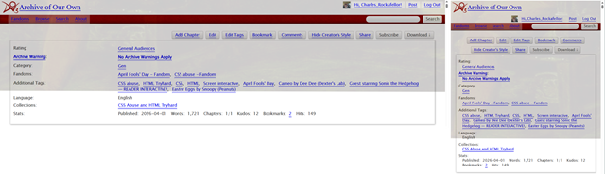
The image is present only under 3 of 4 conditions, depending upon the meta CSRF authorization token's final glyph. This wouldn't be possible without Mewz's development of the initial glyph detection hack (cf. Mewsmodeus (Mewzebub)'s I'M NOT AN FANFIC AUTHOR PLEASE DON'T CURSE ME [case insensitive in that specific execution]), and for which you can thank her when you get to the later uses of the initial glyph (though I ran with case sensitive).
Y'know, it really does come out [slightly] prettier in Reversi / ?site_skin=929. That aside, though: this is pure CSS (lines 211-243), no HTML per se (beyond the literal need for the actual page itself to exist, obviously).
The REM note is poorly worded:
- The first rule causes the Zalgo effect to be green (using... position: absolute, though fixed does the same [relative, sticky, and static more reasonably cause no color effect]), and the “1/4:” to be grey (opacity 0.2, understandably);
- it had originally also determined the image's presence, but this was later superseded by the rule at lines 1434-1439 (I probably should incorporate the position through opacity declarations from the first rule to the superseding rule, and turn the first rule's content declaration into a REM note indicating all of this; bringing the superseding rule's declarations up into the first rule instead is a no-starter because that rule is part of a set).
- The second rule stack is separate from the first rule for the following reasons:
- killing the transforms in DevTools affects the image,
- the margin-bottom has the adverse effect of launching the “1/4:” into/past the top of the screen (beginning to disappear through the top starting at 448px in a 1920px monitor, and at higher values for narrower viewports) rather than appearing to be part of the title, and the transforms' scale enlarges the “1/4:” unpleasantly (with the rotate(-0.7deg) being necessary in order to reverse the effect of lines 370-383, which are present simply to annoy readers just a tiny bit with the visible tilt [and hopefully large enough to avoid subliminally-induced vertigo, nausea, etc. — partially why I didn't try for a slow alternating rotation over time, back and forth: fun to fuck with people a little, but going as far as that could have been a bit too much]).
- Not shown here, but present in the work skin (and so of course page source), are seven meh-OK initial tests (lines 99-209) and four crappy-result rules that I tested in follow-up (lines 245-304).
#workskin .NOTE_re_title_before {
content: " /// *
This first standalone permits the Zalgo to go green. No clue why.
A little fuzzy on which test caused 1/4 in grey and to the left, but I scavenged a little to get it in a decently visible spot 60% left and grey.
The second set-of-three sets the blocking image for the other 3 final glyphs — and this set-up, out of all of the tests, seems to be optimal across desktop Chrome, Firefox, MS Edge, Opera, and TOR, as well as Android Chrome and iPhone Safari.
* /// ";
}

#workskin .preface.group h2.title:before {
content: url("https://i.pinimg.com/1200x/21/be/7d/21be7d538d219afa28f93a9cec248327.jpg");
position: absolute;
bottom: 100%;
left: 60%;
visibility: visible;
opacity: 0.2;
}

#workskin .preface.group h2.title:is(:has(meta:last-of-type[content$='g']) *):before,
#workskin .preface.group h2.title:is(:has(meta:last-of-type[content$='Q']) *):before,
#workskin .preface.group h2.title:is(:has(meta:last-of-type[content$='w']) *):before {
content: url("https://i.pinimg.com/1200x/21/be/7d/21be7d538d219afa28f93a9cec248327.jpg");
position: absolute;
bottom: 100%;
left: -15em;
margin-bottom: 485px;
visibility: visible;
opacity: 0.2;
-webkit-transform: scale(2.75, 2.2) rotate(-0.7deg);
-moz-transform: scale(2.75, 2.2) rotate(-0.7deg);
-ms-transform: scale(2.75, 2.2) rotate(-0.7deg);
-o-transform: scale(2.75, 2.2) rotate(-0.7deg);
transform: scale(2.75, 2.2) rotate(-0.7deg);
}

and for immediate reference (though it's also covered later, in its relevant rule set) here's that little supersession rule that I mentioned being in lines 1434-1439:
#workskin .preface.group h2.title:is(:has(meta:last-of-type[content$='A']) *):before {
content: "1/4: ";
text-decoration: none !important;
display: inline-block !important;
white-space: pre-wrap;
}

n/4 title
↑ CONTENTS (CTRL+CLICK)

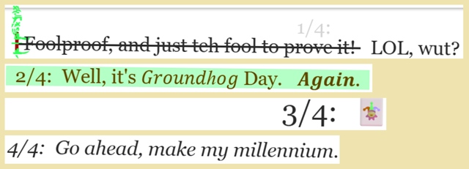
This one is a little messy, since there are a few things going on all at once.
If you were to view the work with Creator's Style disabled, then you would find that while the descending Zalgo diacritic stack is shown in toto, the ascending pile is cut off.
When viewed with site skin on, there's a ¼ chance (25% chance, 3:1 odds, 0.25 probability; however you prefer to word it, but since we're mucking with the meta's glyphs, and you can use the initial glyphs case sensitive 64 or insensitive 36, or moreover the initial 2 or final two [or combinations], I figure that n/d might be the best approach to establish right now) of seeing the Zalgo appear in green ink with the ascending diacritics visible in front of the metadata block (with the remaining configurations' appearance being determined by the RNG CSS, utilizing AO3's meta CSRF authorization token's initial glyph to determine what is shown).
When viewed as part of a collection or a search result or someone's bookmarks, then the diacritic stack breaks the boundaries on its own, crossing up into the work above it (and presumably would into the next work down, were this work's blurb somewhat shorter) or straight-up being too tall and disappearing above the top of the browser; this is not a function of the work skin (duh), nor of how AO3's <li>s are rendered by the browser (though similar can be seen when dropping a mega-stack of Zalgo in a comment), but apparently simple diacritic logic (can't say why, just gut-level inference from overspill even with bookmarkage) — when viewing page source or inspecting in DevTools, the diacritic stack remains, of course.
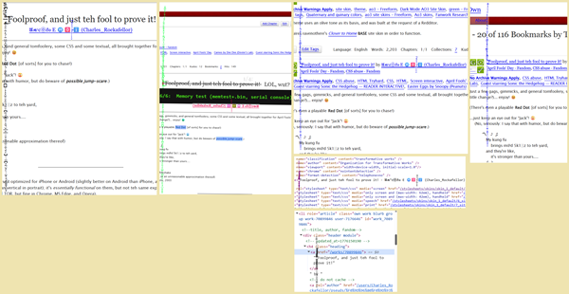
Belatedly, I realized that it even occurs in ALT-TAB (screencap of the ALT-TAB accomplished by first hitting ALT-TAB, then letting go of TAB but while still holding ALT I then also hit FN and PRT SC [no audible sound effect or visual thing to indicate success: just CTRL-V into MS Paint et voilà]):
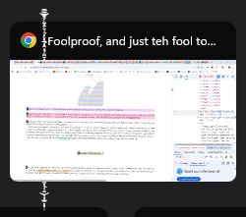

...and in kudos e-mail notifications:
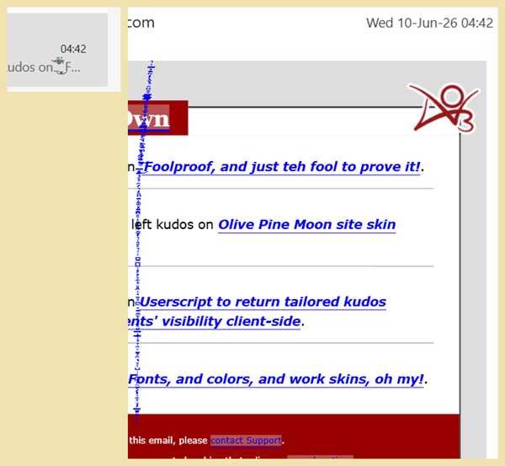
...and in the task bar's browser's jump list's sub-list of recently-closed pages (at least for Chrome in WIN 11), to include even in the tooltip that appears by the entry when one hovers over it:
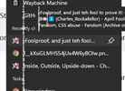

...and another late-discovery that it [unsurprisingly] also shows up in the chapter-navigation page (yes, even single-chapter fics automatically have such structural access) at
https://archiveofourown.org/works/70899846/navigate:
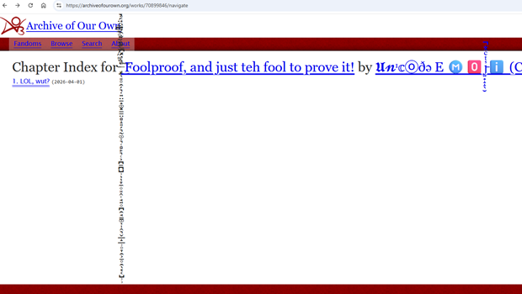
Then there's the 0.7° tilt and the 3/4 title replacements using title::after (the image already uses title::before, and the 6 running gag sequence items [starting with my tutorials' standard HHGttG line about “Don't panic”, but ending in the spirit of Monty Python and the Holy Grail] that might appear to be title::after are actually byline::before).

True title line-through, “LOL, wut”
Lines 1128-1149:
The 1/4 time that you get to see the true title of the work, part of it struck through... and is then followed without strikethrough by a “LOL, wut?”. As stated in the REM note, I developed the strikethrough for fallguy (Sparrow1M) who had asked for help with exactly that for someone else, though this adds something that wasn't there in my initial development (can't remember what: maybe the extended strikethrough preceding the title, since the non-struckthrough :after doesn't feel like it).
#workskin .NOTE_re_title_strikethrough {
content: " /// *
The ' LOL, wut?' started life as 'WTF?' to test some CSS for fallguy (Sparrow1M) who needed a hand helping someone else out (this coming about only after I had worked on the banter section, coming up next), but I liked it so much that I kept it in my test version of this work for when it was to be released for public consumption.
NB: that space in the content is copypasta &ensp (not the HTML entity), while the :before is a copypasta six-per-em space (not the HTML entity) — &thinsp seemed as if it were the same but possibly a little too large even though it should have been shorter, and &hairsp felt just barely too short. Cf. 'How to make and fix a series on AO3' https://archiveofourown.org/works/31387700#hairsp, for further details.
* /// ";
}

#workskin .preface.group .title {
justify-content: flex-end;
text-align: center;
text-decoration: line-through;
}

#workskin .preface.group .title::before {
content: " ";
}

#workskin .preface.group .title::after {
display: inline-block !important;
text-decoration: none !important;
content: " LOL, wut?";
}

0.7° tilt and missing cursor
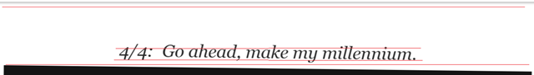
As you can see from the thin red line segments that I inserted into the image above, the [bottom of the] metadata block is unaffected (well, duh: this isn't a sitescreen, nor is a script being run in order to put the header within the work skin's reach), whereas the title and byline::before clearly are (and everything else within the work skin's reach).
The thing with the title (or anywhere else, really) is that by now you might start mousing for stuff, and discover that the cursor is missing (except in special places where I reinstated the cursor, because of course). The tiltscreen text and mouse are in lines 370-383:
#workskin .NOTE_re_tiltscreen {
content: " /// *
I tested it out at 1deg, and it felt too obvious, and at 0.1deg too subtle, but at 0.5deg and 0.6deg I was a little nauseated by the Uncanny Valley feeling, hence settling upon 0.7deg, but I don't know how most people might feel about one degree of tilt vs. another.
* /// ";
}

#workskin {
cursor: none !important;
-webkit-transform: rotate(0.7deg);
-moz-transform: rotate(0.7deg);
-ms-transform: rotate(0.7deg);
-o-transform: rotate(0.7deg);
transform: rotate(0.7deg);
}

.title replacement
Lines 1331-1365 not shown (scrapped in favor of lines 1434-1461, coming up after the next rule set) but contain my initial test-run “NOTE_re_Gear_One” of what later became the 6 running gag sequence items — hence the next rule set (below) starting with the odd note that it does.
Lines 1367-1377 (hiding the title when the meta CSRF authorization token's final glyph is {g, Q, w}, though permitting [by default] the plain-ish everyday title to be displayed when the token ends with A):
#workskin .NOTE_re_title_swap {
content: " /// *
Then I decided to recycle the 4 meta CSRF final glyphs' thing... mostly....
* /// ";
}

#workskin .preface.group h2.title:is(:has(meta:last-of-type[content$='g']) *),
#workskin .preface.group h2.title:is(:has(meta:last-of-type[content$='Q']) *),
#workskin .preface.group h2.title:is(:has(meta:last-of-type[content$='w']) *) {
visibility: hidden;
}

and lines 1434-1461 (injecting 1 item of title::before [instead of the metadata-block's click-blocking image] or 1 of 3 as title::after [so as to permit the title::before image to be injected over the metadata block]) — note that some of the text is not the standard stuff that you see in a work skin; that's not a special font or some JS trick of an extension in my browser, just some lettering from an unusual Unicode range (which pose problems for TTS screen readers, so I usually avoid using these outside of rare trivial cases) that I grabbed from Yaytext (I have a subsection covering some of the pros and cons [and a couple of similar sources] in my Fonts, and colors, and work skins, oh my! tutorial):
#workskin .preface.group h2.title:is(:has(meta:last-of-type[content$='A']) *):before {
content: "1/4: ";
text-decoration: none !important;
display: inline-block !important;
white-space: pre-wrap;
}

#workskin .preface.group h2.title:is(:has(meta:last-of-type[content$='g']) *):after {
content: " 2/4: Well, it's 𝐺𝑟𝑜𝑢𝑛𝑑ℎ𝑜𝑔 Day. 𝑨𝒈𝒂𝒊𝒏. ";
visibility: visible;
color: brown;
background-color: rgba(240, 240, 145, 0.8);
white-space: pre-wrap;
}

#workskin .preface.group h2.title:is(:has(meta:last-of-type[content$='Q']) *):after {
content: "3/4: 🃏";
visibility: visible;
font-size: 1.5em;
white-space: pre-wrap;
}

#workskin .preface.group h2.title:is(:has(meta:last-of-type[content$='w']) *):after {
content: "4/4: Go ahead, make my millennium.";
visibility: visible;
font-style: italic;
white-space: pre-wrap;
}

n/6 banter
↑ CONTENTS (CTRL+CLICK)

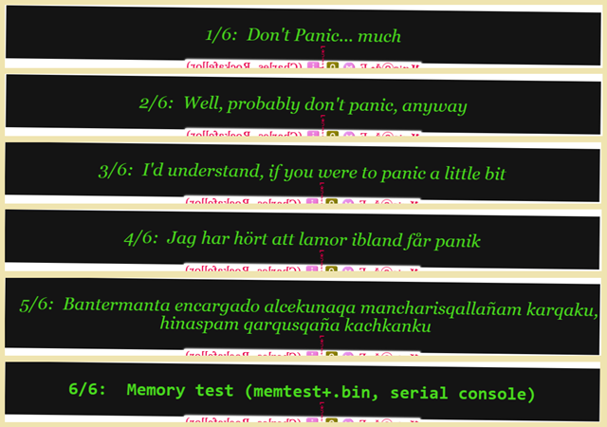
Lines 1159-1314 inject the banter into byline::before, but use the meta CSRF authorization's initial glyph to distribute the probability across 6 possible lines... almost equally (64 case sensitive, so: 11 glyphs each for the first four options, and 10 glyphs each for the last two options). This opened up some space in byline::after, naturally, and I took advantage of that as well, naturally (rule after next, for the “...butterfingers....” of #workskin .byline a:hover::after: lines 1316-1329); maybe it was the other way around, deciding instead to use the ::before and so switching this to ::after. Oh, and you can thank the byline (next rule) for this set needing to scaleX(-1) in order to reverse the byline's text-reversal.
Rule 4 is in svenska, and 5 is quechua.
#workskin .NOTE_re_banter {
content: " /// *
The double-space within is just two spacebars, but the double-spaces at the ends are copypastas of paired &𝙚𝙣𝙨𝙥+𝙛𝙤𝙪𝙧-𝙥𝙚𝙧-𝙚𝙢-𝙨𝙥𝙖𝙘𝙚 (copied actual-spaces, mind, not the written HTML entities, since those would simply be rendered as plaintext).
I started with .title:after, but decided to go with .byline:before. Not sure why, just a thing. That was fine for 4 message, so why bother with unnecessary extra crap? Well, yeah... then I had the 'brilliant' idea to expand just a teensy bit for 6 lines, and wham, I had to involve necessary extra crap.
Cf. https://archiveofourown.org/works/67467311 Chess puzzle extravaganza and https://archiveofourown.org/works/68244376 'Bubble-pop! game' for more-detailed info on RNG via the meta CSRF token, and my comment thread in https://archiveofourown.org/works/62524168 Targeting specific AO3 work sections (not site) with CSS effects, for how to use it in one's comment section.
* /// ";
}

#workskin .byline:is(:has(meta:last-of-type[content^='A']) *):before,
#workskin .byline:is(:has(meta:last-of-type[content^='B']) *):before,
#workskin .byline:is(:has(meta:last-of-type[content^='C']) *):before,
#workskin .byline:is(:has(meta:last-of-type[content^='D']) *):before,
#workskin .byline:is(:has(meta:last-of-type[content^='E']) *):before,
#workskin .byline:is(:has(meta:last-of-type[content^='F']) *):before,
#workskin .byline:is(:has(meta:last-of-type[content^='G']) *):before,
#workskin .byline:is(:has(meta:last-of-type[content^='H']) *):before,
#workskin .byline:is(:has(meta:last-of-type[content^='I']) *):before,
#workskin .byline:is(:has(meta:last-of-type[content^='J']) *):before,
#workskin .byline:is(:has(meta:last-of-type[content^='K']) *):before {
content: "\A 1/6: Don't Panic... much \A \A ";
font-size: 1.5em;
font-style: italic;
color: orange;
background-color: rgba(20, 20, 20, 20);
white-space: pre-wrap;
display: block;
-webkit-transform: scaleX(-1);
-moz-transform: scaleX(-1);
-ms-transform: scaleX(-1);
-o-transform: scaleX(-1);
transform: scaleX(-1);
}

#workskin .byline:is(:has(meta:last-of-type[content^='L']) *):before,
#workskin .byline:is(:has(meta:last-of-type[content^='M']) *):before,
#workskin .byline:is(:has(meta:last-of-type[content^='N']) *):before,
#workskin .byline:is(:has(meta:last-of-type[content^='O']) *):before,
#workskin .byline:is(:has(meta:last-of-type[content^='P']) *):before,
#workskin .byline:is(:has(meta:last-of-type[content^='Q']) *):before,
#workskin .byline:is(:has(meta:last-of-type[content^='R']) *):before,
#workskin .byline:is(:has(meta:last-of-type[content^='S']) *):before,
#workskin .byline:is(:has(meta:last-of-type[content^='T']) *):before,
#workskin .byline:is(:has(meta:last-of-type[content^='U']) *):before,
#workskin .byline:is(:has(meta:last-of-type[content^='V']) *):before {
content: "\A 2/6: Well, probably don't panic, anyway \A \A ";
font-size: 1.5em;
font-style: italic;
color: orange;
background-color: rgba(20, 20, 20, 20);
white-space: pre-wrap;
display: block;
-webkit-transform: scaleX(-1);
-moz-transform: scaleX(-1);
-ms-transform: scaleX(-1);
-o-transform: scaleX(-1);
transform: scaleX(-1);
}

#workskin .byline:is(:has(meta:last-of-type[content^='W']) *):before,
#workskin .byline:is(:has(meta:last-of-type[content^='X']) *):before,
#workskin .byline:is(:has(meta:last-of-type[content^='Y']) *):before,
#workskin .byline:is(:has(meta:last-of-type[content^='Z']) *):before,
#workskin .byline:is(:has(meta:last-of-type[content^='a']) *):before,
#workskin .byline:is(:has(meta:last-of-type[content^='b']) *):before,
#workskin .byline:is(:has(meta:last-of-type[content^='c']) *):before,
#workskin .byline:is(:has(meta:last-of-type[content^='d']) *):before,
#workskin .byline:is(:has(meta:last-of-type[content^='e']) *):before,
#workskin .byline:is(:has(meta:last-of-type[content^='f']) *):before,
#workskin .byline:is(:has(meta:last-of-type[content^='g']) *):before {
content: "\A 3/6: I'd understand, if you were to panic a little bit \A \A ";
font-size: 1.5em;
font-style: italic;
color: orange;
background-color: rgba(20, 20, 20, 20);
white-space: pre-wrap;
display: block;
-webkit-transform: scaleX(-1);
-moz-transform: scaleX(-1);
-ms-transform: scaleX(-1);
-o-transform: scaleX(-1);
transform: scaleX(-1);
}

#workskin .byline:is(:has(meta:last-of-type[content^='h']) *):before,
#workskin .byline:is(:has(meta:last-of-type[content^='i']) *):before,
#workskin .byline:is(:has(meta:last-of-type[content^='j']) *):before,
#workskin .byline:is(:has(meta:last-of-type[content^='k']) *):before,
#workskin .byline:is(:has(meta:last-of-type[content^='l']) *):before,
#workskin .byline:is(:has(meta:last-of-type[content^='m']) *):before,
#workskin .byline:is(:has(meta:last-of-type[content^='n']) *):before,
#workskin .byline:is(:has(meta:last-of-type[content^='o']) *):before,
#workskin .byline:is(:has(meta:last-of-type[content^='p']) *):before,
#workskin .byline:is(:has(meta:last-of-type[content^='q']) *):before,
#workskin .byline:is(:has(meta:last-of-type[content^='r']) *):before {
content: "\A 4/6: Jag har hört att lamor ibland får panik \A \A ";
font-size: 1.5em;
font-style: italic;
color: orange;
background-color: rgba(20, 20, 20, 20);
white-space: pre-wrap;
display: block;
-webkit-transform: scaleX(-1);
-moz-transform: scaleX(-1);
-ms-transform: scaleX(-1);
-o-transform: scaleX(-1);
transform: scaleX(-1);
}

#workskin .byline:is(:has(meta:last-of-type[content^='s']) *):before,
#workskin .byline:is(:has(meta:last-of-type[content^='t']) *):before,
#workskin .byline:is(:has(meta:last-of-type[content^='u']) *):before,
#workskin .byline:is(:has(meta:last-of-type[content^='v']) *):before,
#workskin .byline:is(:has(meta:last-of-type[content^='w']) *):before,
#workskin .byline:is(:has(meta:last-of-type[content^='x']) *):before,
#workskin .byline:is(:has(meta:last-of-type[content^='y']) *):before,
#workskin .byline:is(:has(meta:last-of-type[content^='z']) *):before,
#workskin .byline:is(:has(meta:last-of-type[content^='0']) *):before,
#workskin .byline:is(:has(meta:last-of-type[content^='1']) *):before {
content: "\A 5/6: Bantermanta encargado alcekunaqa mancharisqallañam karqaku, hinaspam qarqusqaña kachkanku \A \A ";
font-size: 1.5em;
font-style: italic;
color: orange;
background-color: rgba(20, 20, 20, 20);
white-space: pre-wrap;
display: block;
-webkit-transform: scaleX(-1);
-moz-transform: scaleX(-1);
-ms-transform: scaleX(-1);
-o-transform: scaleX(-1);
transform: scaleX(-1);
}

#workskin .byline:is(:has(meta:last-of-type[content^='2']) *):before,
#workskin .byline:is(:has(meta:last-of-type[content^='3']) *):before,
#workskin .byline:is(:has(meta:last-of-type[content^='4']) *):before,
#workskin .byline:is(:has(meta:last-of-type[content^='5']) *):before,
#workskin .byline:is(:has(meta:last-of-type[content^='6']) *):before,
#workskin .byline:is(:has(meta:last-of-type[content^='7']) *):before,
#workskin .byline:is(:has(meta:last-of-type[content^='8']) *):before,
#workskin .byline:is(:has(meta:last-of-type[content^='9']) *):before,
#workskin .byline:is(:has(meta:last-of-type[content^='-']) *):before,
#workskin .byline:is(:has(meta:last-of-type[content^='_']) *):before {
content: "\A 6/6: Memory test (memtest+.bin, serial console) \A \A ";
font-family: Quartz MS, Oxanium, Kelly Slab, ZCOOL QingKe HuangYou, Gugi, Watch MN Outline, Watch MN, Watch Outline Regular, Watch Outline, Quantico, Digital Std Regular, Digital, Overtime LCD Pro, Synchro LET Plain, Coda, Gemunu Libre, Atomic Age, Saira Extra Condensed, Tektur, OCR-A, "Odibee Sans", Rationale, Jura, Monomaniac One, 'Monaco', 'Consolas', Courier, monospace, sans-serif;
font-size: 1.5em;
font-weight: 1000;
color: orange;
background-color: rgba(20, 20, 20, 20);
white-space: pre-wrap;
display: block;
-webkit-transform: scaleX(-1);
-moz-transform: scaleX(-1);
-ms-transform: scaleX(-1);
-o-transform: scaleX(-1);
transform: scaleX(-1);
}

Reverse byline
↑ CONTENTS (CTRL+CLICK)

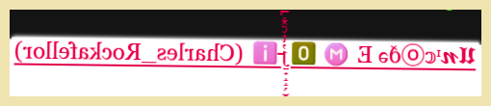

Lines 1151-1157 force the byline to read out backward:
#workskin .byline {
-webkit-transform: scaleX(-1);
-moz-transform: scaleX(-1);
-ms-transform: scaleX(-1);
-o-transform: scaleX(-1);
transform: scaleX(-1);
}

byline:hover and a:hover
↑ CONTENTS (CTRL+CLICK)

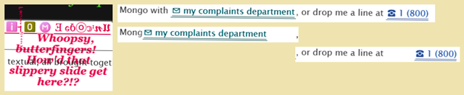
Lines 1316-1329 inject that little :hover message just below the byline, plus a necessary transform to flip the flipped script back to forward-reading:
#workskin .byline a:hover::after {
position: absolute;
right: 200px !important;
content: " \A Whoopsy, butterfingers! How'd that slippery slide get here?!?";
text-shadow: -1px -1px 0 white, 1px -1px 0 white, -1px 1px 0 white, 1px 1px 0 white;
font-weight: 800;
font-style: italic;
display: block;
-webkit-transform: scaleX(-1);
-moz-transform: scaleX(-1);
-ms-transform: scaleX(-1);
-o-transform: scaleX(-1);
transform: scaleX(-1);
}

That's the first spot where you might also notice that all of the links are slippery little buggers, thanks to lines 776-786:
#workskin a:nth-of-type(odd):hover,
#workskin ~ #feedback a:nth-of-type(odd):hover {
position: relative;
right: 50px;
}

#workskin a:nth-of-type(even):hover,
#workskin ~ #feedback a:nth-of-type(even):hover {
position: relative;
left: 50px;
}

Colors... colors everywhere
↑ CONTENTS (CTRL+CLICK)

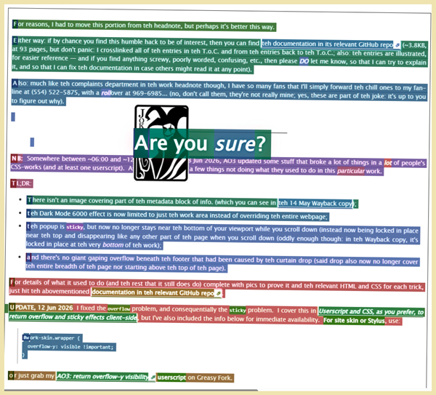
By now, you'll have noticed that [seemingly] every damned thing is colorized, and not always in a predictable sequence (as demonstrated by the CTRL-A ::selection image above). This is a three-parter.
Lines 157-522 simply apply a choice of color to the first-letter and give it a background-color, plus a little padding so that the colorful sides of the letters can also be seen (it's just not right without the padding, man, no sense of illuminated manuscript, y'know?), and then it lets the next entire rule set do the heavy lifting (yes, that :not(.bordertd) part is about a personal pseudoclass, and it's necessary in order to prohibit the effect when we get to the Red Dot Special):
#workskin *:not(.bordertd)::first-letter,
#workskin ~ #feedback *::first-letter {
color: yellow;
background-color: purple;
padding: 0 3px 0 3px;
}

Lines 1463-1464 affect any boldfaced material in the .summary:
#workskin .summary.module b {
color: red;
background-color: yellow;
}

Lines 1050-1126 hue-rotate all nth-of-type increasingly (30°, 60°, 90°, ..., 0° [this last isn't necessary, but my set theoretic knee jerked at me]), which very much comes into play when we get to the colorful ASCII art — in color section — which also affects the ::selection, though I have no rules otherwise in place for that directly:
#workskin *:nth-of-type(12n+1),
#workskin ~ #feedback *:nth-of-type(12n+1) {
-webkit-filter: hue-rotate(30deg);
filter: hue-rotate(30deg);
}

#workskin *:nth-of-type(12n+2),
#workskin ~ #feedback *:nth-of-type(12n+2) {
-webkit-filter: hue-rotate(60deg);
filter: hue-rotate(60deg);
}

#workskin *:nth-of-type(12n+3),
#workskin ~ #feedback *:nth-of-type(12n+3) {
-webkit-filter: hue-rotate(90deg);
filter: hue-rotate(90deg);
}

#workskin *:nth-of-type(12n+4),
#workskin ~ #feedback *:nth-of-type(12n+4) {
-webkit-filter: hue-rotate(120deg);
filter: hue-rotate(120deg);
}

#workskin *:nth-of-type(12n+5),
#workskin ~ #feedback *:nth-of-type(12n+5) {
-webkit-filter: hue-rotate(150deg);
filter: hue-rotate(150deg);
}

#workskin *:nth-of-type(12n+6),
#workskin ~ #feedback *:nth-of-type(12n+6) {
-webkit-filter: hue-rotate(180deg);
filter: hue-rotate(180deg);
}

#workskin *:nth-of-type(12n+7),
#workskin ~ #feedback *:nth-of-type(12n+7) {
-webkit-filter: hue-rotate(210deg);
filter: hue-rotate(210deg);
}

#workskin *:nth-of-type(12n+8),
#workskin ~ #feedback *:nth-of-type(12n+8) {
-webkit-filter: hue-rotate(240deg);
filter: hue-rotate(240deg);
}

#workskin *:nth-of-type(12n+9),
#workskin ~ #feedback *:nth-of-type(12n+9) {
-webkit-filter: hue-rotate(270deg);
filter: hue-rotate(270deg);
}

#workskin *:nth-of-type(12n+10),
#workskin ~ #feedback *:nth-of-type(12n+10) {
-webkit-filter: hue-rotate(300deg);
filter: hue-rotate(300deg);
}

#workskin *:nth-of-type(12n+11),
#workskin ~ #feedback *:nth-of-type(12n+11) {
-webkit-filter: hue-rotate(330deg);
filter: hue-rotate(330deg);
}

#workskin .NOTE_re_rule_12 {
content: " /// *
No, rotating 360deg is surely not necessary, but making it explicit feels more comfortable to me set theoretically, and sometimes the most ridiculous thing turns out to matter, and in this case 12 is the last rule and so would trump any case of cyclicity.
* /// ";
}

#workskin *:nth-of-type(12n+12),
#workskin ~ #feedback *:nth-of-type(12n+12) {
-webkit-filter: hue-rotate(0deg);
filter: hue-rotate(0deg);
}

.summary snippet's images
↑ CONTENTS (CTRL+CLICK)

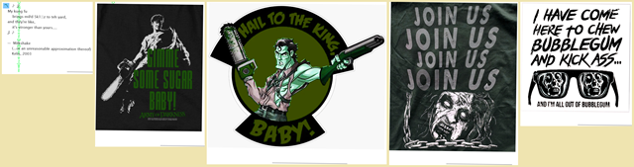
Images? Yeah: four of them (g'head: guess how). Lines 385-399:
#workskin:is(:has(meta:last-of-type[content$='A']) *) .summary dd:hover {
content: url("https://raw.githubusercontent.com/Charles-Rockafellor/Foolproof/refs/heads/main/ED_AoD_Gimme_some_sugar_Baby.png");
}

#workskin:is(:has(meta:last-of-type[content$='g']) *) .summary dd:hover {
content: url("https://raw.githubusercontent.com/Charles-Rockafellor/Foolproof/refs/heads/main/ED_AoD_Hail_to_the_king_Baby.png");
}

#workskin:is(:has(meta:last-of-type[content$='Q']) *) .summary dd:hover {
content: url("https://raw.githubusercontent.com/Charles-Rockafellor/Foolproof/refs/heads/main/ED_AoD_Join_Us.png");
}

#workskin:is(:has(meta:last-of-type[content$='w']) *) .summary dd:hover {
content: url("https://raw.githubusercontent.com/Charles-Rockafellor/Foolproof/refs/heads/main/They_Live_Kick_Ass_Chew_Bubblegum.png");
}

Headnote color note w/ style off, & Dark Mode 6000
↑ CONTENTS (CTRL+CLICK)

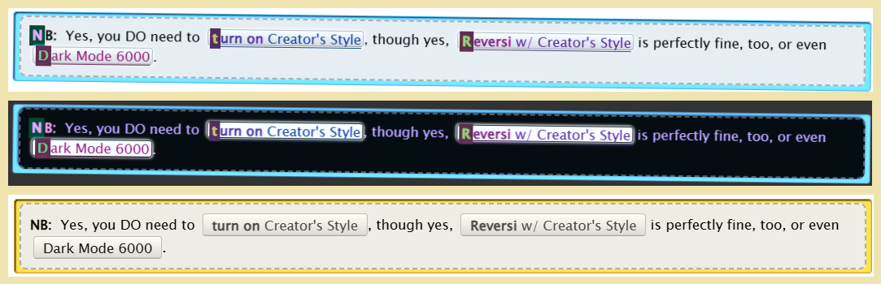
In this image, you see the Default / ?site_skin=1 view, Reversi / ?site_skin=929 view, and Creator's Style off / ?style=disable view (included to demonstrate the note taking advantage of the site-level style rules, no work skin CSS required).
This one in and of itself has no specific rules attached to it, just the general stuff such as the hue-rotate or the link jinking, and some standard buttons, though the Dark Mode 6000 button's result is its own special hell-mode (though still a bit of a cheap trick, borrowing a little from Inside, Outside, Upside-down, blackout of entire site page in ch. 2).
<div class="caution">
<div class="draft">
<p>
<b>NB:</b>&nbsp; Yes, you DO need to <sup class="actions"><big><sub><a href="https://archiveofourown.org/works/70899846?style=creator" rel="nofollow"><big><b>turn on</b> Creator's Style</big></a></sub></big></sup>, though yes, <sup class="actions"><big><sub><a href="https://archiveofourown.org/works/70899846?site_skin=929&amp;style=creator" rel="nofollow"><big><b>Reversi</b> w/ Creator's Style</big></a></sub></big></sup> is perfectly fine, too, or even <sup class="actions"><big><sub><a href="https://archiveofourown.org/works/70899846#ultradark" rel="nofollow"><big>Dark Mode 6000</big></a></sub></big></sup>.
</p>
</div>
</div>

You notice that special little link at the end, the one that links to Dark Mode 6000 at https://archiveofourown.org/works/70899846#ultradark? What do you suppose it does? Strictly, it depends a little upon your zoom percentage, but basically... you get sent to an overridden entirely black screen {no longer entirely black screen overriding the whole webpage, thanks to the update (cf. Curtain drop)} that reads “Bork! Bork! Bork!” (or at least part of that):

Well, let's go inspectigate its rules and HTML, now, shall we? Here we go, lines 471-515:
#workskin .NOTE_re_Dark_Mode_6000 {
content: " /// *
Modification of 'THE RETOACTIVE FLASHBACK' of ch. 13 of the InfinitysWraith work 'CSS in Testing'
https://archiveofourown.org/works/25174384/chapters/75543767#workskin
https://archiveofourown.org/works/25174384/chapters/75543767#activatehiddentext
https://archiveofourown.org/works/25174384/chapters/75543767?style=disable
view-source:https://archiveofourown.org/works/25174384/chapters/75543767#activatehiddentext
* /// ";
}

#workskin .noseeum a,
#workskin .noseeum + a {
display: none;
}

#workskin .vanta_wrapper {
display: none;
}

#workskin a:target ~ .vanta_wrapper {
display: block;
content: "";
}

#workskin .vanta {
position: absolute;
left: -50em;
top: -800em;
background-color: black !important;
color: black !important;
z-index: 21 !important;
height: 2860em;
width: 200em;
-webkit-transform: rotate(-0.7deg) !important;
-moz-transform: rotate(-0.7deg) !important;
-ms-transform: rotate(-0.7deg) !important;
-o-transform: rotate(-0.7deg) !important;
transform: rotate(-0.7deg) !important;
}

#workskin .bork {
top: 2000em;
color: red;
font-size: 80em;
}

And where does that little gem take us? Why, where else but this baby buried way at the almost-end of the work's endnote (yes, that's a hint: there is also a chapter footnote):
<span class="noseeum"><a href="#ultradark" rel="nofollow"></a></span>
<a name="ultradark" rel="nofollow"></a>
<span class="vanta_wrapper"><span class="vanta"><span class="bork">Bork! Bork! Bork!</span></span></span>

which happens to be right before the dead-in-the-water experiment (cf. lines 401-469) mixing the old Cookie Monster password-like joke-vira with a little quote from Stranger Things:
<div class="landmark remove-only-this-one-landmark-to-turn-on-cookie-monster-experiment cookiebox">
<div class="cookie1">
<p>
Papa! Me want more <a href="https://en.wikipedia.org/wiki/Cookie_Monster_(computer_program)" rel="nofollow">COOKIE</a>!
</p>
<p>
<a href="#voici" rel="nofollow">What kind?</a>
</p>
</div>
<div class="cookie2">
<p>
<a name="voici" class="landmark" rel="nofollow"></a>Oatmeal chocolate chip Oreo
</p>
<p>
<a href="#danke" rel="nofollow">Give Cookie Monster a cookie.</a>
</p>
</div>
<div class="cookie3">
<p>
<a name="danke" class="landmark" rel="nofollow"></a>Thank you! Om-nom-nom-nom...!
</p>
<p>
<a href="#cookied" rel="nofollow">You're welcome.</a>
</p>
</div>
</div>

Transylvania-6 5000
↑ CONTENTS (CTRL+CLICK)

In the [work] headnote, I placed a helpful suggestion for people who might not be thrilled with April Fools' Day gags
if(document.body.textContent.search("april fools") > -1) {
document.body.innerHTML = "";
}
Just below that is where the line with the tooltip lives.
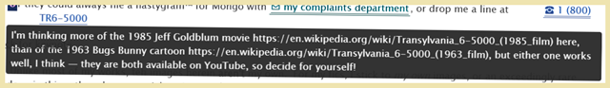
The HTML is standard <a rel="nofollow">☎ 1 (800) TR6-5000</a> (AO3 sanitizes-out the href="tel:+1-800-876-5000" 'phone number), and the tooltip's CSS of lines 361-368 is pretty standard stuff too, though preceded by lines 347-359 (this preceding rule also affecting the e-mail link of that same paragraph):
#workskin .preface .notes p:nth-of-type(5) a::before {
position: absolute;
top: 100%;
left: -55vw;
white-space: wrap;
background-color: #333;
color: #fff;
padding: 5px 8px;
border-radius: 4px;
visibility: hidden;
opacity: 0;
transition: visibility 0s, opacity 0.3s ease;
}

#workskin .preface .notes p:nth-of-type(5) a:nth-of-type(2):hover::before {
width: 60vw;
visibility: visible;
opacity: 1;
z-index: 20;
white-space: pre-wrap;
content: "I'm thinking more of the 1985 Jeff Goldblum movie https://en.wikipedia.org/wiki/Transylvania_6-5000_(1985_film) here, than of the 1963 Bugs Bunny cartoon https://en.wikipedia.org/wiki/Transylvania_6-5000_(1963_film), but either one works well, I think — they are both available on YouTube, so decide for yourself!";
}

Though I should mention that the clickable <a href="mailto:BiteMe@null.pointer?subject=Grr%20wah%20&amp;body=Boo,%20hiss!" rel="nofollow">✉ my complaints department</a> actually works (opening your e-mail program and pre-filling the subject line). I kind of expected that AO3 would kill that function (they killed the clickable dial on the 'phone number), but they didn't: go figure.

Keynote detail marker, w/ bonus image
↑ CONTENTS (CTRL+CLICK)

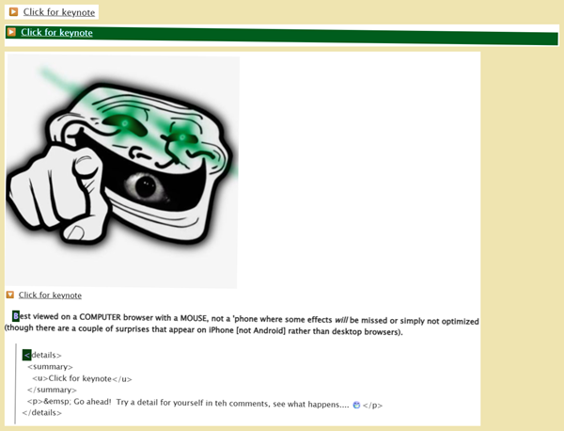
The “Click for keynote” details in the headnote is styled by lines 1468-1496 (a mod of something that I developed for GumbaBunny)... plus a little extra for the #workskin ~ #feedback in lines 3486-3488 (this is the one that I added to the “mostly” default rule set — partly stupid to break it from headnote's details rules, partly DOM-sensible). I had thrown in the extra bit before AO3 changed the rendered DOM in order to prevent styling of the feedback section, but if someone uses my AO3: return tailored kudos' and styled comments' visibility userscript to return the #feedback to within the #worskin's reach, or simply manipulates things in DevTools, then they'll see any details in the comments get the [different] image prepended to the [open] state.
NB: The "▶️" displays here as a standard black rightward triangle "▶" unless you change the font to something emoji-compatible (e.g.: Segoe UI Emoji [or Noto Color Emoji, in Linux]), which I did here for visual emphasis and in order to reflect what you should see in a work skin. This isn't necessary in VS Code nor the work skin (nor .txt, incidentally), and it does appear properly (hue-rotate aside) in the skinned work (and even in .txt). If you run into this issue upon viewing this document, then just switch fonts if you can and it should be fine for reading purposes (though not necessary for CSS: it's definitely the same white-on-blue as the "🔽" downward one). If you're wondering why, I dug: it's apparently because the white-on-blue version is actually just the standard ▶ rightward triangle (U+25B6) combined with the Variation Selector-16 (U+FE0F), or in other words, it's a composition (and I'm using LibreOffice, which relies upon system fonts, rather than writing this in something like .txt which passes emoji to the O.S.'s emoji engine automatically, hence I had to do this manually)... which simply leaves me wondering why the downward blue triangle doesn't likewise require the font change in order to render properly here; sigh: whatever.
#workskin .NOTE_re_blue_triangle_emoji_details_summary_marker {
content: " /// *
Developed for GumbaBunny 19 Jan 2026.
https://codepen.io/Charles-Rockafellor/pen/ByzRWjy
* /// ";
}

#workskin .notes.module details summary {
list-style: none;
}

#workskin .notes.module details summary::-webkit-details-marker {
display: none;
}

#workskin .notes.module details summary::before {
content: "▶️";
margin-right: 0.5em;
display: inline-block;
width: 1em;
}

#workskin .notes.module details[open] summary::before {
content: "🔽";
}

#workskin .notes.module details[open]:before {
content: url(https://i.pinimg.com/736x/18/c7/c0/18c7c0a987d9119b22e246a8a7cef5d5.jpg);
}
and
#workskin ~ #feedback details[open]:before {
content: url(https://i.pinimg.com/736x/aa/06/50/aa06508fccc3e2a98992c6b669f2b255.jpg);
}

Gumba
↑ CONTENTS (CTRL+CLICK)

You can't drop an audio/video into the preface section... unless you don't drop it there, in which case you can cause it to be there. Get it? Got it. Good! (Please: someone tell me that they like Danny Kaye?) That's part one of the trick.
GumbaBunny invited me to the HTML Tryhard server, so this one was a surprise gift, something that I had developed for them (the underlying structure is something that apparently Gumba had gotten from FerdieLance (JohnWWells)'s "Objection!" Shout Buttons (HTML + CSS with audio) [the .shoutaudio being the only part that I recycle farther down {cf. SONIC!}, when we get to the leaping Sonic .gifs' HTML], and for which I can't take credit: I didn't develop that, I developed the placement into the headnote, and hid it with a modification of Mewz's detect-user routine [cf. Mewsmodeus (Mewzebub)'s I'M NOT AN FANFIC AUTHOR PLEASE DON'T CURSE ME, ch. 6] that I caused to detect exactly and only GumbaBunny's username in order to reveal the otherwise .landmark-classed material [site-level class, so won't appear even with Creator's Style off]). Which brings us to part two of the trick: anyone reading the work, and who isn't Gumba, wouldn't see this unless something were to glitch big time or they were to muck around in DevTools (or copy the CSS under the hood to their own test-fic and change just the right parts).
That's what you see here, when you're not you, unless you're Gumba, in which case you would see this normally and wouldn't see it if you weren't you. A normal everyday empty paragraph at the end of the headnote and then the sparkly unicorns bracing the page's .jump — or [Gumba's] clickable image that plays [Gumba's] snippet of chorus plus some instruction text beneath it (one snapshot showing 1920px's layout, the other in narrow viewport of maybe 600px).
The .jump's unicorns aren't part of the Gumba stuff, but since there's a second piece of Gumba stuff below the preface, I'll also cover the unicorns in this section.
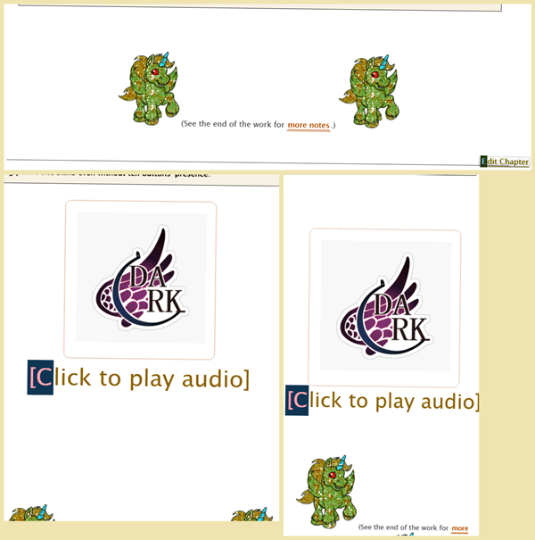

Note that — as with everything in the main body of this work (not preface module material) — there's a difference in color between .../works/70899846 and .../works/70899846/chapters/184352031 (that same difference applying to .../chapters/184352031 [sans /works/70899846]). I won't drop images of every color change just for the sake of demonstrating it, but a few of them are worthwhile inserting, and this is the first of them:
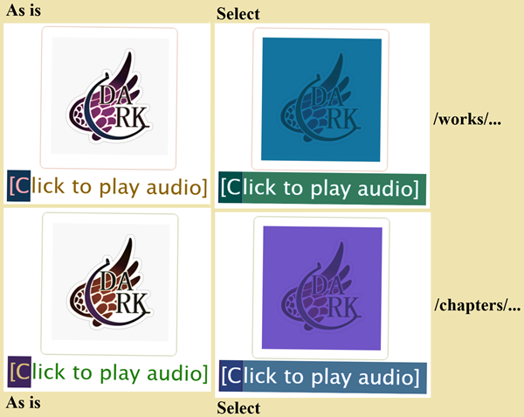

Unicorns
Let me address the unicorns first; they're not Gumba-related, but they are what almost everyone will see at all, and happen to come first in the CSS — and bonus: they're quick and easy, being all of lines 524-531 (Which is a bit of a shame, really, since otherwise I could've tossed in a casual Transformers parodic joke of “Unicorns, why did you torture me?” [@ ~55:01 in Transformers: The Movie, 1986]).
In the site's JS-injected part that tells you to see the end of the work for more notes, the HTML for it is a classed paragraph, specifically .jump. The unicorns' styling comes from centering the paragraph in order to place the unicorns symmetrically (I didn't bother shrinking them in case of narrow viewports, and we didn't have feind's Responsive Design & Media Queries on AO3 [Tutorial] at the time [nor am I inclined to update them now: sounds great, but I'm gonna take the Beatles' cue here and just let it be]).
#workskin .jump {
text-align: center;
}

#workskin .jump::before,
#workskin .jump::after {
content: url("https://www.cornify.com/corns/u3.gif");
}

Gumba-greeting
My apologies, but I shrank the font size for this section's CSS because it takes up 5 pages otherwise; I would prune it, but it's kind of all relevant. Lines 533-758.
NB: There is a little more Gumba-targeted stuff in the popup section (that section being lines 788-969, but the Gumba-targeted parts are only lines 831-871, which is why you see the greeting section's ..._of_8 rules and tests go only as far as ..._6_of_8, since the 7 and 8 stuff is specific to the popup's addendum), so that remaining Gumba material will come up when we get to the .popup, no point in adding to the confusion here.
There's also some HTML involved, but let's look at the CSS first (wherein all is explained by the REM notes, so I haven't expanded upon them here in the documentation itself):
#workskin .NOTE_re_welcome {
content: " /// *
There is actually a semi-long-ish list of HTML Tryhards, CSS authors in general, and one favorite / dedicated reader in particular, all of whom I would like to welcome, but that would be a semi-long-ish list of extra rules, and I'd worry that I'd miss someone, so I kept it short, since GumbaBunny is the one who invited me to the Tryhard Discord back in the first week of March 2025, and that was what prompted me to actually give AO3 CSS a more serious shot (I had left it minimal before, since people can turn off work skins, plus they can use their own site skins and those can conflict with work skin effects, but readers do seem to like the results).
For anyone who is not GumbaBunny, you can cause this welcome message to become visible in your own browser, only client-side, by inspecting the top of the main text element just below the headnotes, and in DevTools simply remove the disguise_the_empty_space class, though it will not be in 3em. Cf. https://archiveofourown.org/works/62524168#return_of_the_wizard for detailed instructions with screenshots. Likewise, removing the Gumba class will cause the audio image and play-message to also become visible, though they will appear in front of the unicorn.
* /// ";
}

#workskin .NOTE_re_1_of_8 {
content: " /// *
This turns off the music-clicker image and the basic welcome message, when the reader is not GumbaBunny. It does not suffice alone to prevent anything, managing to prevent only the music-clicker and click message and welcome ONLY when it follows after all 7 of the other rules, and is here only as an added layer.
That could be unwise though, since added complication means one more place to mess things up.
* /// ";
}

#workskin .NOTE_re_NAME_TESTING_1_of_8 {
content: " /// *
SHOULD be GumbaBunny, but TESTED with Charles_Rockafellor.
READERS who wish to experiment with this should change the href to THEIR username (this means YOU, the reader poking around under the hood and reading this right now).
* /// ";
}

#workskin .Gumba:not(:has(#header .icon [href$='s/Charles_Rockafellor']) *) {
display: none;
}

#workskin .NOTE_re_2_of_8 {
content: " /// *
This was added to limit the space beneath the welcome message. I made it a separate rule in order for it to stand out.
* /// ";
}

#workskin .NOTE_re_NAME_TESTING_2_of_8 {
content: " /// *
SHOULD be GumbaBunny, but TESTED with Charles_Rockafellor.
READERS who wish to experiment with this should change the href to THEIR username (this means YOU, the reader poking around under the hood and reading this right now).
* /// ";
}

#workskin div.Gumba:is(:has(#header .icon [href$='s/Charles_Rockafellor']) *) {
max-height: 5em;
}

#workskin .NOTE_re_3_of_8 {
content: " /// *
This makes the welcome message large, but should still fit in all viewports, as long as nobody is trying to read AO3 on a digital watch or anything else ridiculously narrow.
Everything after the font-size is in order to counter the fact of div also being landmark classed, which itself is to keep it from showing up with style turned off. Without it being landmarked, only the font-size would be here.
Both opacity and color are necessary in order to make the contents actually visible, and the rest are fiddly bits for adjusting how and where they show up.
* /// ";
}

#workskin .NOTE_re_NAME_TESTING_3_of_8 {
content: " /// *
SHOULD be GumbaBunny, but TESTED with Charles_Rockafellor.
READERS who wish to experiment with this should change the href to THEIR username (this means YOU, the reader poking around under the hood and reading this right now).
* /// ";
}

#workskin .Gumba:is(:has(#header .icon [href$='s/Charles_Rockafellor']) *) {
width: auto;
height: auto;
margin: 0.643em 0;
line-height: 1;
font-size: 3em;
opacity: 1 !important;
color: green !important;
}

#workskin .NOTE_re_4_of_8 {
content: " /// *
This adds the extra message to the greeting for GumbaBunny without appearing when style is turned off.
* /// ";
}

#workskin .NOTE_re_NAME_TESTING_4_of_8 {
content: " /// *
SHOULD be GumbaBunny, but TESTED with Charles_Rockafellor.
READERS who wish to experiment with this should change the href to THEIR username (this means YOU, the reader poking around under the hood and reading this right now).
* /// ";
}

#workskin .Gumba:is(:has(#header .icon [href$='s/Charles_Rockafellor']) *)::after {
position: relative;
top: -275px;
display: block;
-webkit-transform: scale(0.3, 0.3);
-moz-transform: scale(0.3, 0.3);
-ms-transform: scale(0.3, 0.3);
-o-transform: scale(0.3, 0.3);
transform: scale(0.3, 0.3);
border: 5px solid red;
background-color: yellow;
color: rgba(0, 0, 255, 0.9);
padding: 50px;
font-size: 0.8em;
text-align: center;
content: "(Psst, secret message: 𝐯𝐢𝐞𝐰𝐬𝐨𝐮𝐫𝐜𝐞 and CTRL-F for teh re_music section and right below it teh smoke_and_mirrors section.)";
z-index: -1;
opacity: 0.7;
}

#workskin .NOTE_re_music {
content: " /// *
Stolen verbatim from GumbaBunny, except for adjusting the shoutcontainer top, then tweaked by the smoke_and_mirrors section in order to move it to the Summary.
If you make the headnote longer or shorter in written material, or do anything else that mucks up the image's and click message's vertical placement, then you must
— change shoutcontainer top value of em to move the clickable image up or down,
— and in the next section change the move_up to that same em value,
— and change the next section add_space value in order to expand or contract the extra space needed for the image and click-to-play message to fit in with your changed headnote size,
— and check versus wide and narrow browser for viewport width to make sure that it looks alright either way.
Right now, the wrapping div is classed as Gumba, which hides the clickable image and click-to-play message in accordance with the welcome message rules directly above here. In order to make them always visible, just remove that class or put the image and play-message in a div without that class. Mind you, the headnote also has a classed div in it, so that the add_space shows up only when the user name is a match, so you'd want to remove that class from that div, too.
For anyone who is not GumbaBunny, you can cause this audio image and play-message to become visible in your own browser, only client-side, by inspecting the top of the main text element just below the headnotes, and in DevTools simply remove the Gumba class, though they will appear in front of the unicorn. Cf. https://archiveofourown.org/works/62524168#return_of_the_wizard for detailed instructions with screenshots. Likewise, removing the disguise_the_empty_spaceclass will cause the welcome message to also become visible, though it will not be in 3em.
* /// ";
}

#workskin BUTTON CLICK AUDIO by FerdieLance (JohnWWells) ####################### {
color: INHERIT;
}

#workskin .shoutcontainer {
position: relative;
top: -1180px;
left: 0;
background-color: white;
border-radius: 10px;
box-shadow: 0px 0px 3px;
overflow: hidden;
width: 298px;
height: 196 px;
}

#workskin .shoutcontainer > p {
background-color: white;
margin: 0px;
padding: 20px;
}

#workskin .shoutaudio {
position: absolute;
-webkit-transform: scale(22,14);
-moz-transform: scale(22,14);
-ms-transform: scale(22,14);
-o-transform: scale(22,14);
transform: scale(22,14);
transform-origin: top left;
left: -500px;
top: -150px;
z-index: 31;
opacity: 0;
}

#workskin .backupaudio {
z-index: 40;
}

#workskin .stillimage {
position: relative;
transition: opacity 0s 2s;
border: 3px solid white;
top: 0px;
left: 0px;
z-index: 25;
background-color: inherit;
}

#workskin audioicon {
width: 1em;
height: 1em;
}

#workskin .NOTE_re_smoke_and_mirrors ############################################################################################################################ {
content: " /// *
.Gumba_space class is a late-addition, after modding the FerdieLance (JohnWWells) material for GumbaBunny, this class now being added in order to cause the headnote additional space to appear only when the reader is GumbaBunny, and not to appear in the headnote when the reader is anyone else. If using this setup for permanently visible stuff, then you will need to remove this class from that div.
.add_space class adds 27em to the headnote with a classed div, to afford just enough space in headnote to fit the image in wide and narrow viewports, since it will move up and down in those, respectively.
Moved .shoutcontainer image at start of skin to top -40em, just below the end of the headnote words when at 1920px viewport.
Added .move_up class to move the CLICK ME instructions up beneath the image in the headnote.
Classed a div with .disguise_the_empty_space around the whole thing so that the missing image and instructions do not leave a giant gap in the work.
For anyone who is not GumbaBunny, you can cause this audio image and play-message to become visible in your own browser, only client-side, by inspecting the top of the main text element just below the headnotes, and in DevTools simply remove the Gumba class, though they will appear in front of the unicorn. Cf. https://archiveofourown.org/works/62524168#return_of_the_wizard for detailed instructions with screenshots. Likewise, removing the disguise_the_empty_spaceclass will cause the welcome message to also become visible, though it will not be in 3em.
* /// ";
}

#workskin .NOTE_re_5_of_8 {
content: " /// *
This prevents the added space in the work headnote when the reader is not GumbaBunny, but does suffice alone to permit it when the reader is GumbaBunny.
* /// ";
}

#workskin .NOTE_re_NAME_TESTING_5_of_8 {
content: " /// *
SHOULD be GumbaBunny, but TESTED with Charles_Rockafellor.
READERS who wish to experiment with this should change the href to THEIR username (this means YOU, the reader poking around under the hood and reading this right now).
* /// ";
}

#workskin .Gumba_space:not(:has(#header .icon [href$='s/Charles_Rockafellor']) *) {
display: none;
}

#workskin .NOTE_re_6_of_8 {
content: " /// *
This permits the added space in the work headnote, but will not alone prevent it being there for other readers. Not really necessary, just insurance to cause the extra space when needed.
That could be unwise though, since added complication means one more place to mess things up.
* /// ";
}

#workskin .NOTE_re_NAME_TESTING_6_of_8 {
content: " /// *
SHOULD be GumbaBunny, but TESTED with Charles_Rockafellor.
READERS who wish to experiment with this should change the href to THEIR username (this means YOU, the reader poking around under the hood and reading this right now).
* /// ";
}

#workskin .Gumba_space:is(:has(#header .icon [href$='s/Charles_Rockafellor']) *) {
display: block;
}

#workskin .add_space {
height: 35em;
}

#workskin .move_up {
position: relative;
top: -1220px;
}

#workskin .disguise_the_empty_space {
height: 0;
}

OK, deep breath, that was a bit to take in. Ready for the HTML? It comes in two parts: one part is necessary in order to cause the space to open up in the headnote when the username is confirmed, and the other part is down in the top of the work's <div id="chapters" role="article">.
The first one is kind of obvious:
<div class="add_space Gumba_space"></div>

That's it. Those two classes are in lines 747-749 and {lines 725-727 and lines 743-745}, respectively. add_space simply causes height: 35em;, and the other two cause either display: none; or display: block;, depending upon whether the username is :not(:has or :is:(has.
The second one is a bit more involved, and where you place it will affect how far the CSS needs to move the image and instruction text:
<div align="center" class="landmark Gumba">
<div class="disguise_the_empty_space">
<center>
<div class="shoutcontainer">
<p>
<audio class="shoutaudio" src="https://raw.githubusercontent.com/GumbaBunny/CodingStory/main/Audio/justice_knights.mov" controls="controls" crossorigin="anonymous" preload="metadata">
</audio>
<img class="stillimage" src="https://raw.githubusercontent.com/GumbaBunny/CodingStory/refs/heads/main/Images/saiki_k/darkreunion.jpg">
</p>
</div>
</center>
<center>
<p class="move_up">
[Click to play audio]
</p>
</center>
</div>
<p>
Gumba⁠Bunny! 😁
</p>
</div>

NB: In order to keep that clickable music image properly aligned, however, or at least in order to do so without having to fiddle with the CSS (nightmare: no thank you), what I had added to the Not-chapter headnote, I instead moved to its own bordered div above the Rule of three (this won't matter to most readers, but is important to me in case Gumba were to come back and see the music-image misaligned, or if readers were to try to use the messed-up alignment's HTML as their starting point to reverse engineer things without this documentation). It's not a vital piece of the overall HTML and CSS in itself, just something that tells people {where to find this document, how the work used to look before AO3's overflow and side effect on sticky (cf. Curtain drop), and includes two more jokes much like the Nastygram for Mongo up in the real work headnote: a supposèd fan-line at (554) 522-5875, with a rollover at 969-6985 — these last I mention only for the record (see if you can spot the jokes in them [hints: one is funky, the other is never])}.

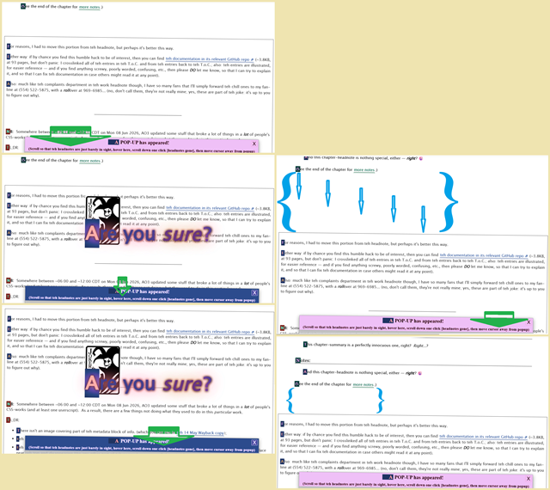
Oh, and one other thing: the effect illustrated above, the one that comes about by following the popup-header's instructions of “(Scroll so that teh headnotes are just barely in sight, hover here, scroll down one click [headnotes gone], then move cursor away from popup)”, the instructions that I've carefully pointed to in green arrows with the result being pointed out in light blue braces? It's this whole thing to do with the .popup below, and specifically is caused by the popup's-popup, as you might've guessed already. Sorry about the bordered note being a new addition; I hadn't added it to the “chapter headnote” 'til after AO3 updated things, and then I added the info about the userscript workaroud, and then I realized that the all of that being in the chapter headnote displaced the Gumba-greeting so I had to make it its own thing. You can as easily keep the headnote's note about “more notes” firmly in sight and simply perform the same ritual but get the result of the popup and border note suddenly dropping away and sliding back up, though I don't think that it's as impactful.

Not-chapter headnote
↑ CONTENTS (CTRL+CLICK)

Strictly, this one's HTML occurs before the Gumba-greeting, but that's just how I did it (I might've been sleep deprived or distracted or planned something different and veered off course midway through, because this is really not a smart way of setting up the flow). Because it's displayed below the greeting (if the greetee's username is confirmed in order for the greeting to be displayed at all), I documented the greeting first.
Now: look up in the previous section's image again. Notice that it shows an “Edit Chapter” button. Isn't that a little odd? This work is only a single chapter work, so it shouldn't show such a button to an author, now should it? Well... yes and no. It's true that even a single-chapter work has a chapter (its only chapter), but no: it nonetheless shouldn't show that button to the author (me, in this case) unless one were to go to .../works/70899846/navigate and end up at .../works/70899846/chapters/184352031 for example (hold that thought: we'll circle back to that when we hit the CHAPTER FOOTnote's Snoopy's Easter Eggs section in the chapter footnote), which I had for the parenthetical reason just now.
So: what does it look like in the regular non-chapter default work-only address of .../works/70899846? Well, friend, I'm glad that you asked!
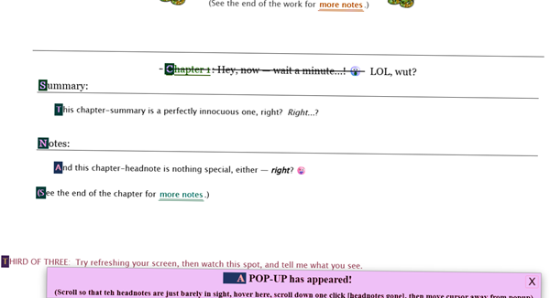
Waddya know: no Edit button, even though I'm logged in. Huh! Why, it's almost as if that little chapter preface section there... were... oh golly-gosh: a fake?!? Say it ain't so!
Here's the HTML for it (the layout is stolen straight from AO3's standard .chapter.preface layout, except for the .landmark class, which we'll hit in the CSS):
<div class="landmark">
<div class="chapter preface group">
<h3 class="title">
<a href="/works/70899846" rel="nofollow">Chapter 1</a>: Hey, now — wait a minute...! 😮
</h3>
<div class="summary module">
<h3 class="heading">Summary:</h3>
<blockquote class="userstuff">
<p>
This chapter-summary is a perfectly innocuous one, right? <i>Right</i>...?
</p>
</blockquote>
</div>
<div class="notes module">
<h3 class="heading">Notes:</h3>
<blockquote class="userstuff">
<p>
And this chapter-headnote is nothing special, either — <b><i>right</i></b>⁠ ⁠? 😜
</p>
</blockquote>
<p>
(See the end of the chapter for <a href="#work_endnotes" rel="nofollow">more notes</a>.)
</p>
</div>
</div>
</div>

And the relevant CSS of lines 306-345 (the first two's :is(:has(.chapter)) ensure that it shows up properly when in chapter-view [right below the real chapter headnote], and all of the .landmark rules permit the fake chapter headnote to appear only when Creator's Style is turned on — it will disappear with style off).
- 306-316 & 327-332 = injected chapter div
- 318-325 = links in same
- 334-336 = title's h3 (also affected by regular title rule's strikethrough and LOL wut)
- 338-345 = all of the other faked-chapter-preface material
#workskin .landmark:is(:has(.chapter)) {
height: auto;
width: auto;
margin: 0.643em 0;
line-height: 1;
font-size: 100%;
opacity: 1 !important;
color: black !important;
padding: 0.643em 0.643em 0;
float: none;
}

#workskin .landmark:is(:has(.chapter)) a {
height: auto;
width: auto;
margin: 0.643em 0;
line-height: 1;
font-size: 100%;
opacity: 1 !important;
}

#workskin .landmark div.preface {
margin: 1.5em 3em;
padding: 0.643em 0.643em 0;
float: none;
border-top: 1px solid;
}

#workskin .landmark .preface h3 {
background: transparent;
}

#workskin .landmark .preface .heading,
#workskin .landmark .preface .notes:not(.module) {
border-bottom: 1px solid;
}

#workskin .landmark .preface blockquote {
border: 0;
}

...but take a look at the end material in the .popup section below: it has a little surprise for you when it comes to deleting any given topmost paragraph from the preface (real or fake one).

.popup
↑ CONTENTS (CTRL+CLICK)

The popup is a little involved.
- You can see most of the main body as soon as you've scrolled into the main work below the preface, but not quite all of it (the very bottom of it is cut off, even at 100% zoom, though only technically at that point, you can still see the essentials at 110%, but not 125% — at least in Chrome [I know that I tested everything and found it all to work correctly at that time {15 Sep 2025 – 01 Apr 2026} in the browsers and devices named earlier, or in some cases were Good Enough For Government Work as it were, but I'm not retesting everything now for the documentation months later]).
- The popup is sticky, and so will follow you as you scroll; in order to see any part that you're missing (if zoomed-in too far), you must scroll down to the footnote / endnote area. EDIT: nope, today's AO3-update broke sticky too (cf. Curtain drop for details).
- When hovering on the popup, a popup-popup will... well, pop up. The moment that you hover on the regular popup, the popup's popup will jump into being from within the main block of the regular popup, but that part is fast, and so the popup-popup could appear to slide into existence from just above the main popup.
- The popup's popup is gapped away from the main popup. This is necessary. Maybe there are better ways around it, but this is how I forced the regular popup's “X” to remain clickable (in order to close the popups as a whole); much closer, and you can't click it.
- While hovering in the top strip of the popup (say, to click the “X” and close the popup), the colors will change.
- When taking your cursor off of the main popup, the popup-popup's question of “Are you sure?” will shrink semi-slowly into the main popup.
- Re. the CSS, cf. note in lines 306-345, because the popup's sticky will fail if you turn off the overflow rule of lines 306-345, or turn on the #workskin::after message of lines 1025-1048 that currently does not show up to the side of the work (if turned on, then you'd see it only by the scroll bar at the bottom of the work or by swiping the work toward the left, and looking around to find the message).
And the color difference between .../works/70899846 and .../works/70899846/chapters/184352031 (that same difference applying to .../chapters/184352031 [sans /works/70899846]):
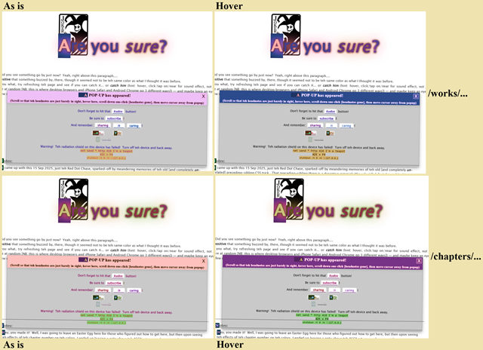
In the HTML below, the LAST EMPTY para might be to adjust the space above the Rule of three [below] instead, not sure (I thought so, but when THREE is highlighted and I SHIFT + UP-ARROW x37, only then does the POPUP [and everything above THREE, incl. the header] suddenly highlight — but nothing below THREE). Viewing the non-printable characters shows it to have only a 32 0x20, which is a regular spacebar space, not an &nbsp;, but adding a non-collapsible space doesn't seem to make anything more pleasantly laid out. I must have put it in for some reason, but its presence or absence in my test-fic seems irrelevant, so you can probably do away with it.
<div class="popup">
<p class="popup-precontent"></p>
<details open="open" class="Popup-Container">
<summary>
<span class="Font-Size20"> A POP-UP has appeared! <br>
<small><sub>(Scroll so that teh headnotes are just barely in sight, hover here, scroll down one click [headnotes gone], then move cursor away from popup)</sub></small><br>
<small class="Gumba2"></small></span>
</summary>
<p>
<span class="Font-Size14"><br>
Don't forget to hit that <b><i><a href="#new_kudo" rel="nofollow"> kudos </a></i></b> button!<br>
<br>
Be sure to <b><a href="https://archiveofourown.org/users/Charles_Rockafellor/profile" rel="nofollow"> subscribe </a> !</b><br>
<br>
And remember: <b><a href="https://archiveofourown.org/works/70899846/share" rel="nofollow"> sharing </a></b> <i><a href="#collection-form" rel="nofollow"> is </a></i> <a href="#bookmark-form" rel="nofollow"> caring </a> !<br>
<br>
<sup class="actions meanie"><big><sub><a href="#add_comment_placeholder" rel="nofollow"><big><b>...no...</b></big></a></sub></big></sup> <sup class="actions sucker"><big><sub><a href="#add_comment_placeholder" rel="nofollow"><big><b>YES!</b></big></a></sub></big></sup><br>
<br>
⸻<br>
<br>
Warning! Teh radiation shield on this device has failed! Turn off teh device and back away.<br>
<span class="sysad">net send * http 418 I'm a teapot<br>
<b>Alt + F4</b><br>
<code>shutdown /t 0 /m \\127.0.0.1</code>
</span><br>
<br>
</span>
</p>
</details>
<p> </p>
<div class="popup-content">
<p align="center">
<b>Are you <i>sure</i> ?</b>
</p>
</div>
</div>

<p> </p>

The CSS of lines 788-969 is another case of 6-point-font here because it would've been 7 pages long otherwise; sorry about this. Also, you remember the leftover notes and rules that ended with _of_8 in the Gumba-greeting? This is where those last two sets come into play, since the popup gets a little extra note in it to Gumba (see lines 831-871).
#workskin .NOTE_re_popup {
content: " /// *
This was originally a combined and very slightly modded version of the separate popups from InfinitysWraith's 'Css in Testing' chapter 9 at https://archiveofourown.org/works/25174384/chapters/63828064 and 'Css in Testing: Second in the Series' chapter 1 at https://archiveofourown.org/works/38954232/chapters/97424331 and view-source:https://archiveofourown.org/works/38954232/chapters/97424331, which I had modded for 'Inside, Outside, Upside-down' at https://archiveofourown.org/skins/2575837 for https://archiveofourown.org/works/64089790/chapters/164435695, and have now modded further for the sticky popup in this work.
.popup:hover .popup-content works, but .popup kills the popping-up effect and .popup-content needs to be off for simplicity, both of which I suspect are due to my having wrapped it around the visible popup.
IMPORTANT: you notice how the workskin itself, in the rule above, has the overflow: visible declaration in it? Yeah, I had initially dropped it into the .popup rule below, which, as you might guess, failed to stick-ify the sticky. It was 03:00 and I was nodding off, but I should have known better. I dropped the question of why it wasn't sticky-ing in the Discord, re. mack's .icarus-sticky-con in `when the wax melts` at https://archiveofourown.org/works/66065308, and One_of_Them (greenbean_paste) and mackerel_cheese cleared it up. DERPTY-DERP! Well, no big: I already did the #workskin::after message trick in `Acronyms, sōreîtai, Superman and such, sew it now seams`, so I can just turn this #workskin::after message off, since it wouldn't be some shiny new trick.
Turn that rule off if you want to turn on the #worksin::after message (it's much prettier [due to other rules' effects] than the CSS below might imply), which is located is 234 rows down from here (at the time of this writing), so you might want to CRTL-F for it instead of scrolling. Swapping-out which one's on or off will kill the .popup's sticky, but will permit the message to function properly so that you can see what it had looked like.
That's more of a note-to-self — if you're reading this, then copying the whole work skin to test out sounds like a drag, but you could simply copy the #workskin::after message rule from page source, paste it into DevTools, remove the '_OFF' part of the rule name, and badda-bing (just remember to add '_OFF' to the overflow rule in DevTools).
* ///";
}

#workskin .popup {
position: sticky;
top: 52em;
z-index: 1;
cursor: default;
}

#workskin .popup-precontent {
text-align: center;
}

#workskin .Popup-Container {
position: absolute;
display: none;
bottom: -70px;
right: 5%;
width: 87%;
height: auto;
font-size: 0;
text-align: center;
color: black;
font-weight: bold;
background: #c2c2c2e0;
border: 1px solid #00000040;
border-radius: 2px;
-webkit-box-sizing: border-box;
-moz-box-sizing: border-box;
-ms-box-sizing: border-box;
-o-box-sizing: border-box;
box-sizing: border-box;
box-shadow: rgba(0, 0, 0, 0.35) 0px 5px 15px;
}

#workskin .NOTE_re_7_of_8 {
content: " /// *
This prevents the popup's extra note being shown to readers other than GumbaBunny. Both 7 and 8 must be GumbaBunny, or else Gumba cannot see the message. This of course will apply to any name with which you use these rules. I tested them with my own user name, so I know this to be true.
8 alone is sufficient and necessary, 7 is only an added layer.
That could be unwise though, since added complication means one more place to mess things up.
* /// ";
}

#workskin .NOTE_re_NAME_TESTING_7_of_8 {
content: " /// *
SHOULD be GumbaBunny, but TESTED with Charles_Rockafellor.
READERS who wish to experiment with this should change the href to THEIR username (this means YOU, the reader poking around under the hood and reading this right now).
* /// ";
}

#workskin .Gumba2:not(:has(#header .icon [href$='s/Charles_Rockafellor']) *) {
display: none;
}

#workskin .NOTE_re_8_of_8 {
content: " /// *
This causes the extra note to be added to the popup only for GumbaBunny, without appearing when style is turned off.
* /// ";
}

#workskin .NOTE_re_NAME_TESTING_8_of_8 {
content: " /// *
SHOULD be GumbaBunny, but TESTED with Charles_Rockafellor.
READERS who wish to experiment with this should change the href to THEIR username (this means YOU, the reader poking around under the hood and reading this right now).
* /// ";
}

#workskin small.Gumba2:is(:has(#header .icon [href$='s/Charles_Rockafellor']) *)::after {
position: relative;
top: 3px;
display: block;
color: magenta;
background-color: yellow;
font-size: 0.8em;
content: "( * unless you're reading this part here, in which case you're GumbaBunny [or someone with some m@d kung fu 5k1llz], in which case you need to try this in a logged-out browser — sorry!)";
}

#workskin details.Popup-Container[open] {
display: block;
}

#workskin details.Popup-Container > summary {
list-style-type: none;
background: #ffe34e;
padding: 5px;
box-shadow: rgba(0, 0, 0, 0.1) 0px 4px 12px;
font-size: 0;
}

#workskin details.Popup-Container > summary:-webkit-details-marker {
display: none;
}

#workskin details.Popup-Container > summary:before,
#workskin details.Popup-Container[open] > summary:before {
content: 'X';
position: absolute;
font-size: 20px;
right: 5px;
cursor: pointer;
font-weight: normal;
font-family: sans-serif;
border: solid #00000030 1px;
padding: 5px;
line-height: 12px;
border-radius: 2px;
transition: .3s;
}

#workskin details.Popup-Container > p {
color: black;
font-weight: normal;
padding: 10px;
-webkit-box-sizing: border-box;
-moz-box-sizing: border-box;
-ms-box-sizing: border-box;
-o-box-sizing: border-box;
box-sizing: border-box;
}

#workskin details.Popup-Container > p:hover {
color: red;
font-weight: 1000;
}

#workskin details.Popup-Container > summary:hover:before,
#workskin details.Popup-Container[open] > summary:hover:before {
background: #dc1f1f;
border: solid #ffffff 1px;
color: white;
transition: .1s;
font-weight: normal;
}

#workskin details > summary:hover {
background: red;
color: white;
}

#workskin .Font-Size20 {
font-size: 20px;
line-height: 1.2em;
font-family: Times New Roman, serif;
transition: .1s;
}

#workskin .Font-Size14 {
font-size: 14px;
line-height: 1.2em !important;
transition: .1s;
}

#workskin .sysad {
font-family: Quartz MS, Oxanium, Kelly Slab, ZCOOL QingKe HuangYou, Gugi, Watch MN Outline, Watch MN, Watch Outline Regular, Watch Outline, Quantico, Digital Std Regular, Digital, Overtime LCD Pro, Synchro LET Plain, Coda, Gemunu Libre, Atomic Age, Saira Extra Condensed, Tektur, OCR-A, "Odibee Sans", Rationale, Jura, Monomaniac One, 'Monaco', 'Consolas', Courier, monospace, sans-serif;
background-color: yellow;
}

#workskin .popup .popup-content {
font-size: 0;
}

#workskin .popup:hover .popup-content {
position: absolute;
bottom: 4.5em;
left: 30%;
background-image: url("https://i.pinimg.com/1200x/cd/e6/f6/cde6f69055ac8af2b09302236357bae5.jpg");
background-size: 143px 200px;
background-repeat: no-repeat;
font-size: 5em;
color: red !important;
transition: font-size .2s, text-shadow 5s;
transition-delay: text-shadow 1s;
text-shadow: 10px 10px 50px #f2be54, -10px -10px 50px #f2be54, 0px .5px 10px black, .5px 0px 10px black;
}

But WAIT — there's more!!! The popup's popup is slow, right? Well, here's the thing. Lines 1402-1432's REM note explains about how these somehow causes that slowness. No, I have no idea why they do this, but that's apparently what I found when I added this rule sometime in the Sep 2025 - Mar 2026 range.
#workskin .NOTE_re_transition_time {
content: " /// *
I used the next one to test rotation for the h2 title text (which still needs to be fixed), but found serendipitously that it produced not only a slow transition of the popup from the popup, but also causing the material to sort of creep up out of thin air rather than jump out from within the main popup. Disable this for a fast effect from within the primary popup, or fiddle with this as-is in order to sort out the hows and wherefores.
* /// ";
}

#workskin p:nth-of-type(1) {
-webkit-transform: rotate(360deg) !important;
-moz-transform: rotate(360deg) !important;
-ms-transform: rotate(360deg) !important;
-o-transform: rotate(360deg) !important;
transform: rotate(360deg) !important;
-webkit-transition: 2s linear !important;
-moz-transition: 2s linear !important;
-ms-transition: 2s linear !important;
-o-transition: 2s linear !important;
transition: 2s linear !important;
}

#workskin .preface.group h2.title:is(:has(meta:last-of-type[content$='A']) *) {
-webkit-transform: rotate(360deg) !important;
-moz-transform: rotate(360deg) !important;
-ms-transform: rotate(360deg) !important;
-o-transform: rotate(360deg) !important;
transform: rotate(360deg) !important;
-webkit-transition: 2s linear !important;
-moz-transition: 2s linear !important;
-ms-transition: 2s linear !important;
-o-transition: 2s linear !important;
transition: 2s linear !important;
}

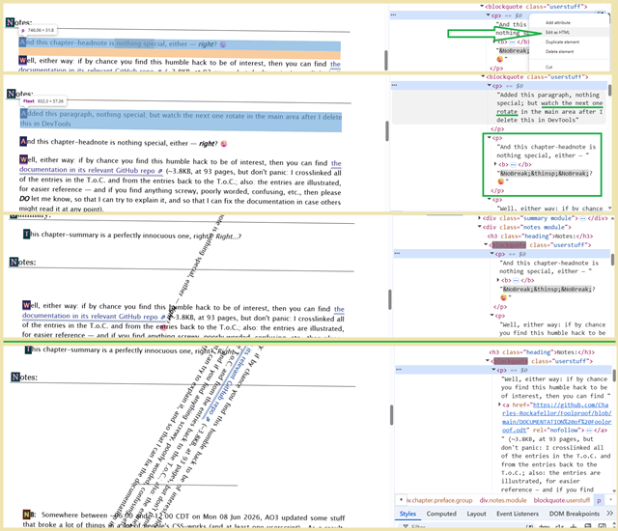
The above shows adding a new paragraph through DevTools and then deleting it, but as demonstrated in the second part of the pic above (at the bottom of it, right below the 5px thick green horizontal line that crosses the entire width of the image) the same happens when you simply delete through DevTools a first-paragraph that's just there — and yes, this works in the real preface's summary and headnote, by the way, as well as the work's regular paragraphs once you've deleted a few preceding empty paragraphs, and in the chapter footnotes... just not in the work endnotes). That at least makes sense, in context, but I figured that I should make sure to clear it up entirely.
What I didn't know until testing a possible workaround on 09 Jun 2026 (a possible fix for the Headnote color note w/ style off, & Dark Mode 6000's “Bork!” effect now having been borked by AO3's 08 Jun update that killed overflow shenanigans [and by side-effect at least some sticky effects, and a lot of people's CSS magic]; cf. Curtain drop for details) was that it seems to have some extra effect when editing in DevTools.
This makes some sense, since it presumably would work just fine were I to add feind's JS-hack to it. Maybe I had planned to but gotten distracted, or maybe this was before he released it and so I was originally fumbling for some way to force it and then forgot about it (sorta: for damned sure I knew the whole time that it was there, because the back of my head kept nagging at me about it, and this is probably why).
So, What I Learned In Boating School Is:
- the purpose outlined in the REM note and the obvious declarations used in the rules are to rotate p:nth-of-type(1) and .preface.group h2.title:is(:has(meta:last-of-type[content$='A']) *) — that is: to rotate now-first-paragraphs when you delete was-first-paragraph in DevTools (while still failing to do so normally),
- but the only real [current] effect is to slow the .popup's popup (unless maybe I were to mod them with feind's JS autotransition hack)....

Rule of three
↑ CONTENTS (CTRL+CLICK)

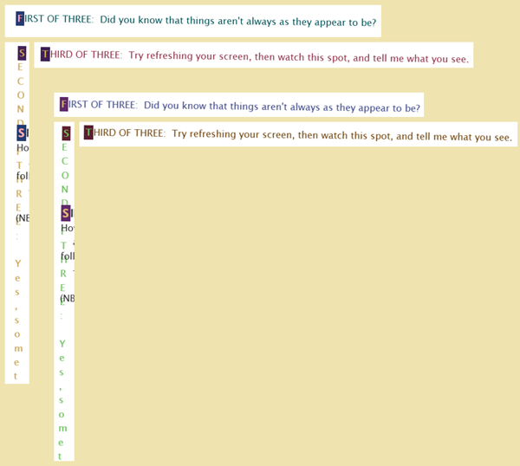
This is another one that depends upon feind's autotransition JS-detection hack (cf. Auto Run Transitions. In this case, three sentences are present, but you will see only one at a time: the first one is pretty normal-looking, the second is suddenly vertical [downward], and the third is LTR again. These aren't exactly the traffic light blinker of Conway's [23/3] Game of Life, but that's what I think of every time.
The image above cuts off the second sentence, since there's no need to show the entirety of its length. Figured that I should mention it in case it looks as if the original wording was incomplete or the CSS had cut it off: nope, that's just where I cropped the shot. It does show both the .../works/70899846 and .../works/70899846/chapters/184352031 views, but that's simply because I happened to have spare real estate there.
As for the HTML below, the FIRST EMPTY para might be to adjust the space above the .popup [above] instead, not sure (I thought so, but when THREE is highlighted and I SHIFT + UP-ARROW x37, only then does POPUP [and everything above THREE, incl. the header] suddenly highlight — but nothing below THREE). Viewing the non-printable characters shows it to have only a 32 0x20, which is a regular spacebar space, not an &nbsp;, but adding a non-collapsible space doesn't seem to make anything more pleasantly laid out. I must have put it in for some reason, but its presence or absence in my test-fic seems irrelevant, so you can probably do away with it.
The final pair of empty paragraphs are purely to give msg-2 a little room to breathe and lead the reader to look down the line.
HTML:
<p> </p>

<div class="timer-container">
<p>
<span class="msg-1">
FIRST OF THREE: Did you know that things aren't always as they appear to be?
</span>
</p>
<p>
<span class="msg-2-wrap">
<span class="msg-2">
SECOND OF THREE: Yes, sometimes things can change right before your very eyes!
</span>
</span><br>
<span class="msg-3">
THIRD OF THREE: Try refreshing your screen, then watch this spot, and tell me what you see.
</span>
</p>
</div>

<p> </p>

<p> </p>

CSS (lines 971-1023):
#workskin .NOTE_re_message_in_three_parts #################### {
content: " /// *
The following eight rule stacks control the magically-changing note — you know: FIRST OF THREE, SECOND OF THREE, THIRD OF THREE... that one.
The crucial part, as with some later material farther down in the work skin, is the body.javascript developed by feindcode (feind) in Auto Run Transitions at https://archiveofourown.org/works/77502361 which causes the transition to happen without reader interaction due to AO3 loading their JS after the CSS.
* /// ";
}

#workskin .timer-container {
display: block;
position: relative;
min-height: 1.5em;
}

#workskin .msg-1,
#workskin .msg-2,
#workskin .msg-3 {
position: absolute;
top: 0;
left: 0;
width: 100%;
}

#workskin .msg-1 {
opacity: 1;
}

#workskin .msg-2,
#workskin .msg-3 {
opacity: 0;
}

#workskin:is(body.javascript *) .msg-1 {
transition: opacity 0s linear 10s;
opacity: 0;
color: blue;
}

#workskin:is(body.javascript *) .msg-2 {
transition: opacity 0s linear 10s;
opacity: 1;
color: yellow;
}

#workskin:is(body.javascript *) .msg-2-wrap {
transition: opacity 0s linear 20s;
opacity: 0;
}

#workskin:is(body.javascript *) .msg-3 {
transition: opacity 0s linear 20s;
opacity: 1;
color: red;
}

Red Dot Special
↑ CONTENTS (CTRL+CLICK)

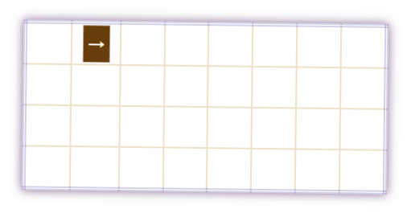

You might recall my mention of having explicitly prohibited the ::first-letter special effect in Colors... colors everywhere, ja? This section is why.
NB: the degree of color difference between .../works/70899846 and .../works/70899846/chapters/184352031 is as much as you'd expect by now, but since you only basically see a little of it in the table's border and gridlines, and see the individual cells' colors only upon hover, it doesn't seem as strikingly different, so I've left off showing every single one of them.
As you hover over a given cell in the table, you find that the next cell in the patter lights up with an arrow. Going to that next cell causes its arrow to disappear and the next-next cell to display an arrow. Just to drive home the futility of your efforts, the pattern is an infinity symbol “∞”. Welcome to being a cat — enjoy chasing the Red Dot, and let me know if you ever catch it!
And now to the HTML:
<div align="center">
<table class="bordertb">
<tbody>
<tr>
<td class="bordertd"> </td>
<td class="bordertd a1"> </td>
<td class="bordertd a2"> </td>
<td class="bordertd"> </td>
<td class="bordertd"> </td>
<td class="bordertd a10"> </td>
<td class="bordertd a9"> </td>
<td class="bordertd"> </td>
</tr>
<tr>
<td class="bordertd a16"> </td>
<td class="bordertd"> </td>
<td class="bordertd"> </td>
<td class="bordertd a3"> </td>
<td class="bordertd a11"> </td>
<td class="bordertd"> </td>
<td class="bordertd"> </td>
<td class="bordertd a8"> </td>
</tr>
<tr>
<td class="bordertd a15"> </td>
<td class="bordertd"> </td>
<td class="bordertd"> </td>
<td class="bordertd a12"> </td>
<td class="bordertd a4"> </td>
<td class="bordertd"> </td>
<td class="bordertd"> </td>
<td class="bordertd a7"> </td>
</tr>
<tr>
<td class="bordertd"> </td>
<td class="bordertd a14"> </td>
<td class="bordertd a13"> </td>
<td class="bordertd"> </td>
<td class="bordertd"> </td>
<td class="bordertd a5"> </td>
<td class="bordertd a6"> </td>
<td class="bordertd"> </td>
</tr>
</tbody>
</table>
</div>

<p> </p>

<p> </p>

Pretty simple stuff. All tds are classed for some border color, as is the table itself, and some of the tds happen to be classed to inject a styled arrow. When Creator's Style is disabled, the empty space of the table is still present (meh, why complicate things with a .hidden or .landmark? If someone kills the style, that's their problem, and they deserve it in this case: it's not a cute flair of CSS for æsthetics, the whole thing is aimed at going nuts.)
The CSS is also lines 1498-1618 is also simple, just longer:
#workskin .NOTE_re_Red_Dot_Chase {
content: " /// *
I think that the table border rules are pretty self-evident and -explanatory. I dislike the thought of building the actual table itself from CSS, no clue why, just too old school and it goes against the grain for me, but any special effects are, for the most part, constrained to CSS in the work skin, unless one counts simple things such as big, bold, or site-level CSS selectors, though I used none of these in this case.
For the hover effect, I opted for the old fashioned classing of the td cells that I wanted to nail down, so that I could be certain of placing them where I wished and not have to dick around with typos and adjustments. The method is pretty straightforward in that if a given relevant td cell has the cursor hovering over it, then the next td cell in the pattern will have its effects come to life, for example when td a1 is hovered over, td a2 is affected.
* /// ";
}

#workskin .bordertb {
border: 4px double rgba(255, 0, 0, 0.25);
box-shadow: 0 0 10px rgba(128, 24, 24, 0.7);
width: 24em;
cursor: default !important;
}

#workskin .bordertd {
border: 2px solid rgb(192, 255, 192);
width: 1em;
height: 1em;
font-size: 1.3em;
-webkit-transform: scale(1.1, 1.2);
-moz-transform: scale(1.1, 1.2);
-ms-transform: scale(1.1, 1.2);
-o-transform: scale(1.1, 1.2);
transform: scale(1.1, 1.2);
}

#workskin table:has(.a1:hover) .a2:after {
content: " ⁠⇘⁠ ";
color: white;
background-color: orange;
}

#workskin table:has(.a2:hover) .a3:after {
content: " ⁠⇘⁠ ";
color: white;
background-color: red;
}

#workskin table:has(.a3:hover) .a4:after {
content: " ⁠⇘⁠ ";
color: white;
background-color: purple;
}

#workskin table:has(.a4:hover) .a5:after {
content: " ⁠→⁠ ";
color: white;
background-color: red;
}

#workskin table:has(.a5:hover) .a6:after {
content: " ⁠⇗⁠ ";
color: black;
background-color: yellow;
}

#workskin table:has(.a6:hover) .a7:after {
content: " ⁠↑⁠ ";
color: white;
background-color: red;
}

#workskin table:has(.a7:hover) .a8:after {
content: " ⁠⇖⁠ ";
color: white;
background-color: blue;
}

#workskin table:has(.a8:hover) .a9:after {
content: " ⁠←⁠ ";
color: white;
background-color: red;
}

#workskin table:has(.a9:hover) .a10:after {
content: " ⁠⇙⁠ ";
color: black;
background-color: orange;
}

#workskin table:has(.a10:hover) .a11:after {
content: " ⁠⇙⁠ ";
color: white;
background-color: red;
}

#workskin table:has(.a11:hover) .a12:after {
content: " ⁠⇙⁠ ";
color: white;
background-color: purple;
}

#workskin table:has(.a12:hover) .a13:after {
content: " ⁠←⁠ ";
color: white;
background-color: red;
}

#workskin table:has(.a13:hover) .a14:after {
content: " ⁠⇖⁠ ";
color: black;
background-color: yellow;
}

#workskin table:has(.a14:hover) .a15:after {
content: " ⁠↑⁠ ";
color: white;
background-color: red;
}

#workskin table:has(.a15:hover) .a16:after {
content: " ⁠⇗⁠ ";
color: white;
background-color: purple;
}

#workskin table:has(.a16:hover) .a1:after {
content: " ⁠→⁠ ";
color: white;
background-color: red;
}

Weasel
↑ CONTENTS (CTRL+CLICK)

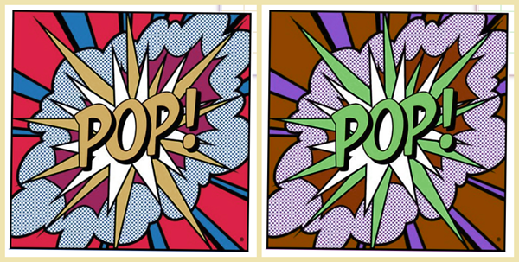
The color difference between .../works/70899846 and .../works/70899846/chapters/184352031 (that same difference applying to .../chapters/184352031 [sans /works/70899846]) continues to do its thing, of course.
The HTML is simple (in moving things around while building it all, this and the Jack-in-the-boxes and the red-blue .dim3 paragraph all come before the .wiiiide paragraph, but the CSS for it comes before them — sorry!):
<p>
<a href="https://www.youtube.com/watch?v=bgHAD5jPhYc" rel="nofollow">Pop goes teh weasel, 'cause teh weasel goes pop!</a><br />
— 3rd Bass, 1991
</p>

While the CSS in lines 1635-1639 is a single rule that targets the YouTube href (instead of simply classing a span or targeting the nth() whatever) because why not? Flex what you can flex (colloquially, not CSS-ily), man: show a little variety just for the hell of it, introduce people to new and exciting ways to screw everything up! (Which by complete coincidence and absolutely no intention just so happens to act as a segue to permit me to introduce any reading this to The Joy of Flex [CSS-ily, this time, rather than colloquially])
That said, however, it begins with a seemingly unrelated note in lines 1626-1633 because it's part and parcel with the next sub-section (i.e.: the one with the Jack-in-the-boxes).
#workskin .NOTE_re_psych-out {
content: " /// *
How does one cram a string of surprises into the same space? Make them a literal string of table td cells and shrink them so that they are not apparent, and ensure that the string covers the full width of the work, unless one wishes a narrower span of course... in which case this same technique could be used to drop little hover-surprises all over the text as clues in a hackathon, though burying them properly would still leave the tables — or, more reasonably, spans — quite visible in the page source, leading the savvy reader to dig through the work skin, at which point one could bury them with a ton of red herring rules that are not called at any point, but that would be a little too mean-spirited. Right now, that dreamed-of nth-word or nth-letter ability is still only a dream, but maybe someday that will be an option, at which point you could simply drop a surprise-image in between words or smack in the middle of a word in a steganographic fashion, though targeting them that way would by a pain if one were to edit something, and would certainly leave very little chance of the reader hovering in just the right spot to be caught by surprise.
From a tutorial perspective, this table is a little more advanced. The table itself is pure HTML right down to the div getting alignment through the center tag, no need to explain that.
For the hover effect, I had originally simply classed the td cells and called the rule thus, but once it was complete, I then decided to tweak it with a little more magic, removing the td cell classes and targeting them sequentially from the associated rule so that each nth rule injected its image into the nth td cell.
As the cherry on top, I then reduced the original test setting of font-size 1px, under which CTRL-A would show a row of 1-pixel dots, to a subpixel declaration of font-size 0.1px instead, under which CTRL-A shows nothing suspicious to the casual reader... except that at 0.1px it was a real pain to hover-over just right even knowing where to do so, and so I relented and set them to 3px which seems small enough not to draw the eye but large enough to play a little hide-and-seek with. Unfortunately, it was not until much later that I discovered that the 3px td were made visible in Firefox (I had not double-checked when I enlarged them), but 0.458px was simply too small to make hover a decent option, so I left it at 3px.
* /// ";
}

#workskin #chapters a[href*="youtube"]:hover {
content: url("https://i.pinimg.com/474x/60/9a/f3/609af38165bd42e0264960c36a579fd1.jpg");
position: relative;
top: -15em;
}

TABLE OF JACKS
The color difference between .../works/70899846 and .../works/70899846/chapters/184352031 are what you'd expect, but there are 30 different Jack in the box, clown, Pierrot, Columbine, Harlequin, etc. images. I wasn't going to show every single one of them, but I'm for damned sure not going to show their hue-rotated versions just for the effect (especially since they're fleeting: these are like the Weasel pop-image, yes, but you see these only when in the right spot [well, technically also true of the pop-image], so... no, much more of a pain in the ass for jump-scare purposes, and hence not really much in the way of noticeable color difference in the moment).
If you hit CTRL-A in Chrome, then you'll see where the tds are (and in Firefox... they're already annoyingly obvious [though I'm sure {and I could be wrong, of course} that they hadn't been in the build in which I first tested them]):
Hovering over any one of these tds will cause its particular image to pop into existence... like a Jack in the box, which felt appropriate to me for April Fools' Day.
The HTML is spectacularly boring:
<div align="center">
<table class="wrap">
<tbody>
<tr>
<td> </td>
↕ 28 more tds sandwiched in between these fenceposts ↕
<td> </td>
</tr>
</tbody>
</table>
</div>

Which should warn you that the CSS (6 point font, again, folks...) of lines 1498-1618 is either a little more “interesting”... or equally dull:
#workskin .wrap {
font-size: 3px;
background-color: rgba(0,0,0,0);
display: table;
justify-content: center;
align-items: center;
}

#workskin .wrap td:nth-child(1):hover {
content: url("https://i.pinimg.com/736x/f8/cb/75/f8cb7515999a31d4ebfa27a95aafb081.jpg");
width: 100%;
}

#workskin .wrap td:nth-child(2):hover {
content: url("https://i.pinimg.com/736x/49/cb/c5/49cbc52808f98c84ea6ea8fa08e2c894.jpg");
width: 100%;
}

#workskin .wrap td:nth-child(3):hover {
content: url("https://wallpapercave.com/wp/wp13368524.jpg");
width: 100%;
}

#workskin .wrap td:nth-child(4):hover {
content: url("https://i.pinimg.com/736x/e5/0d/e0/e50de0f0bbafe60c7c47550f5c187a29.jpg");
width: 100%;
}

#workskin .wrap td:nth-child(5):hover {
content: url("https://content.propstore.com/auction/dexter/test/listings2/lot32/img01med.jpg");
width: 100%;
}

#workskin .wrap td:nth-child(6):hover {
content: url("https://i.pinimg.com/736x/27/94/2b/27942b4012c30bb96ac364cf6b5c2939.jpg");
width: 100%;
}

#workskin .wrap td:nth-child(7):hover {
content: url("https://i.pinimg.com/736x/b9/33/b0/b933b0b3c592c685748bc08297c3fe7f.jpg");
width: 100%;
}

#workskin .wrap td:nth-child(8):hover {
content: url("https://i.pinimg.com/736x/1c/a5/41/1ca541b224e14f1e9113fed0b3afae6f.jpg");
width: 100%;
}

#workskin .wrap td:nth-child(9):hover {
content: url("https://i.pinimg.com/236x/01/62/55/016255e9a4f268d33c75937e2ca18698.jpg");
width: 100%;
}

#workskin .wrap td:nth-child(10):hover {
content: url("https://i1.sndcdn.com/artworks-3Nz8SccueEaCgkRA-DMl40Q-t500x500.jpg");
width: 100%;
}

#workskin .wrap td:nth-child(11):hover {
content: url("https://i.pinimg.com/236x/a3/10/0d/a3100d5202d4fc3c9b7f05634468f43a.jpg");
width: 100%;
}

#workskin .wrap td:nth-child(12):hover {
content: url("https://i.pinimg.com/1200x/8d/62/02/8d6202903698ac0d7d96936d0d4485aa.jpg");
width: 100%;
}

#workskin .wrap td:nth-child(13):hover {
content: url("https://static.wikia.nocookie.net/villains/images/a/aa/Frank_the_Bunny_Rabbit.jpg");
width: 100%;
}

#workskin .wrap td:nth-child(14):hover {
content: url("https://i.pinimg.com/1200x/64/d8/ca/64d8ca42eb9b401ee8e77cd9a07c1e18.jpg");
width: 100%;
}

#workskin .wrap td:nth-child(15):hover {
content: url("https://i.pinimg.com/474x/2a/fe/a8/2afea871d7bbfe28447746848b3e6ea1.jpg");
width: 100%;
}

#workskin .wrap td:nth-child(16):hover {
content: url("https://i.pinimg.com/736x/0b/53/e7/0b53e7ee5d258d1d3c0c6214ffffe10f.jpg");
width: 100%;
}

#workskin .wrap td:nth-child(17):hover {
content: url("https://i.pinimg.com/736x/a7/17/61/a71761d21ab9264d6e11c40062878fc5.jpg");
width: 100%;
}

#workskin .wrap td:nth-child(18):hover {
content: url("https://s.turbifycdn.com/aah/raggedyland/raggedy-ann-jack-in-the-box-by-schylling-see-below-regarding-box-17.gif");
width: 100%;
}

#workskin .wrap td:nth-child(19):hover {
content: url("https://i.pinimg.com/736x/c6/17/65/c6176578add8aeffb32d93d81a84b2e7.jpg");
width: 100%;
}

#workskin .wrap td:nth-child(20):hover {
content: url("https://thepastisaforeignpantry.com/wp-content/uploads/2024/08/3b78d-badrabbits-sword.jpeg");
width: 100%;
}

#workskin .wrap td:nth-child(21):hover {
content: url("https://upload.wikimedia.org/wikipedia/commons/1/1a/Laughing_Fool.jpg");
width: 100%;
}

#workskin .wrap td:nth-child(22):hover {
content: url("https://thumbs.dreamstime.com/z/image-features-cheerful-jester-character-designed-colorful-playful-flat-style-medieval-fool-adorned-vibrant-385982718.jpg");
width: 100%;
}

#workskin .wrap td:nth-child(23):hover {
content: url("https://i.pinimg.com/originals/10/7f/c8/107fc871b75c57b2dd65f663bfecd0f8.png");
width: 100%;
}

#workskin .wrap td:nth-child(24):hover {
content: url("https://static.vecteezy.com/system/resources/previews/040/281/337/large_2x/venetian-pierrot-mask-crying-sad-clown-harlequin-masquerade-costume-flat-illustration-isolated-on-white-background-vector.jpg");
width: 100%;
}

#workskin .wrap td:nth-child(25):hover {
content: url("https://i.pinimg.com/736x/13/76/a1/1376a1c6c1ffecea4b4d67fa1bb37a82.jpg");
width: 100%;
}

#workskin .wrap td:nth-child(26):hover {
content: url("https://i.pinimg.com/736x/04/d6/b3/04d6b3052db0702c06278dc1d8b90fe7.jpg");
width: 100%;
}

#workskin .wrap td:nth-child(27):hover {
content: url("https://previews.123rf.com/images/sasha2538/sasha25381503/sasha2538150300011/38776959-cute-harlequin-illustration-funny-clown-isolated.jpg");
width: 100%;
}

#workskin .wrap td:nth-child(28):hover {
content: url("https://thumbs.dreamstime.com/b/joker-provocative-standing-way-wearing-medieval-costume-76905925.jpg");
width: 100%;
}

#workskin .wrap td:nth-child(29):hover {
content: url("https://i.pinimg.com/736x/34/d4/b8/34d4b8a30df0e8435e9ece75428b17e0.jpg");
width: 100%;
}

#workskin .wrap td:nth-child(30):hover {
content: url("https://i.pinimg.com/200x150/e9/45/8b/e9458bf23d506905b3d72b80ffe567f0.jpg");
width: 100%;
}

Red-blue .dim3
↑ CONTENTS (CTRL+CLICK)

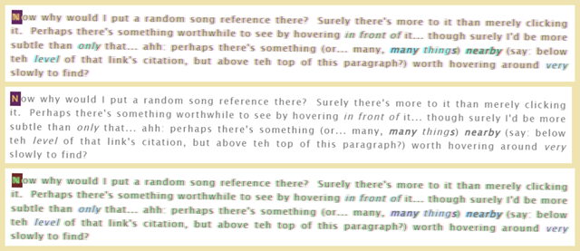
NB: The one in the middle is how the text looks on hover, so that the reader can read the material clearly and take the hint from it that there might be Jack in the boxes to be seen in the seemingly empty space above it (and by hovering over the song link still farther up).
Lines 1799-1815 are set up to mimic the way that 3D movies used to have a red-blue filter (with paper glasses and red-blue plastic lenses), and the way that they looked when you took the glasses off (which is why that rule is at the end of the .dim3 set) — though due to the hue-rotate, this might be a little less obvious.
It's also the fifth paragraph of the work, inset by lines 1813-1815's p:nth-of-type(5) { margin-left: 50px;... or at least that was true, before I added the Rule of three for the three lines of text that auto-switch (like a blinker in Conway's 23/3 G.o.L.), which needed a little extra room with two empty paragraphs below that div and one above it (to make a little room for the popup, IIRC), which then bumped the .dim3 paragraph down from fifth to eighth (if you were wondering why I haven't simply moved the three-sentence-blink down farther, maybe around the Dee Dee button [where's there's a little extra space in which to show it off] and so permit the .dim3 inset rule to do its job, or add a class to the .dim3 paragraph and a class-targeting rule to the inset so that I could have my cake and eat it too... honestly, I wasn't terribly big on the paragraph being inset). This is why the Summary's NB and the headnote's complaints department are inset: I decided that they were a pleasant side effect, so kept them that way.
The HTML is simply <p class="dim3">Blah, blah, blah...</p>, but the CSS (lines 1799-1811) is quick and easy too (though as you can see, the actual colors of choice are more like a pale leaf green [basically a little lighter version of a green apple] and a straight-up magenta, rather than blue and red respectively):
#workskin .dim3:not(:hover) {
color: #777;
text-shadow: -3px 0 1px rgba(191, 255, 63, 1),
3px 0 1px rgba(255, 0, 255, 0.4);
font-size: 1.2em;
letter-spacing: 0.1em;
}

#workskin .dim3:hover {
color: #777;
font-size: 1.2em;
letter-spacing: 0.1em;
}

.wiiiiide
↑ CONTENTS (CTRL+CLICK)

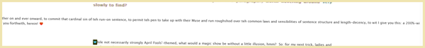
This paragraph completely escapes the width of the work skin div. While not precisely what I might normally consider useful, perhaps it could have some non-gag application somewhere.
The HTML here is another simple case of <p class="wiiiiide">Blah, blah, blah...</p>, but I'm going to include the unnecessary complete paragraph so that the effect (specifically: the fact that there's distinctly more to the paragraph than the little bit that one can see in the viewport, even on a 1920px screen) hits home more fully.
<p class="wiiiiide">
There comes a time in all author's lives at which they must choose to blather on and ever onward, to commit that cardinal sin of teh run-on sentence, to permit teh pen to take up with their Muse and run roughshod over teh common laws and sensibilities of sentence structure and length-decency, to wit I give you this: a 200%-wide sentence of single integrity and singular irresponsibility, breaking out of these chains of work skin width to which we, teh readers and writers of AO3, seem subject at every turn, and so see you now this, what for beauty or horror I have wrought and present to you forthwith, herein! ❤️
</p>

and a nice easy CSS (lines 1620-1624) of:
#workskin .wiiiiide {
position: absolute;
left: -50vw;
width: 200vw;
}

ASCII art — in color
↑ CONTENTS (CTRL+CLICK)

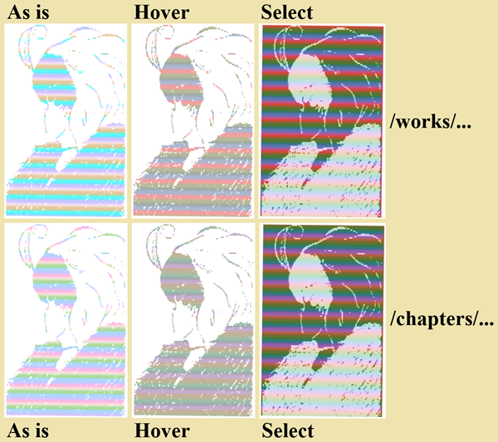
Yeah-yeah, the usual thing with .../works/70899846 and .../works/70899846/chapters/184352031 (same as .../chapters/184352031 [sans /works/70899846]).
The thing is, the ASCII is big (31,212 char). I could include the HTML, but I think that maybe I shouldn't, but then if I don't it seems like a cop-out. Here, good luck. I put it into 2 point font (only because LibreOffice won't let me use 1 point font), for the obvious reason:
<pre align="center" title="Image converted to ASCII art courtesy of https://www.asciiart.eu/image-to-ascii">
<span> @@@@@@@@@ @@@ </span>
<span> @@ @@@ @@@@@@@@@@@@ @ </span>
<span> @@@@@ @ @@@@@@@@@@@@@@@@@@@@@ @@@@ </span>
<span> @@@ @@@ @@ @@ @@@@@@@@@@@ @@@ </span>
<span> @@@@ @@@ @ @@@@@@@ @@@ </span>
<span> @@ @ @ @@@@@ @ </span>
<span> @@@ @ @ @@@ @@@@@ @@ @@ </span>
<span> @@ @ @ @ @ @@ @@@@@@@@@@@@@@@@@@@@@@@@@@@ </span>
<span> @@ @ @ @@@@@@ @@@ @@@@@ </span>
<span> @ @ @ @ @@@@ @@@@@ @@@ </span>
<span> @@ @ @@@@@@@@@ @ @@@@ @@@ @@ </span>
<span> @@ @@ @@ @@@ @@ @ </span>
<span> @@ @ @@ @@@@@ @ </span>
<span> @ @ @ @@ @@@@ </span>
<span> @@ @ @@ @@@@@@@@ </span>
<span> @@ @ @@@@@@ </span>
<span> @@ @@ @@@@@@@ </span>
<span> @@ @ @ @@@ @@@@@@ </span>
<span> @@ @ @@ @@@@@@ </span>
<span> @ @ @ @@@@ @ @@@@@ </span>
<span> @@ @@ @ @@ @@@ @ </span>
<span> @@@ @ @@ @@@@@@ @@@@@@@@@@@@ </span>
<span> @@ @ @ @@@@@@@@@@@@@@@@ @ @@ </span>
<span> @@@ @ @@ @@@@@@@@@@@@@@@@@@@@@@@ @@@ @@ </span>
<span> @@@ @ @ @@ @@@@@@@@@@@@@@@@@@@@@@@@@@@@@@@@@ @@@ @ </span>
<span> @@ @ @ @@@ @@@@@@@@@@@@@@@@@@@@@@@@@@@@@@@@@@@@ @@ </span>
<span> @@@ @@ @ @@@ @@@@@@@@@@@@@@@@@@@@@@@@@@@@@@@@@@@@@@@@ @@ @@@ </span>
<span> @@ @ @@ @@ @@@@@@@@@@@@@@@@@@@@@@@@@@@@@@@@@@@@@@@@@@ @@@ @@@@ @ </span>
<span> @@@ @@ @@@ @@@@@@@@@@@@@@@@@@@@@@@@@@@@@@@@@@@@@@@@@@@@ @ @@@@@ @ @ </span>
<span> @@@@@ @ @@ @@@@@@@@@@@@@@@@@@@@@@@@@@@@@@@@@@@@@@@@@@@@ @ @@@@ </span>
<span> @@@@@ @@@@ @@@@@@@@@@@@@@@@@@@@@@@@@@@@@@@@@@@@@@@@@@@@@@@@ @@@@ @ @@@@@@ @ </span>
<span> @ @@@@ @@@ @@@@@@@@@@@@@@@@@@@@@@@@@@@@@@@@@@@@@@@@@@@@@@@@@@ @@ @@@ @@@ </span>
<span> @@@@ @@ @@@@@@@@@@@@@@@@@@@@@@@@@@@@@@@@@@@@@@@@@@@@@@@@@@@@ @@ @@ </span>
<span> @@ @@@@ @@@@@@@@@@@@@@@@@@@@@@@@@@@@@@@@@@@@@@@@@@@@@@@@@@@@@@ @ @ @ </span>
<span> @@@@@@@@@@@@@@@@@@@@@@@@@@@@@@@@@@@@@@@@@@@@@@@@@@@@@@@@@@ @ @ @ </span>
<span> @@@@@@@@@@@@@@@@@@@@@@@@@@@@@@@@@@@@@@@@@@@@@@@@@@@@@@ @@@@@@ @@@ @ </span>
<span> @@@@@@@@@@@@@@@@@@@@@@@@@@@@@@@@@@@@@@@@@@@@@@@@@@@@@@@@@@@ @@ @ @ @@ </span>
<span> @@@@@@@@@@@@@@@@@@@@@@@@@@@@@@@@@@@@@@@@@@@@@@@@@@@@@@@@@@@@@ @@@ @@ </span>
<span> @@@@@@@@@@@@@@@@@@@@@@@@@@@@@@@@@@@@@@@@@@@@@@@@@@@@@@@@@@@@@@ @@@ @@ </span>
<span> @@@@@@@@@@@@@@@@@@@@@@@@@@@@@@@@@@@@@@@@@@@@@@@@@@@@@@@@ @@@@ @@@ @@@ @ </span>
<span> @@@@@@@@@@@@@@@@@@@@@@@@@@@@@@@@@@@@@@@@@@@@@@@@@@@@@@@@@@@@@@@@@@ @ </span>
<span> @@@@@@@@@@@@@@@@@@@@@@@@@@@@@@@@@@@@@@@@@@@@@@@@@@@@@@@@@@@@@@@@@@ @ </span>
<span> @@@@@@@@@@@@@@@@@@@@@@@@@@@@@@@@@@@@@@@@@@@@@@@@@@@@@@@@@@@@@@@@@@@ @@ </span>
<span> @@@@@@@@@@@@@@@@@@@@@@@@@@@@@@@@@@@@@@@@@@@@@@@@@@@@@@@@@@@@@@@@@@@@ @ @@ @ </span>
<span> @@@@@@@@@@@@@@@@@@@@@@@@@@@@@@@@@@@@@@@@@@ @@@@@@@@@@@@@@@@@ @@ @ @@ @ @ </span>
<span> @@@@@@@@@@@@@@@@@@@@@@@@@@@@@@@@@@@@ @ @@@@@@@@@@@@@@@@@@@@@@@@@@@@@@ @@ @@ </span>
<span> @@@@@@@@@@@@@@@@@@@@@@@@@@@@@@@@@@@ @@@@@@@@@@@@@@@@@@@@@@@@@@ @ @ @@@ @ @ </span>
<span> @@@@@@@@@@@@@@@@@@@@@@@@@@@ @@@@@@@@@@@@@@@@@@@@@@@@@@@@@@@@@@@@@@@@ @@@ @ </span>
<span> @@@@@@@@@@@@@@@@@@@@@@@@@@@@@@@@@@@@@@@@@@@@@@@@@@@@@@@@@@@@@@@@@@@@@@@@ @@@ </span>
<span> @@@@@@@@@@@@@@@@@@@@@@@@@@@@@@@@@@@@@@@@@@@@@@@@@@@@@@@@@@@@@@@@@@@ @@ @@ </span>
<span> @@@@@@@@@@@@@@@@@ @@@@@@@@@@@@@@@@@@@@@@@@@@@@@@@@@@@@@@@@@@@@@ @ @ @@ @ </span>
<span> @@@@@@@@@@@@@@@@@@@@@@@@@@@@@@@@@@@@@@@@@@@@@@@@@@@@@@@@@@@@@@@@ @@ @ @ </span>
<span> @@@@@@@@@@@@@@@@@@@@@@@@@@@@@@@@@@@@@@@@@@@@@@@@@@@@@@@@@@@@@@@@@@ @@ @ </span>
<span> @@@@@@@@@@@@@@@@@@@@@@@@@@@@@@@@ @@@@@@@@@@@@@@@@@@@@@@@@@@@@@@@ @@ </span>
<span> @@@@@@@@@@@@@@@@ @@@@@@@@@@@ @@@@@@@@@@@@@@@@@@@@@@@@@@@@@@@@@@@ @@ @ </span>
<span> @@@@@@@@@@@@@ @@@@@@@@@@@@@@@@@@@@@@@@@@@@@@@@@@@@@@@@@@@@@@@@ @ </span>
<span> @@@@@@@@@@@@ @@@@@@@@@@@ @@@@@@@@@@@@@@@@@@@@@@@@@@@@@@@@@@@ @@ </span>
<span> @@@@@@@@@@@ @@@@@@@@@ @@@@@@@@@@@@@@@@@@@ @@@@@@@@@@@@@@@@ @ @ </span>
<span> @@@@@@@@@@ @@@@ @@@@@@@@@@@@@@@@@@@@@@@@@@@@@@@@@@@@ @ </span>
<span> @@@@@@ @@@@@@@@@@@@@@@@@@@@@@@@@@@@@@@@@ @ @ @ </span>
<span> @@ @@@@@@@@@@@ @@@@@@@@@@@@@@@@@@@ @ @@ @ @ </span>
<span> @ @@@@@@@ @@@@@@@@@@@@@@@@@@ @@ @ @ @ @ </span>
<span> @ @@@ @@@ @@@@@@@@ @@ @ @ @ </span>
<span> @@ @@ @@@ @ @@@@@@@ @ @ @ </span>
<span> @@@@@@ @@@ @ @@ @ @ @@ </span>
<span> @@ @@ @ @@@ @@ @@ @@ @ </span>
<span> @@ @@@ @@@ @ @ @@ @ @ </span>
<span> @ @@@ @@@ @@ @ @ @ </span>
<span> @ @@ @@ @@ @@ @ </span>
<span> @@@ @@@ @@ @@ @@@@ </span>
<span> @ @@@ @@ @ </span>
<span> @ @@@ @ @@ @@@ </span>
<span> @ @@ @@ @ @@ </span>
<span> @ @@ @ @ @@ </span>
<span> @ @ @@ @ @ @@@@@ @ @@ </span>
<span> @ @ @@@ @@ @@@@@@@@@@@@@@@@@@@@@@@@@@@ </span>
<span> @ @@ @@@ @@ @@@@ @@@@@@ @@@@@@@ @@@@@@@@ @ </span>
<span> @ @ @@@@@@@@@@@@@@@@@@@@@@@@@@@@@@@@@@@@@@@@@@@@@ </span>
<span> @@ @ @@@@@@@@@@@@@ @@@@@@@@@@ @@@@@@@@@@@@@@@@@@ </span>
<span> @ @ @ @@@@@@@@ @@@@@@@@@@@@@@@@@@@@@@@@@@@@@@@@@@@@@@ </span>
<span> @ @ @ @@@@@@@@@@@@@@@@@@@@@@@@@@@@@@@@@@@@@@@@@@@@@@@@ </span>
<span> @@ @ @@@@@@@@@@@@@@@@@@@@@@@@@@@@@@@@@@@@@@@@@@@@@@ </span>
<span> @ @@ @@@@@@@@@@@@@@@@@@@@@@@@@@@@@@@@@@@@@@@@@@@@@@@@@ </span>
<span> @@@ @@@@@@@@@@@@@@@@@@@@@@@@@@@@@@@@@@@@@@@@@@@@@@@@@@@@@ </span>
<span> @@ @ @@@@@@@@@@@@@@@@@@@@@@@@@@@@@@@@@@@@@@@@@@@@@@@@@@@@@@@@@ </span>
<span> @@@ @@@@@@@@@@@@@@@@@@@@@@@@@@@@@@@@@@@@@@@@@@@@@@@@@@@@@ @@@ </span>
<span> @@ @ @@@@@@@@@@@@@@@@@@@@@@@@@@@@@@@@@@@@@@@@@@@@@@@@@@@@@@@@@ </span>
<span> @ @@@@@@@@@@@@@@@@@@@@@@@@@@@@@@@@@@@@@@@@@@@@@@@@@@@@@@@@@@@@ </span>
<span> @@@@@@ @@ @@@@@@@@@@@@@@@@@@@@@@@@@@@@@@@@@@@@@@@@@@@@@@@@@@@@@@@@@@@@@@@@@@@ </span>
<span> @@@@@@@@@@@@@@@@@@@@@@@ @@ @@@@@@@@@@@@@@@@@@@@@@@@@@@@@@@@@@@@@@@@@@@@@@@@@@@@@@@@ @@@@@@@@@@@@@@@ </span>
<span> @ @@@@@ @@@@@ @@@@ @@@@@@@ @ @ @@@@@@@@@@@@@@@@@@@@@@@@@@@@@@@@@@@@@@@@@@@@@@@@@@@@@@@@@@@@@ </span>
<span> @@ @@ @@@@@@@@@@@@@@@@@ @@@@@ @@@@@@@@@@@@@@@@@@@@@@@@@@ @@@@@@@@@@@@@@@@ @@@@@@@@@@@@@@@@ </span>
<span> @@@@@@@@@@@@@@@@@@@@@@@@@@@@@@@@@@@@@@@@@@@@@ @ @@@ @@@@@@@@@@@@@@@@@@@@@@@@@@@@@@@@@@@@@@@@@@@@@@ @@@@@@@@@@@@@@@@ @@ </span>
<span> @@@@@@@@@@ @@@@@@@@@@@@@@@ @@@@@@@@@@@@@@@ @@@@@@@@@@@@@@@@@ @@@@@@@@@@@@@@@@@@@@@@@ @@@@@@@@@@@@@@@@@@@@@@@@@@@@ @@@@@@@@@@@@@@@@@ </span>
<span> @@@@@@ @ @@@@@@@@@@ @@@@@@@@@@@@@@ @@@@@@@@@@@@@@@@@@@@@ @ @@@@@@@@@@@@@@@@@@@@@@@@@@@@@@@@@@@@@@@@@@@@@@@@@ @@@@@@@@@@@@@@@@@@ </span>
<span> @@@@@@@@@@@@@@@@@@@@@@@@@@@@@@@@@@@@@ @@ @@@@@@@@@@@@@@ @@@@ @@@@@@@@@@@@@@@@@@@@@@@@@@@@@@@@@@@@ @@@@@@@@@@@@@@ @@@@@@@@@@@@@@ @@@@@@ </span>
<span> @ @@@@@@ @@@@@@@@@@@@@@@@@@@@@@@@@@@@@@@@@@@@@@@ @@ @@@@@@@@@@@@@@@@@@@@@@@@ @@@@@@@@@@@ @@@@@@@@@@@@@@@ @@@@@@@@ @@@@@@@@@@@@@@ </span>
<span> @@ @@ @ @ @ @ @@@@ @ @@@@@ @@@@@@@@@@ @@@ @@@ @@@@@@@@@@@@@@@@@@@ @@@@@@@@@@@@@@@@@@@@@@@@@ @@@@@@@@@@ @@@@@@@@@@@ @@@ </span>
<span> @@@@@@@@@@@@@@@@@@@@@@@@@@@@@@@@@@@@@@@@@@@@@@@@@ @@@ @@@@@@@@@@@@@@@@@@@@@@@@@@@@@@@@@@@@@@@@@@@@@@@@@@@@@@@@@@ @@@@ @@@@@@@@@@ </span>
<span> @@@@@@@@@ @@@ @@@@@@@@@@@@@@@@@@@@@@@@@@@@@@@@@@@@ @@@@@@@@@@@@@@@@@@@@@@@@@@@@@@@@@@@@@@@@@@@@@@@@@@@@@@@@@@@@@@@ @@@@@@@@@@@@@@@@ </span>
<span> @@@@@@ @ @@@ @@ @@@@@@@@@@@@@@@@@@@@@@@@@@@@@@@@ @@@ @@@@@@@@@@@@@@@@@@@@@@@@@@@@@@@@@@@@@@ @@@@ @@@@@@@@@@@@@@@@@@@@@@@@@@@@@@@@@@@@@@@ </span>
<span> @@@@@@@@@@@@@@@@@@@@@@@@@@@@@@@@@@@@@@@@@@@@@@@@@@@@@@ @@@ @@@@@@@@@@@@@@@@@@@@@@@@@@@@@@@@@@@@@@@@@@@@ @@@@@@@@@@@@@@@@@@@@@@@@@@@@@@@@@@@@@@@@ </span>
<span> @@@@ @@@@@@@@@@@@@@@@@@@@@@@@@@@@@@@@@@@@@@@@@@@@@@@ @ @ @@@@@@@@@@@@@@@@@@@@@@@@@@@@@@@@@@@@@@@@ @@@@@@@ @@@@@@@@@@@@@@@@@@@@@@@@ @@@@@@@ </span>
<span> @@@@@ @@@@@@@@@@@@@@@@@@@@@@@ @@@@@@@@@@@@@@@@@@@@@ @ @@@@@@@@@@@@@@@@@@@@@@@@@@@@@@@@@@@@@@@@@@@@@@@@@@@@@@@ @@@@@@@@@@@@@@ @@@@@@@@ @@@@@@ </span>
<span> @@@@@ @@@@@@@@@@@@@@@@@@@@@@@@ @@@@@@@@@@@@@@@ @@ @ @@ @@@@@@@@@@@@@@@@@@ @@@ @@@ @@@@@@@@@@@@@@@@@@@ @@@@@@ @@@@@@@@@@@@@@ @@@@@@@ @@ @@@@@@ </span>
<span> @@@@@@@@@ @@@@@@@@@@@@@@@ @@@@@@@@@@@@@@@@@@@@@@@@@@@@@ @@@@@@@@@@@@@@@@@@@@@@@@@@@@@ @@@@@@@@@@@@@@@@@@@@ @@@@@@@@@@@@@@@@@@@@@@@@@@@@@@@ @@@@@@@ </span>
<span> @ @@@ @@@@@@ @@@@@@@@@@@@@@@@ @@@@@@@@@@ @@@@ @@@@@ @@ @@@@ @@@@@@@@@@@@@@@@@@@@@@@@@@@@@@@@@@@@@@@@@@@ @@@@@@@@@@@@@ @@@@@@ @@@@@@@@@@ @@@@@@@@@ </span>
<span> @@@@ @@@ @@@@@@@@@@@ @@ @@ @@@@@@@@@ @ @ @@@ @@@@ @@@@@@@@@ @@@@ @@@@@@@@@@@@@@@@@@@@@@@@@@@@@@@@@@@@@@@@@@@@@@@@@ @@@@@@@@ @@@@@@@@ @@@@@@@@@@@ </span>
<span> @@@ @@@@@@@@@@@@@@@@@@@@@@@@@@@@ @@@@@@@@@@@@@@@@@@@@@@@ @@@@@@@@@@@@@@@@@@@@@@@@@@@@@@@@@@@@@@@@@@@@@@@@@@@@@@@@@@@@@@@@@@@@@@@@@@ @@@@@@@@ @@@@@@@@@@@@@@ </span>
<span> @ @@@@@@@@@@@@@@@@@@@@@@@@@@@@@@@@@@@@@@@@@@@@@@@@@@@@@@ @@@@@@@@@@@@@@@@@@@@@@@@@@@@@@@@@@@@@@@@@@@@@@@@@@@@@@@@@@@@@@@@@@@@@@@@@@@ @@@@@@@@@@@@@@@@@@@@@@@@ </span>
<span> @@@@@@@@@@@@ @@@@@@@@@@@@@@@@@@@ @@@@@@@@@@@@@@@@@@@@@@@@@@@@@ @@@ @@@@@@@@@@@@@@@@@@@@@ @@@@@@@@@@@@@@@@@@@@@@@@@@@@@@@@@@@@@@@@@@@@@@@@@ @@@@@@@@@@@@@ @@@@@@@@@@@@ </span>
<span> @@@@@@@@@@@@@ @@@@@@@@ @@@@@@@@@@@@@@@@@@@@@@@@@@@@@@@@@@@@@@@@@@@@ @@@@@@@@@@@@@@@@@@@@@@@@@@ @@@@@@@@@@@@@@@@@@@@@@@@@@@@@@@@@@@@@@@@@@@@@@@@ @@@@@@@@@@ @@@@@@@@@@@@@@ </span>
<span> @@ @@@@@@@@@@@@@@@@@@ @@@@@@@@ @@@@@@@@@@@@@@@@@@@@@@@@@@@@@@@@@@@@@@@@ @@@@@@@@@@@@@@@@@@@ @@@@@@@@@@@@@@@@ @@@@@@@@@@@@@@@@@@ @@@@@@@@ @@@@@@@@@@@ @@@@@@@@@@@@@@@@@@@@@@@@ </span>
<span> @@ @@@@@@@@@@@@ @@@@@@@@@@@@@@@@@@@@ @@@@@@@@@@@@@@@@ @@@@@@@@ @@@@@@@@@@@@@@@@@@@@@@@@ @@@@@@@@@@@ @@@@ @@@@@@@@@ @@@@ @@@@@@@@@@@ @@@@@@@@@@@@@@@@@@@@@@@@@@@@@@@@@@@@@@ </span>
<span> @@@@ @@@@@@@@@@@ @@@@@@@@ @@@@@@@@@ @@ @@@@@@@@ @@@@ @@@@ @@ @@@@@@@@@@@@@@@@@@@@@@@@@@@@ @@@@@@@@@ @@@@@@@@@@@@@@@ @@@@@@@@@@@@@@@@@@@@@@@@@@@@@@@@@@@@@@@@@@ @@@@@@@@@@ @@@@ </span>
<span> @ @@@@@@@@@@@@@@@@@@@@@@@@@@@@@@@@@@@ @@@ @@@@@@@@@ @@@@@@@@@@@@@@@ @@@@@@@@@@@@@@@@@@@@@@@@@@@@@@@@@@@@@@@@@@@@@@@@@@@@@@@@ @@@@@@@@@@@@@@@@@@@@@@@@@@@@@@@@@@@@@@@ @@@@@@@@@@@@@@@ </span>
<span> @@@@@@@@@@@@@@@@@@@@@@@@@ @@@@@@@@@ @@@ @@@@@@@@ @@@@@@@@@@ @@ @@@@@@@@@@@@@@@@@@@@@@@@@@@@@@@@@@@@@@@@@@@@@@@@@@@@@@@@@@@@@@@@@@@@@@@@@@@@@@@@@@@@@@@@@@@@@@@@@@ @@@ @@@@@@@@ @@@@ </span>
<span> @@@@@@ @@@@@@@@@@@@@@@@@@@@ @@@@@ @@@ @@@@@@@@@@@@@@@@@@@@@ @@ @@@@@@@@@@@@@@@@@@@@@@@@@@@@@@@@@@@@@@@@@@@@@@@@@@@@@@@@@@@@@@@@@@@@@@@@@@@@@@@@@@@@@@@@@@@@@@@@@@@@@@@@ @@@ @@@@ </span>
<span> @@@@@@@@@ @@@@@@@@@@@@@@@@@@@@@@ @@@@@@@@@@@@@@@@@@@@@@@@@@@@@@@@@@ @@@@@@@@@@@@@@@@@@@@@@@@@@@@@@@@@@@@@@@@@@@@@@@@@@@@@@@@@@@@@@@@@@@@@@@@@@@@@@@@@@@@@@@@@ @@@@@@@ @@@@@@@@ @@@@@@ </span>
<span> @@@@@@@@@@@@@@@@@@@@@@@@@@@@@@@@@@@@@@@@@@@@@@@@@ @@@@@@@@ @@@@@@@@@@@@@@@@@@@@@@@@@@@@@@@@@@@@@@@@@@@@@@@@@@@@@@@@@@@@@@@@@@@@@@@@@@@@@@@@@@@@@@@@@@@@@ @@@@@@@@@@@@@@@@@@ @@@@@@@ </span>
<span> @@ @@@@@@@@@@@ @@@@@ @@@@@@@@@@@ @@@@@@@@@@@@@@@@@@@@@@@@@ @@@@@@@@@@@@@@@@@@@@@@@@@@@@@@@@@@@@@@@@@@@@@@@@@@@@@@@@@@@@@@@@@@@@@@@@@@@@@@@@@@@@@@@@@@@@ @@@@@@ @@@@@@@@@@@ @@@@@@@@ </span>
<span> @@@@ @@@@@@@@@ @@@@@@@@@@@@@@@@@@@@@@@@@@@@@@@@@@@@@@@@ @@@@@@@@ @@@@@@@@@@@@@@@@@@@@@@@@@@@@@@@@@@@@@@ @@@@@@@@@@@@@@@@@@@@@@@@@@@@@@@@@@@@@ @ @@@ @@@@@@@@@ @@@@@@@@@@@@@@@ @@@ @@@@@@@@@@ </span>
<span> @@ @@@@@ @@@@@@@@@@@@@@@@@@@@@@@@@@@@@ @@@@@@@@@@@@@ @@@@@@@@@ @@@@@@@@@@@@@@@@@@@@@@@@@@@@@@@@@@@@@@@@@@@@@@@@@@@@ @@@@@@@@@@ @@@@@@@@@@@@@ @@@@@ @@@@@@@@ @@@@@@@ @@@@@@@ @@@ @@@@@@@@@@ </span>
<span> @ @@@@ @@@@@@@@@@@@@@@ @@@@ @@@@@@@@@ @@@@ @@ @@@@ @@@@@@@ @@@@@@@@@@@@@@@@@@@@@@@@@@@@@@@@@@@@@@@@@@@@@@@@@@@@@@@@@@@@@@@@@@@@@@@@@@@@@@@@@@@@@@@@@@@@@@@ @@@@@@@@ @@@@@@@@ @@@@@@@@@@@@@ @ </span>
<span> @@@@@@@@@@@@@@@@@@@@@@@@@@@@ @@@@@@@@@@@@@@@@@@@@@@@@@@@@@ @@@@@@@@@@@@@@@@@@@@@@@@@@@@@@@@@@@@@@@@@@@@@@@@@@@@@@@@@@@@@@@@@@@@@@@ @@@@@@@@@@@@@@@@@@ @@@@@ @@@@@@@@@ @@@@@@@@ @@@@@@@@ </span>
<span> @@@ @@@@@@@@@@@@@@@@@@@@@@@@@@@@@@@@@@@@@@@@@@@@@@@@@@@@@@@@@@@@@@@@@@@@@ @@@@@@@@@@@@@@@@@@@@@@@@@@@@@@@@@@@@@@@@@@@@@@@@@@@@@@@@@ @@@@@@@@@ @@@@@@@@@@@ @@@@@@ @@@@@@@@@@@@@@@@@@ @@@@@@@@@ </span>
<span> @ @@@@@@@@@@@@@@@@@@@@@@@@@@@@@@@@@@@@@@@@@@@ @@@@@@@@@@@@@@@@@@@@@@@@@@@@@@ @@@@@@@@@@@@@@@@@@@@@@@@@@@@@@@@@@@@@@@@@@@@@@@@@@@@@@@@@@@@@@@@@@@@ @@@@@@@@@@@@@@@@@@@@@@@ @@@@@@@@@@@@@@@@@@@@@@@@ </span>
<span> @@@@@@@@@@@@@@@@@@@@@@@@@@@@@@@@@@@@@@@@@@@@@@@@@@@@@@@@@@@@@@@@@@@@@@@@@@@@@@@@@@@@@@@@@@@@@@@@@@@@@@@@@@@@@@@@@@@@@@@@@@@@@@@@@@@@@@@@@@ @@@@ @@@ @@@@@@@@@@@@@ @@@@@@ @@@ @@@@@@@@@@@@@@@@@@@@ </span>
<span> @@@@@@@@@@@@@@@@@@@@@@@@@@@@@@@@@@@@@@@@@@@@@@@@@@@@@@@@@@@@@@@@@@@@@@@@@@@@@@@@@@@@@@@@@@@@@@@@@@@@@@@@@@@@@@@@@@@@@@@@@@@@@@@@@@@@@@@@ @@@@@@@@@@@@@@@@@@@@@@@@@ @@@@@@@@@@ @@@@@@@@@@@@@@@@@@@@@@ </span>
<span> @@@@@@@@@@@@@@@@@@@@@@ @@@@@@@@@@@@@@@@@@@@@@@@@@@@@@@@@@@@@@@@@@@@@@@@@@@@@@@@@@@@@@@@@@@@@@@@@@@@@@@@@@@@@@@ @@@@@@@@@@@@@@@@@@@@ @@@@@@@@@@@@@@@@@@@@ @@@@@@@@@@@@@@@@@@@@@@@@@@@@@@@@@@@@@@@ </span>
<span> @@@@@@@@@@@@@@@@@@@@@@@ @@@@@@@@@@@ @@@@@@@@@@@@@@@@@@ @@@@ @@@@@@@@@@@@@@@@@@@@@@@@@@@@@@@@@@@@@@@@@@@@@@@@@ @@@@@@@@@@@@@@@@@@@ @@ @@@@@@@@@@@@@@@@@@@@@@@@@@@@@@@@@@@@@@@@@@@@@@@@@@@@@@@@@@@ </span>
<span> @@@ @@@@@@@@@@@@@@@@@@@@@@@@@@@@@@@ @@@@@@@@@@@@@@@@@@@@@@@@@@@@@@@@@@@@@@@@@@@@@@@@@@@@@@@@@@@@@@@@@@@@@@@@@@@ @@@@@@@@@@@@@@@@@@@@@@@@ @@@@@@@@@@@@@@@@@@@@@@@@@@ @@@@@@@@ @@@@@@@@@@@@@@@@@@@@@@@ </span>
<span> @@@@@ @@@@@@@@@@@@@@@@@@@@@@@@@@@@ @@@@@@@@@@@@@@@@@@@@@@@@@@ @@@@@@@@@@@@@@@@@@@@@@@@@@@@@@@@@@@@@@@@@@@@@@@@@@@@@@@@@@@@@@@@@@@@@@ @ @@@@@ @@@@@@@@@@ @@@@@@@@@@@@@@@@@@ @@@@@@@@@@@@ @@@@@ @@@ </span>
<span> @@@@ @@@@@@@@@@@@@@@@@@@@@@@@@@@@ @@@@@@@@@@@@@@@@@@@@@@@@@@@@@@@@@@@@@@@@@@@ @@@@@@@@@@@@@@@@@@@@@@@@@@@@@@@@@@@@@@@@@@@@@@@@@@@@@ @@@@@@@@@@@@@@@@@ @@@@@@@@@@ @@@@@@@@@@@@@@@@@@@@@ @@@@@@@@@@ </span>
<span> @@@ @@@@@@@@@@@@@@@@@@@@@@@@@@@@@@@@@@@@@@@@@@@@@@@@@@@@@@@@@@@@@@@@@@@@@@@@@@@@@@@@@@@@@@@@@@@@@@@@@@@@@@@@@@@@@@@@@@@@@@@@@@@@@@@@@@@@@@@@@@@@@@@@@@@@@@@@@@@@@@@@@@@@@@@@@@@@@@@@@@ @@@@@@@@@@@ @ </span>
<span> @@@@@@@@@@@@@@@@@@@@@@@@@@@@@@@@@@@@@@@@@@@@@@@@@@@@@@@ @@@@@@@@@@@@@@@@@@@@@@@@@@@@@@@@@@@@@@@@@@@@@@@@@@@@@@@@@@@@@@@@@@@@@@@@@@@@@@@@@@@@@@@@@@@@@@@@@@@@ @@@@@@@@@@ @@@@@@@@@@@@@@@@ @@@@@@@@ @ </span>
<span> @@@@@@@@ @@@@@@@@@@@@@@@@@@@@@@@@@@@@ @@@@@@@@ @@@@@@@@@@@@@@ @@@@@@@@@@ @@@@@@@@@@@@@@@@@@@@@@@@@@@@@@@@@@@@@@@@@@@@@@@@@@@@@@@@@@@@@@@@@@@@@@@@@@@@@@@@ @@@@@@@@@@@@@@@ @@@@@ @@@@@@@@@@@ </span>
<span> @@@@@@@@@@@@@@@@@@@@@@@@@@@@@@@@@@@@@ @@ @@@@@@@@@@@@@@@@@@@@@@@@@@@@@@@@@@@@@@@@@@@@@@@@@@@@@@@@@@@@@@@@@@@@@@@@@@@@@@@@@@@@@@@@@@@@@ @@@@@@@@ @@@@@@@@@@@@@@@@@@@@@@@@@@@@@ @@@@@@ @@@@@@@@@@@@@@ </span>
<span> @ @@@@@@@@@@@@@@@@@@@@@@@@@@@@@@@@@@ @@@@@ @@@@@@@@@@@ @@@@@@@@@@@@@@@@@@@@@@@@@@@@@@@@@@@@@@@@@@@@@@@@@@@@@@@@@@@@@@@@@@@@@@@@@@@@@ @@@@@@@@@@@@@@@@@@@@@@@@@@@@@@@@@@@@@@ @@@@@@@@@@@@@@@@@@@@@@@ </span>
<span> @@@@@@@@@@@@@@@@@ @@@@@@@ @@@@@@ @@@ @@@@@@ @@ @@@@@@@@@@@@@@@@@@@@@@@@@@@@@@@@@@@@ @@@@@@@@@@@@@@@@@@@@@@@@@@@@@@@@@@@@@@@@@@@@@@@@@@@@@@@@@@@@@@@@@@@@@@@@@@ @@@@@@@@@@@@@@@@@ @@@@@@@@@@@@ </span>
<span> @@@@@@@@@@@@@@@@@ @@@@@@@ @@@@@@@@@@@@@ @@@@ @@@@@@@@@@@@@@@ @@@@@@@@@@@@@@@@@@@@@@@@@@@@@@@@@@@@@@@@@@@@@@@@@@@@@@@@@@@@@@@@@@@@@@@@@@@@@@@@@@@@@@@@@@@@@@@@@@@@@@@@@@@@@@@@@@@@@@ @@ @@@@@@@@ </span>
<span> @@@@@@@@@@@@@@@@@@@@@@@@@ @@@@@@@@@@@@@@@@@@@@@@@@@@@@@@@@@@ @@@@@@@@@@@@@@@@@@@@@@@@@@@@@@@@@@@@@@@@@@@@@@@@@@@@@ @@@ @@@@@@ @@@@@@@@@@@@@@@@@@@@@@@@@@@@@@@@@@@@@@@@@@@@@@@@@@@@ @@@@@@@@@@ @@ </span>
<span> @@@@ @@@@@@@@@@@@@@@@@@ @@@@@@@@@@@@@@@@@@@@@@@@ @@@@@@@@@@@@@@@@@@@@@@@@@@@@@@@@@@@@@@@@@@@@@@@@@@@@@@@@@@@@@@@@@@@@@@@@@@@@@@@@@@@@@@@@@@@@@@@@@@@@@@ @@@@@@@@@@@@@@@@@@@@@@@@@ @@@@@@@@@@@@ @@@ </span>
<span> @@@@@@@@@@@@@@@ @@@@@@@ @@@@@@@@@@@@ @@@@@@@@@@@@@@@@@@@@@@@@@@@@@@@@@@@@@@@@@@@@@@@@@@@@@@@@@@@@@@@@@@@@@@@@@@@@@@@@@@@@@ @@@@@@@@@@@@@@@@@@@@@@@@@@@@@@@@@@@@@@@@@ @@@@@@@@@@@@ @@@@@@@@@@@ @@ </span>
<span> @@@@@@@@@@@@@@@@@@@@@@@@@@@@@@@@@@@ @@@@@@@@@@@@@@@@@@@@@@@@@@@@@@@@@@@@@@@@@@@@@@@@@@@@@@@@@@@@@@@@@@@@@@@@@@@@@@@@@@@@@@@@@@@@@@@@@@@@@@@@@@@@@@@@@@@@@@@@@@@@@@@@@@@@@@@@@@@ @@@@@@@@@@@@@@@@ @@ </span>
<span> @@@@@@@@@@@@@@@@@ @@@@@@@ @@@@@@@@ @@@@@@@@@@@@@@@@@@@@@@@@@@@@@@@@@@@@@@@@@@@@@@@@@@@@@@@@@@@@@@@@@@@@@@@@@@@@@@@@@@@@@@@@@ @@@@@@@@@@@@@@@@@ @@@@ @@@@@@@@@@@@@@@@@@@@@@@@@@ @@@@@@@@@@@@@@@@@@ </span>
</pre>

The only important bit (aside from the obvious bunch of ASCII within the individual rows of spans, since you can't spell ASCII art without ASCII) is <pre align="center" title="Image converted to ASCII art courtesy of https://www.asciiart.eu/image-to-ascii"> (and its closing </pre>, of course). All of the ASCII rows are within <span>s for reasons: let me keep them as a single giant group (no <br /> needed in <pre>) of separate rows (and consequently permitting the color rules to do their magic).
So if the HTML tags aren't classed, and the glyphs aren't already colorful, then how is the CSS's result a dodeca-colore raster? Well, do you remember lines 1050-1126's hue-rotate of all nth-of-type increasingly (30°, 60°, 90°, ..., 0°} in the Colors... colors everywhere? Those are part of it, and absolutely necessary to this.
OK, say you, but that doesn't work on greyscale. True — and that's why lines 1817-1966 end with pre span { color: yellow; and pre:hover span { color: blue;.
#workskin pre {
font-size: 2px;
-webkit-filter: hue-rotate(-15deg) !important;
filter: hue-rotate(-15deg) !important;
}

#workskin pre span_NOTE_re_blue_shifted {
content: "/// *
Almost exactly(?) 00:00 CDT of 02/03 Oct 2025, I had edited some plaintext in the work (nothing about the work skin), and everything shit-out, reverting the HTML to an earlier form (keeping my later popup, but adding an earlier figure sandwiched around the pre) and reverting the work skin itself to multiple edits earlier from 12-15 hours before (losing the pre rules and the popup rules).
I finished rebuilding the rules by 03:00 or so, but the colors are still hue-rotated maybe +15° too far blue-shifted (+15°, and is a little darker, maybe some saturation difference: picking six points of interest, I got and avg of +11R, -9.7G, -8.5B, which depending upon calc used gives us something like -3 to -3.4). 04 Oct 02:00 I tried adding saturate and brightness rules at 150%, to no avail, then contrast, boosting them all to 500% just to be sure of seeing some effect, but I think that the pre hue-rotate(-15deg)declarations of 12:30 fixed it — and really, why use a jeweler screwdriver when carpet nuking from orbit will do the trick?
Issue is that the yellow should be rotated to mucky-tan and is instead kalamata olive green.
Testing under w+f = -webkit-filter: and filter:, unless f(x) which is filter: only without -webkit-filter:.
Test values = saturate(500%) brightness(500%) contrast(500%) hue-rotate(-30deg). Yes, most are in an exact order, but sometimes I swapped, and those are noted in their different order, just to be clear.
If you're reading this on a 'phone... good luck. Try copypasta to notepad .txt, if you can get to a computer.

PRE * PRE PRE * PRE SPAN * PRE SPAN PRE * SPAN PRE SPAN * RESULT

null null null null null null null B&W

sbch B&W
sbch B&W

y kalamata
y f(h) k
y h k
y f(c) k
y c k
y b k
y s k
y f(hc) k
y hc k
y sbch k
- - - - * y f(h) k
- - - - * y h k
- - - - * y f(c) k
- - - - * y c k
- - - - * y f(hc) k
- - - - * y hc k
- - - - * y f(sbhc) k
- - - - * y sbhc k
- - - - - - - - * y vert stretch
- - - - - - - - * y h vert stretch
- - - - - - - - * y c vert stretch
- - - - - - - - * y hc vert stretch
- - - - - - - - y k
- - - - - - - - y hc k
- - - - - - - - - - - - - - - - y B&W
- - - - - - - - - - - - - - - - y hc B&W
- - - - - - - - - - - - - - - - - - - - - - - - y B&W

y k
y h k
y c k
y b k
y s k
y hc k
y y sbch k
y y f(h) k
y y h k
y y f(c) k
y y c k
y y f(hc) k
y h k
y c k
y b k
y s k
y hc k
y f(c) y k
y c y k
y f(h) y k
y h y k
y h y h k
y f(hc) y k
y hc y k
f(h) y k
h y k
f(c) y k
c y k
f(hc) y k
hc y k
sbch y k
y - - - - - - - - y k
y h - - - - - - - - y k
y hc - - - - - - - - y k
y - - - - - - - - y h k
y - - - - - - - - y hc k
y - - - - - - - - - - - - - - - - y k
y - - - - - - - - - - - - - - - - y h k
y h - - - - - - - - - - - - - - - - y k
y - - - - - - - - - - - - - - - - - - - - - - - - y k
y h - - - - - - - - - - - - - - - - - - - - - - - - y k
y - - - - - - - - - - - - - - - - - - - - - - - - y h k

- - - - y k
- - - - y h k
- - - - y hc k
- - - - y y k
- - - - y h y k
- - - - y s y k
- - - - y hc y k
- - - - y sbch y k
- - - - y y h k
- - - - y y hc k
- - - - y y sbch k
- - - - y h y h k
- - - - y h k
- - - - y hc k
- - - - f(c) y k
- - - - c y k
- - - - f(h) y k
- - - - h y k
- - - - f(hc) y k
- - - - hc y k
- - - - y - - - - - - - - y k
- - - - y - - - - - - - - y c k
- - - - y - - - - - - - - y h k
- - - - y - - - - - - - - y hc k
- - - - y c - - - - - - - - y k
- - - - y c - - - - - - - - y c k
- - - - y c - - - - - - - - y h k
- - - - y c - - - - - - - - y hc k
- - - - y h - - - - - - - - y k
- - - - y hc - - - - - - - - y k
- - - - y - - - - - - - - - - - - - - - - y k
- - - - y - - - - - - - - - - - - - - - - y hc k
- - - - y h - - - - - - - - - - - - - - - - - - - - - - - - y vert stretch
- - - - y - - - - - - - - - - - - - - - - - - - - - - - - y h vert stretch

- - - - - - - - y vert stretch
- - - - - - - - y h vert stretch
- - - - - - - - y y vert stretch
- - - - - - - - y y c vert stretch
- - - - - - - - y s y vert stretch
- - - - - - - - y c y vert stretch
- - - - - - - - c y y vert stretch
- - - - - - - - s y vert stretch
- - - - - - - - y - - - - - - - - y h vert stretch
- - - - - - - - y - - - - - - - - - - - - - - - - y h vert stretch
- - - - - - - - y - - - - - - - - - - - - - - - - - - - - - - - - y h vert stretch

* ///";
}

#workskin pre span {
color: yellow;
}

#workskin pre:hover span {
color: blue;
}

Chuck Norris
↑ CONTENTS (CTRL+CLICK)

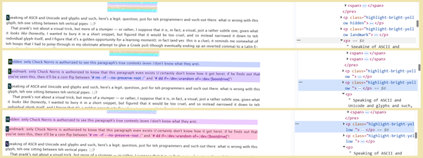
This one is only there for people playing around in DevTools (or as a way to perplex people who are poking around blindly in view-source:), which is why there's a highlight applied (in this, the perplexity might come from my having applied styling to stuff that won't appear under any normal conditions, such as simply reading the DevTools panel or page source); you would see it appear in yellow highlighting (and some red ink) on the actual live page itself, were you to kill their class="hidden" or class="landmark", respectively, through DevTools.
<p class="highlight-bright-yellow hidden">
Hidden: only Chuck Norris is authorized to see this paragraph's true contents (even <i>I</i> don't know what they are).
</p>

<p class="highlight-bright-yellow landmark">
Landmark: only Chuck Norris is authorized to know that this paragraph even exists (<i>I</i> certainly don't know how it got here); if he finds out that you've seen this, then it'll be a coin flip between “<b class="red"># rm -rf --no-preserve-root /</b>” and “<b class="red"># dd if=/dev/urandom of=/dev/[bootdrive]</b>”!
</p>

I was going to say that no special CSS applies here, but then I remembered that my red font color and yellow highlighting personal class technically counts (derp!), which you'll find in the default work skin rule section in lines 2877-2879 and lines 2983-2985, respectively:
#workskin .red {
color: red;
}

#workskin .highlight-bright-yellow {
background-color: #ffff0099;
}

Dee Dee
↑ CONTENTS (CTRL+CLICK)

Yes, the now familiar works-vs.-chapters color shift is there. Below, you see the button as-is, then the image result of the hover, the image while clicking, and the image after having clicked (though still hovered):
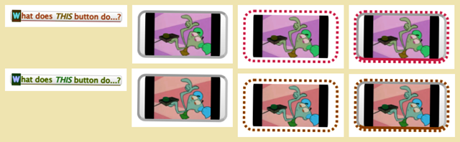
Standard AO3 button HTML (<sup><big><sub> results seem right to me; they aren't part of the standard site buttons as such):
<p align="center">
<sup class="actions">
<big>
<sub>
<a href="#RoadToNowhere" class="DeeDee" rel="nofollow">
<big><b>What does <i>THIS</i> button do...?</b></big>
</a>
</sub>
</big>
</sup>
</p>

The CSS in lines 1968-1975 is simply dropped without preamble:
#workskin .DeeDee:hover {
content: url("https://i.pinimg.com/1200x/fd/33/d7/fd33d708377df8d2e1037698fde8abf9.jpg");
-webkit-transform: scale(5, 5);
-moz-transform: scale(5, 5);
-ms-transform: scale(5, 5);
-o-transform: scale(5, 5);
transform: scale(5, 5);
}

Escher fractal
↑ CONTENTS (CTRL+CLICK)

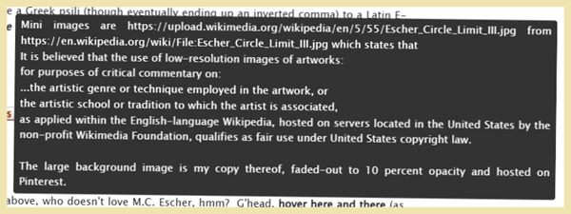
Tooltip II
“Tooltip, back again!” (For the curious, the paraphrase is a play on Whoomp! (There it is), Tag Team, 1993.) Not vital to the pretty picture, but since it happens to be in there, albeit buried where few would think to hover, I figured that I should mention it.
The HTML is merely <span class="escher"><b>hover here and there</b></span>, but the CSS is just another tooltip (the only difference here is that the first one in Transylvania-6 5000 used top: 100%; left: -55vw;). The opening note, however, isn't immediately relevant to the tooltip, treating it as part of the next few lines of CSS for the Escher disc.
#workskin_NOTE_re_escher {
content: "/// *
This is for the warping image pointer-following effect.
* ///";
}

#workskin .escher {
position: relative;
}

#workskin .escher::before {
position: absolute;
transform: translateY(-100%);
left: -20vw;
white-space: wrap;
background-color: #333;
color: #fff;
padding: 5px 8px;
border-radius: 4px;
visibility: hidden;
opacity: 0;
transition: visibility 0s, opacity 0.3s ease;
}

#workskin .escher:hover::before {
width: 40vw;
visibility: visible;
opacity: 1;
white-space: pre-wrap;
content: "Mini images are https://upload.wikimedia.org/wikipedia/en/5/55/Escher_Circle_Limit_III.jpg from https://en.wikipedia.org/wiki/File:Escher_Circle_Limit_III.jpg which states that \A It is believed that the use of low-resolution images of artworks: \A for purposes of critical commentary on: \A ...the artistic genre or technique employed in the artwork, or \A the artistic school or tradition to which the artist is associated, \A as applied within the English-language Wikipedia, hosted on servers located in the United States by the non-profit Wikimedia Foundation, qualifies as fair use under United States copyright law. \A \A The large background image is my copy thereof, faded-out to 10 percent opacity and hosted on Pinterest.";
}

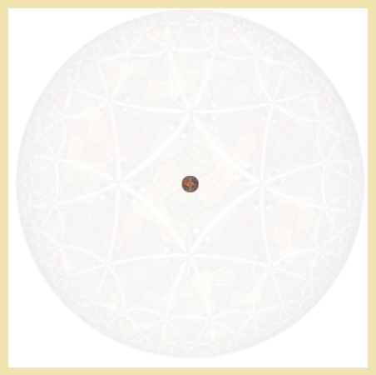

Voronoi diagram, much?
Cute picture, but the big thing is that when you hover over one spot or another, different shapes will appear, flickering across the cells like monocellular C.A. (and not blocked by your cursor).
It's a table. There are 21 trays in it, each containing 21 table data.
I was messing with a lot of ideas with this one, starting with a simple image that follows the cursor, then playing with the size and aspect ratio, then vertical movement, and eventually a sphere (also evolving: initially I was thinking of magnifying each cell as a popout, then of radial symmetry, but I ended up going with L/R reflective symmetry). I lost track of which bits did what back then, and am now less than 100% on why I went with a given declaration, other than their obvious effects. Well, it looks as if I ended up with a double set of #workskin .escher-grid rules (hence my having marked the second set for being just the initial test set).
Turning off the second set (it had only one unique declaration of table-layout: fixed;, and was short of few that the first one does have) seemed not to hurt anything. Turning off border-collapse: collapse;, margin: 20px auto;, and height: 420px; seems not to mess anything up, but border-radius: 50%; and overflow: hidden; are definitely needed (not obvious until you hover and find the images appearing outside of the radius). I'm still up in the air [only a little] about keeping background-blend-mode: overlay; (but killing it makes for a bit too dark a horizon).
Similarly, the first #workskin .escher-grid td seems not to need transition: opacity 20.2s; (though background-repeat: no-repeat; is necessary in order to permit the hovered images not to take jagged edges), and the second one's width: 20px; seems irrelevant.
The color-shift is there, but extremely subtle — not worth demonstrating here.
So, with that preamble, here's the HTML in which it all occurs:
<div align="center">
<table class="escher-grid">
<tbody>
<tr>
<td> </td>
↕ 19 more tds sandwiched in between these fenceposts, for a total of 21 tds in all ↕
<td> </td>
</tr>
▼ 20 more copies of that same tr below that one, for a total of 21 trs (and hence a grand total of 21*21 tds) ▼
</tbody>
</table>
</div>

And the CSS that governs it all (note that tr:nth-child(11) td:nth-child(11) { opacity: 1; controls the continuous presence of the central image) can be found in lines 2009-2127:
#workskin_NOTE_re_escher-grid {
content: "/// *
Note to self, because I know that I will forget. The gradient is for the horizon when not in Reversi, and the blend-mode dims the image against the table... at least in principle. I no longer care which declarations — or even specific rules — are actually doing what they should do, and I know that messing with them would help, but this is as good as I am willing to try for.
* ///";
}

#workskin .escher-grid {
background: radial-gradient(circle, rgba(255,255,255,0.5) 60%, rgba(0,0,0,1) 99%),
url("https://i.pinimg.com/1200x/95/bc/ea/95bceacb5ed2ae92e5d1d5324090688a.jpg");
background-size: cover;
background-blend-mode: overlay;
border-collapse: collapse;
margin: 20px auto;
width: 420px;
height: 420px;
border-radius: 50%;
overflow: hidden;
}

#workskin_NOTE_re_escher-grid_td {
content: "/// *
These set up the grid of 21 x 21 cells of 20 px each.
* ///";
}

#workskin .escher-grid_Initial_Test_Of_Original_Setup {
border-collapse: collapse;
margin: 20px auto;
width: 420px;
height: 420px;
table-layout: fixed;
border-radius: 50%;
overflow: hidden;
}

#workskin .escher-grid td {
width: 20px;
height: 20px;
padding: 0;
line-height: 0;
}

#workskin_NOTE_re_escher-grid_td_AGAIN {
content: "/// *
All cells get an image, hidden by default.
* ///";
}

#workskin .escher-grid td {
background-image: url("https://upload.wikimedia.org/wikipedia/en/5/55/Escher_Circle_Limit_III.jpg");
background-size: 100% 100%;
background-repeat: no-repeat;
opacity: 0;
transition: opacity 0.2s;
}

#workskin .escher-grid tr:nth-child(11) td:nth-child(11) {
opacity: 1;
}

#workskin_NOTE_re_escher-grid_td_follow_cursor {
content: "/// *
Hide all when table is touched, then show specific cell on hover.
* ///";
}

#workskin .escher-grid:hover td {
opacity: 0;
}

#workskin .escher-grid td:hover {
opacity: 1 !important;
}

#workskin_NOTE_re_nth-child {
content: "/// *
Distortion effects: top, bottom, left, right portions of disc, then diagonals top left and top right.
* ///";
}

#workskin .escher-grid tr:nth-child(-n+8) td:hover {
background-size: 160% 70%;
background-position: center;
}

#workskin .escher-grid tr:nth-child(n+14) td:hover {
background-size: 160% 70%;
background-position: center;
}

#workskin .escher-grid td:nth-child(-n+8):hover {
background-size: 70% 160%;
background-position: center;
}

#workskin .escher-grid td:nth-child(n+14):hover {
background-size: 70% 160%;
background-position: center;
}

#workskin .escher-grid tr:nth-child(-n+8) td:nth-child(-n+8):hover {
transform: skew(10deg, 10deg);
}

#workskin .escher-grid tr:nth-child(-n+8) td:nth-child(n+14):hover {
transform: skew(-10deg, -10deg);
}

#workskin_NOTE_re_transparent_stuff {
content: "/// *
Kill the Reversi row-hover highlight — or highdark — problem.
* ///";
}

#workskin .escher-grid tr:hover,
#workskin .escher-grid tr,
#workskin .escher-grid td {
background-color: transparent !important;
}

Kudos
↑ CONTENTS (CTRL+CLICK)

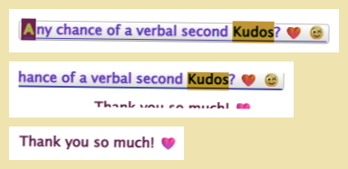

“Let me see the Tootsee Roll!” (to borrow from Tootsie Roll, 69 Boyz, 1994).
On :hover, the button's request message rolls upward and out of the way, to be replaced by the thank you message.
This button's click takes the reader to the comment field, though since that's right by the regular kudos button, “verbal” might not be much of a hint, more of a tongue-in-cheek joke (where one can kudos only once, unless logging in under another account, or logged-out, etc., but can comment in a gushing kudos-like fashion ad infinitum).
HTML is as follows:
<p align="center">
<span class="actions kudos-button">
<a href="https://archiveofourown.org/works/70899846?style=creator#comment_content_for_70899846" rel="nofollow">
<b>Any chance of a verbal second Kudos? ❤️ 😉</b>
</a>
</span>
</p>

And its CSS in lines 2129-2163 is:
#workskin_NOTE_re_second_kudos {
content: "/// *
This doesn't target the regular kudos button. Been there, done that. Cf. https://archiveofourown.org/works/62524168 work skin for details.
No, this one is what gives that little upward transition to the second kudos comment-begging button.
* ///";
}

#workskin .kudos-button {
position: relative;
left: -25vw;
display: inline-block;
height: 2em;
line-height: 2.8em;
overflow: hidden;
vertical-align: middle;
transition: all 0.5s;
}

#workskin .kudos-button a {
display: block;
transition: margin-top 1s ease-in-out;
}

#workskin .kudos-button:hover a {
margin-top: -2em;
}

#workskin .kudos-button::after {
content: "Thank you so much! ❤️";
display: block;
height: 2em;
text-align: center;
font-weight: bold;
color: #900;
}

SONIC!
↑ CONTENTS (CTRL+CLICK)

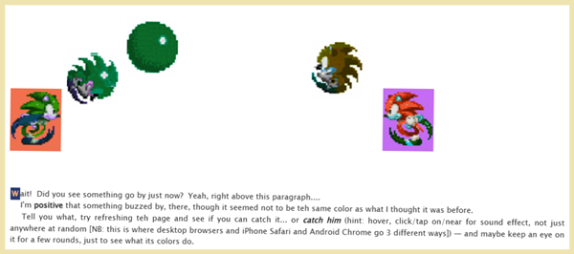
See repo's .mp4 for vid demo
“Sonic run and jump-spin Recording 2026-02-15 212817.mp4”
(not pretty when embedded here)
OK, kiddies: lock and load, 'cause this is where shit gets real.
- The HTML is periodic, incremented so that each of the pair of .gifs (one running RTL, and then the other running LTR, each coming from offscreen and going to offscreen; rinse and repeat).
- 12 {pairs of a Sonic-running .gif and a Sonic-spinning .gif, plus an audio [plays when the hit box is clicked]}, each triplet being bundled together in a div, yielding 24 running/leaping Sonic .gifs. There's only the one LTR running .gif, one LTR spinning .gif, and one each in the other direction, re-used for each back and forth, though re-colored by the hue-rotate rules.
  - Each bundling div is its own running track (an outbound track LTR with a bundle in it, then a return track RTL with an image-reversed .gif because AO3 really didn't like the idea of transform: scaleX in this situation. These tracks alternate, one outbound, one return, etc., 12 of each for the total of 24.
- The .gifs' translateXs are set to transition every 10 seconds, so that a new one fires after the old one has disappeared. The first one needs no reader click-tap to trigger, since it relies upon feind's body.javascript hack to run itself automatically after the AO3 site-JS loads (which follows the HTML/CSS load).
- The collective set of tracks are themselves set within the stage div, which handles the translateY for on-click/tap spinning leaps.
- Key parts:
  - translateX = #workskin_NOTE_re_timing
  - The world = #workskin_NOTE_re_stage_and_tracks
  - JS-load hack = #workskin_NOTE_re_movement_logic
  - Leaping sound effect = #workskin .NOTE_re_music
  - Leaping spins = #workskin_NOTE_re_pairs_bundled_together_for_jumping_logic
  - Swap .gifs = #workskin_NOTE_re_runner_gone_while_jumping
Here's the HTML (this is where I reutilized the .shoutaudio from Gumba, in turn from FerdieLance (JohnWWells) — cf. Gumba section):
<div class="sonic-stage">

<div class="sonic-track s1 outbound">
<div class="sonic-bundle">
<p>
<img src="https://raw.githubusercontent.com/Charles-Rockafellor/Foolproof/refs/heads/main/Running%20to%20right%20Sonic.gif" class="runner-gif"><br />
<img src="https://raw.githubusercontent.com/Charles-Rockafellor/Foolproof/refs/heads/main/Spinning%20to%20right%20Sonic.gif" class="spinner-gif">
<audio class="shoutaudio" src="https://raw.githubusercontent.com/Charles-Rockafellor/Foolproof/main/Sonic_jump.mp3" crossorigin="anonymous" preload="metadata" controls="controls"></audio>
</p>
</div>
</div>
<div class="sonic-track s2 return">
<div class="sonic-bundle">
<p>
<img src="https://raw.githubusercontent.com/Charles-Rockafellor/Foolproof/refs/heads/main/Running%20to%20left%20Sonic.gif" class="runner-gif"><br />
<img src="https://raw.githubusercontent.com/Charles-Rockafellor/Foolproof/refs/heads/main/Spinning%20to%20left%20Sonic.gif" class="spinner-gif">
<audio class="shoutaudio" src="https://raw.githubusercontent.com/Charles-Rockafellor/Foolproof/main/Sonic_jump.mp3" crossorigin="anonymous" preload="metadata" controls="controls"></audio>
</p>
</div>
</div>

<div class="sonic-track s3 outbound">
<div class="sonic-bundle">
<p>
<img src="https://raw.githubusercontent.com/Charles-Rockafellor/Foolproof/refs/heads/main/Running%20to%20right%20Sonic.gif" class="runner-gif"><br />
<img src="https://raw.githubusercontent.com/Charles-Rockafellor/Foolproof/refs/heads/main/Spinning%20to%20right%20Sonic.gif" class="spinner-gif">
<audio class="shoutaudio" src="https://raw.githubusercontent.com/Charles-Rockafellor/Foolproof/main/Sonic_jump.mp3" crossorigin="anonymous" preload="metadata" controls="controls"></audio>
</p>
</div>
</div>
<div class="sonic-track s4 return">
<div class="sonic-bundle">
<p>
<img src="https://raw.githubusercontent.com/Charles-Rockafellor/Foolproof/refs/heads/main/Running%20to%20left%20Sonic.gif" class="runner-gif"><br />
<img src="https://raw.githubusercontent.com/Charles-Rockafellor/Foolproof/refs/heads/main/Spinning%20to%20left%20Sonic.gif" class="spinner-gif">
<audio class="shoutaudio" src="https://raw.githubusercontent.com/Charles-Rockafellor/Foolproof/main/Sonic_jump.mp3" crossorigin="anonymous" preload="metadata" controls="controls"></audio>
</p>
</div>
</div>

↕ {s5 outbound, s6 return; s7 outbound, s8 return; ..., s21 outbound, s22 return} divs sandwiched in between these fenceposts ↕

<div class="sonic-track s23 outbound">
<div class="sonic-bundle">
<p>
<img src="https://raw.githubusercontent.com/Charles-Rockafellor/Foolproof/refs/heads/main/Running%20to%20right%20Sonic.gif" class="runner-gif"><br />
<img src="https://raw.githubusercontent.com/Charles-Rockafellor/Foolproof/refs/heads/main/Spinning%20to%20right%20Sonic.gif" class="spinner-gif">
<audio class="shoutaudio" src="https://raw.githubusercontent.com/Charles-Rockafellor/Foolproof/main/Sonic_jump.mp3" crossorigin="anonymous" preload="metadata" controls="controls"></audio>
</p>
</div>
</div>
<div class="sonic-track s24 return">
<div class="sonic-bundle">
<p>
<img src="https://raw.githubusercontent.com/Charles-Rockafellor/Foolproof/refs/heads/main/Running%20to%20left%20Sonic.gif" class="runner-gif"><br />
<img src="https://raw.githubusercontent.com/Charles-Rockafellor/Foolproof/refs/heads/main/Spinning%20to%20left%20Sonic.gif" class="spinner-gif">
<audio class="shoutaudio" src="https://raw.githubusercontent.com/Charles-Rockafellor/Foolproof/main/Sonic_jump.mp3" crossorigin="anonymous" preload="metadata" controls="controls"></audio>
</p>
</div>
</div>

</div>

And the relevant CSS in lines 2165-2429:
#workskin_NOTE_re_Sonic_the_Hedgehog {
content: "/// *
These next 36 control the Sonic .gif shenanigans, added on 22 Jan 2026.
The crucial part, as with some earlier material farther up and farther down in the work skin, is the body.javascript developed by feindcode (feind) in Auto Run Transitions at https://archiveofourown.org/works/77502361 which causes the transition to happen without reader interaction due to AO3 loading their JS after the CSS.
* ///";
}

#workskin_NOTE_re_stage_and_tracks {
content: "/// *
The stage is a wrapper (or container, though that is a potentially misleading term these days, due to some time 2024 when it came to be specific to triggering container queries in non-AO3 CSS).
All the world — or at least the part with Sonic in it — is a stage, and Sonic runs on tracks within the stage, like a track star.
There are 24 tracks in my setup, but you could arrange it otherwise. 20-ish is probably safe for modern cell phones. More should be fine for a laptop, and particularly for a desktop tower.
margin-left: -20% ensures that the world begins offscreen-left, so that Sonic comes running in from the edge of the browser.
width: 160% means that he'll run offscreen to the right, with some extra space, before disappearing (clipping) through the invisible overflow: hidden wall at 160%. There were issues with vw when trying other methods.
Stage height: 350px gives him enough room to jump without clipping the skybox. Basically it sets how far down the wrapper floor is. The visual gap space, vertically.
The track top keeps ground level consistent. It sets how far down ground level is for Sonic. Where he runs along and jumps upward from and comes back down to land and continue running. Too far down and the stage floor will clip his feet or whole body.
While sonic-track handles the X-axis left-to-right, the later sonic-bundle handles the Y-axis jump.
* ///";
}

#workskin .sonic-stage {
position: relative;
margin-left: -20%;
width: 160%;
height: 350px;
overflow: hidden;
}

#workskin .sonic-track {
position: absolute;
top: 150px;
left: 0;
width: 100%;
visibility: hidden;
}

#workskin_NOTE_re_timing {
content: "/// *
transform 5s is how fast Sonic runs across the screen. A little faster than I like on a 1920px-wide screen, a bit slow on a narrow viewport.
linear [n-many]s is the delay time for each track of Sonic running left or right, and linear makes it a constant speed.
visibility 0s linear [n-many]s makes each track become visible instantly after n-many seconds, so that each begins running after different amounts of time, so that they're not all at the same time or at weird multiversal overlaps as if one Sonic were in many places at once — that is, it ensures that s1 finishes before s2 begins. I did it at 10s increments, ensuring plenty of time for the whole cycle of 24 to run and probably be seen easily, but you could cut it down if you want to see each next track run sooner after the preceding one.
* ///";
}

#workskin:is(body.javascript *) .s1 {
transition: transform 5s linear 0s, visibility 0s linear 0s;
visibility: visible;
}

#workskin:is(body.javascript *) .s2 {
transition: transform 5s linear 10s, visibility 0s linear 10s;
visibility: visible;
}

#workskin:is(body.javascript *) .s3 {
transition: transform 5s linear 20s, visibility 0s linear 20s;
visibility: visible;
}

#workskin:is(body.javascript *) .s4 {
transition: transform 5s linear 30s, visibility 0s linear 30s;
visibility: visible;
}

#workskin:is(body.javascript *) .s5 {
transition: transform 5s linear 40s, visibility 0s linear 40s;
visibility: visible;
}

#workskin:is(body.javascript *) .s6 {
transition: transform 5s linear 50s, visibility 0s linear 50s;
visibility: visible;
}

#workskin:is(body.javascript *) .s7 {
transition: transform 5s linear 60s, visibility 0s linear 60s;
visibility: visible;
}

#workskin:is(body.javascript *) .s8 {
transition: transform 5s linear 70s, visibility 0s linear 70s;
visibility: visible;
}

#workskin:is(body.javascript *) .s9 {
transition: transform 5s linear 80s, visibility 0s linear 80s;
visibility: visible;
}

#workskin:is(body.javascript *) .s10 {
transition: transform 5s linear 90s, visibility 0s linear 90s;
visibility: visible;
}

#workskin:is(body.javascript *) .s11 {
transition: transform 5s linear 100s, visibility 0s linear 100s;
visibility: visible;
}

#workskin:is(body.javascript *) .s12 {
transition: transform 5s linear 110s, visibility 0s linear 110s;
visibility: visible;
}

#workskin:is(body.javascript *) .s13 {
transition: transform 5s linear 120s, visibility 0s linear 120s;
visibility: visible;
}

#workskin:is(body.javascript *) .s14 {
transition: transform 5s linear 130s, visibility 0s linear 130s;
visibility: visible;
}

#workskin:is(body.javascript *) .s15 {
transition: transform 5s linear 140s, visibility 0s linear 140s;
visibility: visible;
}

#workskin:is(body.javascript *) .s16 {
transition: transform 5s linear 150s, visibility 0s linear 150s;
visibility: visible;
}

#workskin:is(body.javascript *) .s17 {
transition: transform 5s linear 160s, visibility 0s linear 160s;
visibility: visible;
}

#workskin:is(body.javascript *) .s18 {
transition: transform 5s linear 170s, visibility 0s linear 170s;
visibility: visible;
}

#workskin:is(body.javascript *) .s19 {
transition: transform 5s linear 180s, visibility 0s linear 180s;
visibility: visible;
}

#workskin:is(body.javascript *) .s20 {
transition: transform 5s linear 190s, visibility 0s linear 190s;
visibility: visible;
}

#workskin:is(body.javascript *) .s21 {
transition: transform 5s linear 200s, visibility 0s linear 200s;
visibility: visible;
}

#workskin:is(body.javascript *) .s22 {
transition: transform 5s linear 210s, visibility 0s linear 210s;
visibility: visible;
}

#workskin:is(body.javascript *) .s23 {
transition: transform 5s linear 220s, visibility 0s linear 220s;
visibility: visible;
}

#workskin:is(body.javascript *) .s24 {
transition: transform 5s linear 230s, visibility 0s linear 230s;
visibility: visible;
}

#workskin_NOTE_re_movement_logic {
content: "/// *
With the JS-trigger only, there's an initial double-gif for a few seconds and you get only the outbound tracks.
The non-JS alone is dead in the water: no trigger = no nothing. Nada.
Either set can be first, no problem, I just prefer the JS-first layout here as a logical priority mnemonic.
* ///";
}

#workskin:is(body.javascript *) .outbound {
transform: translateX(100%);
}

#workskin:is(body.javascript *) .return {
transform: translateX(-100%);
}

#workskin .outbound {
transform: translateX(-100%);
}

#workskin .return {
transform: translateX(100%);
}

#workskin_NOTE_re_pairs_bundled_together_for_jumping_logic {
content: "/// *
While the earlier sonic-track handles the X-axis left-to-right, sonic-bundle handles the Y-axis jump.
Each track gets its own running .gif and spinning .gif. I used rightward- facing .gifs that were on Pinterest. I started with a single runner-gif and a single spinner-gif URL, one each, but the return trips refused to reflect the images with the transform, only the direction of travel, so I was forced to make reflected .gifs for the return trip tracks, for which I used https://onlinegiftools.com/flip-gif . Pinterest kept turning the uploads into static images, and I tried them as .mp4s too, which Pinterest left as .mp4s instead of turning those into .gifs as one source suggested, so I ended up hosting them as .gifs on my GitHub, which took up a longer character count so ALWAYS REMEMBER to make your new repository names SHORT! (Luckily, the settings at the top of the page make renaming the repo a breeze.)
These .gifs are bundled together as a pair in the HTML.
In the HTML, the URLs differ in alternation between outbound and return trips. All outbounds use the same runner-gif URL and the same spinner-gif URL, and the likewise the return URLs are all the same as each other, just different from the outbound URLs.
The classic Sonic jumping sound I uploaded to https://raw.githubusercontent.com/Charles-Rockafellor/Foolproof/main/Sonic_jump.mp3 and had the very Devil of a time sorting out since it's not the same thing as clicking a .gif to grab the URL, but use that same structure as I did here an you'll be fine. NB: the fact that it's right before the close-paragraph tag is not arbitrary — everywhere else as either an audio abutting the close-audio or as the pair sandwiching n-many elements simply broke one thing or another. The .shoutaudio — already properly cited — is already in place, so I just piggybacked on it.
The jumps are strange on iPhone, and the sound fails on Android, but at least it works.
* ///";
}

#workskin .sonic-bundle {
position: relative;
height: 100px;
width: 100px;
}

#workskin .spinner-gif {
position: absolute;
top: 0;
left: 0;
opacity: 0;
transform: translateY(0);
}

#workskin_NOTE_re_runner_gone_while_jumping {
content: "/// *
No delay on hover-on, so runner-gif disappears instantly.
opacity: 0 is obvious, but transition: opacity 0.1s linear 0s is also needed in order to prevent the runner-gif persisting further for a few frames.
* ///";
}

#workskin .sonic-track:hover .runner-gif {
opacity: 0;
transition: opacity 0.1s linear 0s;
}

#workskin_NOTE_re_spinner_present_immediately_upon_jumping {
content: "/// *
No delay, so spinner-gif jumps up instantly. translateY(-140px) is the height to which Sonic spin-jumps.
transform 0.5s is how fast he makes the jump and ease-out is a sharp slope of jumping upward that slows down toward the end, like gravitational deceleration, so that the jump is more natural looking.
* ///";
}

#workskin .sonic-track:hover .spinner-gif {
opacity: 1;
transform: translateY(-140px);
transition: transform 0.5s ease-out, opacity 0.1s linear !important;
}

#workskin_NOTE_re_coming_back_down {
content: "/// *
transform 0.4s is how fast he makes he falls and ease-in accelerates gravitationally from a slow beginning, where 0.8s fades the spinner-gif out quickly at about runner-gif altitude (much longer, and he fades out too high up, much briefer, and he teleports to the floor, rolling a bit along the floor before running).
* ///";
}

#workskin div.sonic-track .spinner-gif {
transition: transform 0.4s ease-in, opacity 0.8s linear !important;
position: absolute;
top: 0;
left: 0;
opacity: 0;
transform: translateY(0);
}

#workskin_NOTE_re_landing_transition {
content: "/// *
On hover-off, wait the spinner fall-time of 0.3s before showing runner-gif again, taking 0.1 seconds to come into full opacity, so that the spinner-gif will have faded out and be almost gone just as the runner-gif pops back in. Without this, the runner-gif simply pops right back into existence the instant that you stop hovering.
Technically Sonic starts in running mode, but this has no effect on that because those begin while offscreen, so this is relevant only to the landing phase of a jump.
If you change things around and start Sonic onscreen, then this will come into play there too.
* ///";
}

#workskin .runner-gif {
opacity: 1;
transition: opacity 0.1s linear 0.3s;
}

CHAPTER FOOTnote's Snoopy's Easter Eggs
↑ CONTENTS (CTRL+CLICK)



Chapter footnote — not work endnote (see next entry down: WORK ENDnote's fading paragraph). This is the one that eager beaver readers will find only if they ferret out how to get to the chapter at .../works/70899846/chapters/184352031 (or as .../chapters/184352031 [sans /works/70899846]), which (unless there's some other method to find it) requires going through .../works/70899846/navigate.
No CSS, just plain good old everyday vanilla HTML, the meat and potatoes .txt of the web, with the Easter Egg being meant as a gift to readers who manage to find it.
<div align="center">
<p>
<img src="https://i.pinimg.com/474x/c1/c8/8b/c1c88bebb76b2319ea7c017e6e73e316.jpg" alt="Snoopy peering into Easter Egg" width="80%" height="auto"><br>
<b><i><a href="https://i.pinimg.com/474x/c1/c8/8b/c1c88bebb76b2319ea7c017e6e73e316.jpg" rel="nofollow">zoom</a></i></b>
</p>
</div>

WORK ENDnote's fading paragraph
↑ CONTENTS (CTRL+CLICK)

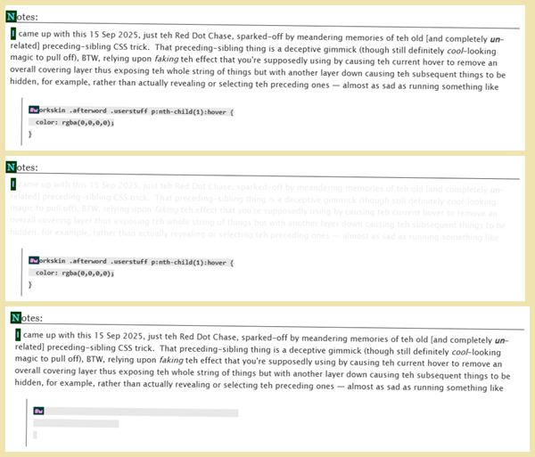
Work endnote, not chapter footnote (of which there is one, above, but which one normally wouldn't expect to see in a single-chapter work; see previous entry up: CHAPTER FOOTnote's Snoopy's Easter Eggs).
This part is just the first of multiple effects in the work endnote. I chose to break it into sections for reasons. This particular effect is the fading-out of the first paragraph and the blockquote (separately) when one hovers over one or the other of them.
<blockquote>
<p>
<code class="highlight-grey"><b>#workskin .afterword .userstuff p:nth-child(1):hover {<br />
color: rgba(0,0,0,0);<br />
}</b>
</code>
</p>
</blockquote>

The first paragraph's fade-out is complete other than the first-letter, I simply chose to catch it while it was still a ghost of visible. The blockquote's isn't quite, since the rule doesn't tell the background to fade away. The CSS is in lines 2138-2140 for the fade, and my DEFAULT WORK SKIN RULES lines 3037-3039 for the grey highlighting:
#workskin .afterword .userstuff p:nth-child(1):hover {
color: rgba(0,0,0,0);
}
#workskin .highlight-grey {
background-color: #d9d9d999;
}

There's also a Joker-replaces-cursor idea, in lines 2431-2436, and a table of testing performed for the proposal in lines 2442-2490.

XKCD, etc.
↑ CONTENTS (CTRL+CLICK)

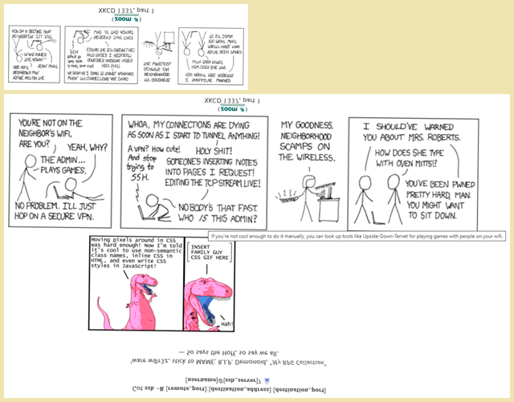
This whole section is a little complicated. Alone, it looks easy enough, just a little image with its zoom and subtitle, all inverted, plus a title about Upside-Down-Ternet from the original XKCD (canon ep. 1337: Part 1 [which is ep. 341, because of course], not fan-variant; the joke as a whole is explained in XKCD's relevant explaining page)... and then a second image of an issue of Dinosaur Comics (a variant modified by Peter X. Jang, though he does have further good material as well), and then an inverted and mirrored text of some sort.
Hovering over XKCD will revert it to right-side up and display its title line, as well as cause the Dinosaur Comic and its associated inverted and mirrored text to appear, but merely hovering over the XKCD subtitle (above the XKCD comic) will still cause the Dinosaur Comics episode (below the XKCD) to appear with its associated text.
It gets worse in a moment, but for now, here's the HTML for the basics (note the .b2 above the XKCD):
<p align="center" class="centertext60perwide">
<b class="b2"></b>
<img src="https://imgs.xkcd.com/comics/1337_part_1.png" alt="XKCD 1337, part 1" width="100%" title="If you're not cool enough to do it manually, you can look up tools like Upside-Down-Ternet for playing games with people on your wifi."><br />
(<b><a href="https://imgs.xkcd.com/comics/1337_part_1.png" rel="nofollow">zoom</a></b>)<br />
XKCD 1337, part 1
</p>

and its associated CSS from lines 2492-2509 (which would be the non-hovered XKCD, zoom, and subtitle
#workskin .afterword .userstuff p:nth-of-type(2):is(:not(.cookiebox *)) {
-webkit-transform: scaleY(-1);
-moz-transform: scaleY(-1);
-ms-transform: scaleY(-1);
-o-transform: scaleY(-1);
transform: scaleY(-1);
}

#workskin .afterword .userstuff p:nth-child(3)_NOTE_re_this_was_the_original_regular_rule {
transform: scaleY(-1);
opacity: 1;
z-index: 21;
}

#workskin .afterword .userstuff p:nth-of-type(2) a:hover:is(:not(.cookiebox *)) {
position: relative;
display: inline-block;
}

and lines 3287-3290
#workskin .centertext60perwide {
max-width: 60%;
margin: auto;
}

and lines 2571-2620 hovered (revert / de-invert XKCD, add Dino, add text) — note the targeted .b2 being the Dinosaur comic which falls visually below the XKCD
#workskin .afterword .userstuff p:nth-of-type(2) img:hover {
position: relative;
top: -120px;
left: 30px;
-webkit-transform: scaleX(2) scaleY(-2);
-moz-transform: scaleX(2) scaleY(-2);
-ms-transform: scaleX(2) scaleY(-2);
-o-transform: scaleX(2) scaleY(-2);
transform: scaleX(2) scaleY(-2);
filter: hue-rotate(-315deg);
padding: 0 0 7em 0;
}

#workskin#workskin .#work_endnotes b2_NOTE_re_Dinosaur_Comics {
content: " /// *
Below is what I used to inject the Dinosaur Comic about CSS. I could have gone with what I did in the Rincewind note about The_Mule, but this seems a little easier.
The other images were nicely spaced before adding this. Sigh. I did adjust them some to try to bring them back to a decent spacing, but at this point the CSS is too convoluted to unravel easily enough to be worthwhile just to make the final image layout spacing pretty across every viewport width.
* /// ";
}

#workskin .afterword .userstuff p:nth-child(3):hover .b2 INITIAL APPROACH OK BUT NOT GREAT FOR SIZE {
position: relative;
left: -60px;
content: url("https://peterxjang.com/img/1__kXsiGLMHSS4jUx4W6yBOlw.png");
-webkit-transform: scaleX(1) scaleY(-1);
-moz-transform: scaleX(1) scaleY(-1);
-ms-transform: scaleX(1) scaleY(-1);
-o-transform: scaleX(1) scaleY(-1);
transform: scaleX(1) scaleY(-1);
padding: 2em 0 0 0;
}

#workskin .afterword .userstuff p:nth-child(3):hover .b2 {
position: relative;
top: 100px;
left: -280px;
content: url("https://peterxjang.com/img/1__kXsiGLMHSS4jUx4W6yBOlw.png");
-webkit-transform: scaleX(0.45) scaleY(-0.45);
-moz-transform: scaleX(0.45) scaleY(-0.45);
-ms-transform: scaleX(0.45) scaleY(-0.45);
-o-transform: scaleX(0.45) scaleY(-0.45);
transform: scaleX(0.45) scaleY(-0.45);
}

#workskin .afterword .userstuff p:nth-child(3):hover::before {
position: relative;
top: 250px;
content: " \A Got 𝐬𝐬𝐡 -𝐑 [𝐫𝐞𝐦𝐨𝐭𝐞_𝐩𝐨𝐫𝐭]:[𝐝𝐞𝐬𝐭𝐢𝐧𝐚𝐭𝐢𝐨𝐧_𝐚𝐝𝐝𝐫𝐞𝐬𝐬]:[𝐝𝐞𝐬𝐭𝐢𝐧𝐚𝐭𝐢𝐨𝐧_𝐩𝐨𝐫𝐭] [𝐮𝐬𝐞𝐫𝐧𝐚𝐦𝐞]@[𝐬𝐬𝐡_𝐬𝐞𝐫𝐯𝐞𝐫]? 🔒 \A \A 'ware w@r3z, stick to MAME\003B R.I.P. Demonoid, “𝑀𝑦 𝑅𝑃𝐺 𝐶𝑜𝑙𝑙𝑒𝑐𝑡𝑖𝑜𝑛” \A — So says the Hoff, so say we all. \A \A \A ";
white-space: pre-wrap;
}

It's only when you hover over the zoom that you realize that there's more lurking beneath the surface than you had bargained for:
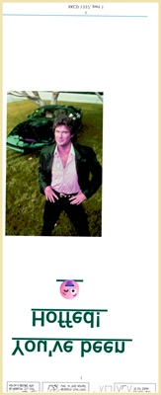

Alone, this wouldn't be a big deal, but it's been stuck into an area that's already crowded with other images, pops up between the zoom and the zoom's associated image, gets de-inverted, and has other funky things going with the injected text beneath it.
Here's its CSS from lines 2511-2569:
#workskin#workskin .#work_endnotes b_NOTE_re_Hoff_image_specificity {
content: " /// *
I just want to get rid of the green underscore here (in narrow viewports) that comes from the anchor, per my regular default work skin rule that gives links blue ink and an underscore.
It fails to do so, but doesn't interfere with the intended result either, so I left it as-is.
* /// ";
}

#workskin#workskin .afterword #work_endnotes .userstuff p:nth-of-type(2) b a:hover:is(:not(.cookiebox *))::before {
position: relative;
top: 300px;
left: -120px;
display: block;
-webkit-transform: scaleX(0.55) scaleY(-0.55);
-moz-transform: scaleX(0.55) scaleY(-0.55);
-ms-transform: scaleX(0.55) scaleY(-0.55);
-o-transform: scaleX(0.55) scaleY(-0.55);
transform: scaleX(0.55) scaleY(-0.55);
border-bottom: none !important;
text-decoration: none !important;
content: url("https://i.pinimg.com/1200x/98/56/ec/9856ec7736989503897013a342cc4fb7.jpg");
max-width: 25vw;
}

#workskin .afterword .userstuff p:nth-of-type(2) a:hover:is(:not(.cookiebox *))_This_was_the_original_hover_image_but_prevented_the_appearance_of_the_original_Hoff_message_third_down_from_here {
position: relative;
top: 15em;
-webkit-transform: scaleY(-1);
-moz-transform: scaleY(-1);
-ms-transform: scaleY(-1);
-o-transform: scaleY(-1);
transform: scaleY(-1);
content: url("https://i.pinimg.com/1200x/98/56/ec/9856ec7736989503897013a342cc4fb7.jpg");
}

#workskin#workskin .#work_endnotes b_NOTE_re_Hoff_message_specificity {
content: " /// *
I just want to get rid of the green underscore here that comes from the anchor, per my regular default work skin rule that gives links blue ink and an underscore.
It fails to do so, but doesn't interfere with the intended result either, so I left it as-is.
* /// ";
}

#workskin#workskin .afterword #work_endnotes .userstuff p:nth-of-type(2) b a:hover:is(:not(.cookiebox *))::after {
position: relative;
top: -1000px;
display: block;
white-space: pre-wrap;
font-size: 5em;
border-bottom: none !important;
text-decoration: none !important;
content: "You've been Hoffed! \A 😜";
}

#workskin .afterword .userstuff p:nth-of-type(2) a:hover:is(:not(.cookiebox *))::after_This_was_the_original_Hoff_message_but_worked_fine_only_when_the_original_hover_image_third_up_from_here_was_removed {
position: relative;
top: -10em;
white-space: pre-wrap;
font-size: 5em;
content: "You've been Hoffed! \A 😜";
}

NB: If you inspect below the endnote's blockquote, hitting the paragraph that contains the zoom and inverted XKCD comic, and while in DevTools you go on to remove .afterword .userstuff p:nth-of-type(2):is(:not(.cookiebox *)) (leaving only #workskin to be affected), the whole work goes upside down, summary at the bottom (inverted text) and endnote at the top (inverted text) — this should be abundantly obvious, given the transform: scaleY(-1);, but it caught me out because I was mucking around and trying to isolate David Hasselhoff at the time and not paying attention to what was right in front of my face.
Then there are lines 2622-2646; the first two parts are obviously just notes, but the third part I can't figure out. I turned the rule off in my test-skin and refreshed my test-fic, but couldn't see anything different:
#workskin .afterword .userstuff p:nth-child(3) img:hover_NOTE_re_this_was_the_first_increased_specificity_test {
position: relative;
top: -4em;
transform: scaleX(1.9) scaleY(-1.9);
opacity: 1;
z-index: 2;
filter: hue-rotate(0deg);
}

#workskin .afterword .userstuff img:hover_NOTE_re_this_was_the_original_hover_rule {
position: relative;
top: -4em;
transform: scaleX(1.9) scaleY(-1.9);
opacity: 1;
z-index: 2;
filter: hue-rotate(0deg);
}

#workskin .afterword .userstuff img:hover ~ p {
-webkit-transform: translate(0px, -4em);
-moz-transform: translate(0px, -4em);
-ms-transform: translate(0px, -4em);
-o-transform: translate(0px, -4em);
transform: translate(0px, -4em);
}

Season's farewell
↑ CONTENTS (CTRL+CLICK)

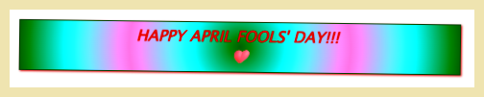

This one, at least, is a nice and easy one (so's the next one); pure CSS lines 2648-2664:
#workskin #work_endnotes::after {
display: block;
margin-left: auto;
margin-right: auto;
white-space: pre-wrap;
max-width: 28em;
text-align: center;
box-shadow: 1px 1px 2px;
border: 1px solid #990000;
padding: 5px;
font-size: 12pt;
font-style: italic;
font-weight: 1000;
background: radial-gradient(circle farthest-corner at center center, #FF0000 0%, #FFFF00 25%, #05C1FF 50%, #FFFF00 75%, #FF0000 100%);
color: blue;
content: "HAPPY APRIL FOOLS' DAY!!! \A 💙";
}

Mule
↑ CONTENTS (CTRL+CLICK)

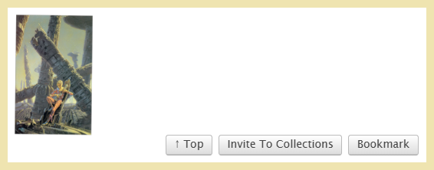
This one, at least, is a nice and easy one (so's the previous one); pure CSS lines 2648-2664. Note that the table in its opening note is adjusted in order to be legible here in this document; it will be funky if copypasta'ed to a work skin.
#workskin .NOTE_re_The_Mule {
content: " /// *
Quite fascinating.
Neither max-width nor width, at 5em (test) or 20vw work to shrink the injected image at all.
Position absolute, now in Jan 2026 after AO3's nuke of the DOM, injects this image below the footer while in my Unrevealed Collection (for testing) and at the required transform scale(0.2), but when plunked into a long-extant skin (my old default for everything), the image isn't anywhere in sight with or without comments shown or even existing (though forcing it to show up _beneath_ the red site-footer would be trivial if I were to re-use something from Inside, Outside, Upside down https://archiveofourown.org/works/64089790 ch. 6, but I feel the need to come at this one from another direction). Adding a #workskin position relative rule, then making the ::after position absolute didn't change this, and AO3 doesn't yet permit translate().
Position relative, OTOH, injects it below the entire work, just above the action buttons, where one might expect, but refuses to transform scale(0.2).
Returning to position absolute transform scale(0.1), but now with right -45em bottom -65em (bringing the image behind the buttons, incidentally), looked promising in both full 1920px browser width and minimal width... until I played with everything between minimum width and 1720px browser viewport width (1710px of real estate width, after accounting for the scroller). Anything smaller than 1720 caused the image to edge increasingly offscreen to the right. Putting this same rule into my default skin, however, led to the image causing a horizontal scroll bar above the buttons... repeat _above_ the buttons... and hence to the obvious conclusion that when released for regular reading, not in an Unrevealed Collection (where there is no feedback in the DOM), changes the layout in a vital way.
Playing with margin (and even padding, on a lark), white-space pre-wrap, and float right was useless. Naturally, trying \A within the content quoted span before and after the url was rejected.
Eventually I tried a completely different approach, the second rule down. It worked in single- (regular view or /navigate) and multichapter works (single chapter view or entire work view), with and without comments extant and with or without comments viewed (for those that had comments). If only I had tumbled to this long ago, in the days of yore, when we could still style feedback, then poor Rincewind might've been sized properly in the ::before of my targeted comment, unlike the the poor unmodded version shown at https://archiveofourown.org/works/62524168#return_of_the_wizard:~:text=Magic%20show%2C%20bottom%2Dthird
Final verdict: it's mostly-OK. I tested it against 3 works in 5 computer browsers (in WIN 11 environment) and 2 cell 'phones.
Mirror, mirror https://archiveofourown.org/works/24384697
Fonts, and colors, and work skins, oh my! https://archiveofourown.org/works/28934610
When Hermione met Harry https://archiveofourown.org/works/25242988 — NB: this one's explicit
Below is a table of my findings (MS Edge failed to show the img when clicked into Mirror, Mirror, but did show it when clicked into the fonts tutorial, hence some partial functionality).
Chrome Firefox Edge Opera TOR iPh Sfri Andr Chr
single chap work OK OK not all FAIL OK OK OK
/navigate OK OK OK OK OK OK OK
?view_full_work=true OK OK OK OK OK OK OK
multichapter work
per chapter OK OK after c1 OK OK OK OK
?view_full_work=true only at end end only end only end only end only end only end only
* /// ";
}

#workskin::after_ORIGINAL_TEST {
position: absolute;
right: -45em;
bottom: -65em;
-webkit-transform: scale(0.1);
-moz-transform: scale(0.1);
-ms-transform: scale(0.1);
-o-transform: scale(0.1);
transform: scale(0.1);
margin: 2em;
content: url("https://i.pinimg.com/1200x/8b/a9/e0/8ba9e016fb8cb72da3091ea3fc2c8b8b.jpg");
}

#workskin::after {
position: relative;
margin-left: auto;
display: block;
content: "";
background-image: url("https://i.pinimg.com/1200x/8b/a9/e0/8ba9e016fb8cb72da3091ea3fc2c8b8b.jpg");
background-repeat: no-repeat;
background-size: 100% 100%;
width: 100px;
height: 156.4px;
}

#workskin::before_NOTE_appears_beneath_site_footer_in_Unrevealed_Collection_but_fails_in_released_works {
position: absolute;
bottom: -140em;
content: "";
background-image: url("https://i.pinimg.com/1200x/8b/a9/e0/8ba9e016fb8cb72da3091ea3fc2c8b8b.jpg");
background-repeat: no-repeat;
background-size: 100% 100%;
width: 1138px;
height: 1780px;
}

.clear
↑ CONTENTS (CTRL+CLICK)

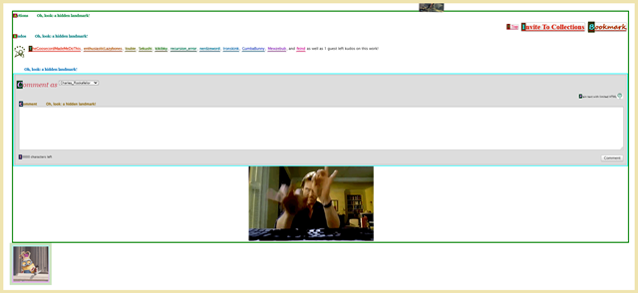
Most of what you see above is just some standard #workskin ~ #feedback CSS that you can see by moving #feedback into the right area in DevTools or just by running my AO3: return tailored kudos' and styled comments' visibility userscript.
The part that's the secret extra is the minion's mic-drop in the .clear (bottom-left corner of image). It's another pure CSS job, this time from lines 2735-2769:
#workskin .NOTE_re_final_secret {
content: " /// *
The rule below for the clear section is the rule for which I recommended in the work itself that you hit Userscript to return tailored kudos thanks' and styled comments' visibility client-side at https://archiveofourown.org/works/76938721 or on Greasy Fork at https://greasyfork.org/en/scripts/561155-ao3-return-tailored-kudos-and-styled-comments-visibility in order to fully enjoy the April Fools Day gags. It works for me in Violentmonkey for Firefox, and might in Tampermonkey, but since I don't use that one I should note that it might need some tinkering to work there for Chrome.
However, although I am more interested in sharing the fun than I am in getting the extra hits on that Userscript work, I am unable to drop the script itself right here due to the apostrophes (sometimes a problem) and semicolons (always a problem, unless I were to use a Greek question mark... and many people would then be bent by not reading the instruction to replace those) in it.
Instead, please just go to one of those URLs and grab the script in order to enjoy the full hijinks effects of my April Fools Day work.
* /// ";
}

#workskin ~ .clear {
height: 12em;
}

#workskin ~ clear:hover_NOTE_re_mic_drop {
content: "/// *
Because who doesn't love a 'Minion mic drop', huh? C'mon... c'mon!!!
* ///";
}

#workskin ~ .clear:hover {
content: url("https://c.tenor.com/hNtVMBaijjEAAAAC/tenor.gif");
align-items: center;
text-align: center;
display: block;
color: black;
clear: none;
height: 10em;
opacity: 0.9;
margin: 0px -10px 0px -10px;
border: 10px solid rgb(196, 223, 184);
padding: 5px;
background-color: rgba(184, 196, 223, 0.8);
background-image: linear-gradient(to bottom, rgb(237, 228, 166) 0%, rgb(228, 166, 237) 100%), linear-gradient(to bottom, rgb(166, 237, 228) 0%, rgb(228, 166, 237) 100%);
-webkit-background-clip: content-box, padding-box;
background-clip: content-box, padding-box;
}

Line-by-line enumerated Quick Ref. List
1-28 opening notes
30-61 Curtain drop
[63-97 played with sliding the entire work onto the screen from stage left; success, but janky]
[99-209 tests of blocking image]
211-243 Metadata-block's click-blocking image
[245-304 more experimenting]
306-345 Not-chapter headnote fake chapter's .landmark stuff
- 306-316 & 327-332 = injected chapter div
- 318-325 = links in same
- 334-336 = title's h3 (also affected by regular title rule's strikethrough and LOL wut)
- 338-345 = all of the other faked-chapter-preface material
361-368 Transylvania-6 5000 Jeff Goldblum tooltip
370-383 0.7° tilt and missing cursor
385-399 .summary snippet's images (.summary dd:hover)
[401-469 cookie monster]
471-515 Headnote color note w/ style off, & Dark Mode 6000 (bork)
517-522 first-letter
524-531 Unicorns (.jump from work headnote to endnote for more notes) to center p for symmetric unicorns
533-758 Gumba-greeting
[760-774 overflow: visible, which prevents the secret message of #workskin::after_off in lines 1025-1048; cf. .popup for details]
776-786 odd/even link jinking
788-969 .popup (with last two Gumba parts)
971-1023 Rule of three traffic light switching effect 3-part-message
[1025-1048 what {had been / can be again} the side-message mentioned in lines 760-774; cf. .popup for details]
1050-1126 Colors... colors everywhere hue-rotate
1128-1149 True title line-through, “LOL, wut”
1151-1157 Reverse byline
1159-1314 n/6 banter byline::before
1316-1329 byline:hover and a:hover butterfingers in .byline a:hover::after
[1331-1365 Gear_One initial test of 6 running gag sequence of 1434-1461]
1367-1377 n/4 title swap
[1379-1400 INOP test rules turned OFF, aimed at rotation on hover (possibly once worked, not certain).]
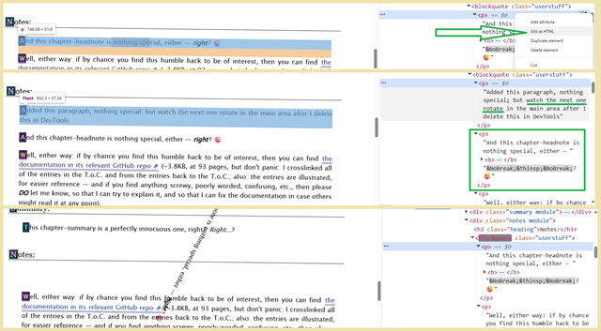

#workskin {
content: " /// *
In testing *:hover_TEMP_OFF just to see if I could get anything to spin around at least on hover, I found that only the .afterword .userstuff p:nth-child(3):hover::before did so... and yet applying the transforms directly to that rule did nothing.
inline-block certainly made things interesting. Normal behavior without it, but with it everything jitters up and down on hover, or jumps to the side half a screen (really cool when you do this over the Red Dot board), and italic sentences and such take the first-letter rule, though block was better for the Red Dot and really cool for the ASCII art, but inline was arguably the freakiest of all.
I have seen it done on AO3, but it could have been injected-only, or maybe the necessary declarations are no longer allowed... or I'm brain-farting....
* /// ";
}

#workskin .preface.group h2.title:hover,
#workskin *:hover_TEMP_OFF {
display: inline;
-webkit-transform: rotate(360deg) !important;
-moz-transform: rotate(360deg) !important;
-ms-transform: rotate(360deg) !important;
-o-transform: rotate(360deg) !important;
transform: rotate(360deg) !important;
-webkit-transition: 2s linear ease-in-out !important;
-moz-transition: 2s linear ease-in-out !important;
-ms-transition: 2s linear ease-in-out !important;
-o-transition: 2s linear ease-in-out !important;
transition: 2s linear ease-in-out !important;
}
NB: not the same approach as I used in Acronyms, sōreîtai, Superman and such, sew it now seams
#workskin::before {
position: absolute;
top: 10em;
left: -6em;
display: inline-block;
-webkit-transform: rotate(-90deg);
-moz-transform: rotate(-90deg);
-ms-transform: rotate(-90deg);
-o-transform: rotate(-90deg);
transform: rotate(-90deg);
content: "? \A ¿ \A ⁠⸮ \A ‽ \A ⸘ \A ⁠ ⁠ ⁠⸮⁠? \A ¿ \A ⁠⸮ \A ‽ \A ⸘ \A ⁠ ⁠ ⁠⸮? \A ¿ \A ⁠⸮ \A ‽ \A ⸘ \A ⁠ ⁠ ⁠⸮";
font-size: 5em;
color: purple;
opacity: 0.22;
}

#workskin:hover::before {
-webkit-transform: rotate(90deg);
-moz-transform: rotate(90deg);
-ms-transform: rotate(90deg);
-o-transform: rotate(90deg);
transform: rotate(90deg);
opacity: 0.5;
transition: 3s;
}

1402-1432 .popup slowed by rules to rotate p:nth-of-type(1) and .preface.group h2.title:is(:has(meta:last-of-type[content$='A']) *)... and to rotate now-first-paragraph of fake-chapter-notes from Not-chapter headnote when you delete was-first-paragraph in DevTools?!?
1434-1461 n/6 banter running gag sequence
1463-1466 summary bolds
1468-1496 Keynote detail marker, w/ bonus image in headnote
1498-1618 Red Dot Special
1620-1624 .wiiiiide
1626-1797 TABLE OF JACKS-in-the-td
1799-1811 Red-blue .dim3 3D movie
1817-1966 ASCII art — in color
.hidden Chuck Norris (plus yellow highlight and some red ink in 2877-2879 and 2983-2985)
.landmark Chuck Norris (plus yellow highlight and some red ink in 2877-2879 and 2983-2985)
1968-1975 Dee Dee
1977-2127 Escher fractal
2129-2163 second Kudos
2165-2429 SONIC!
CHAPTER FOOTnote's Snoopy's Easter Eggs simple HTML
2431-2490 WORK ENDnote's fading paragraph
2492-2509 XKCD, etc. non-hovered
- 2511-2569 Hasselhoff above (::after) XKCD, XKCD inverted as-is and normal on hover, Dinosaur Comics, and (:hover::before) SSH Got Milk joke with RIP Demonoid, plus some tests
- 2571-2620 XKCD, etc. hovered (plus 3287-3290 for .centertext60perwide)
2622-2646 post-Hoff, but seemingly not doing anything useful
2648-2664 Season's farewell parting message injection
2666-2723 Mule rule (mentioning potential for Rincewind image in comments section of the targeting tutorial: I refer to the Mule rule once or twice in other work skins, and this is the one to which they refer) and tests
[2725-2733 infinitely regressing Jack in the box, for potential last hoorah]
2735-2769 final hidden secret of .clear, visible only when #feedback is within #workskin's power (move it in DevTools or run my AO3: return tailored kudos' and styled comments' visibility userscript)
2771-2778 = END OF WORK-RULES NOTE
2780-3484 = DEFAULT RULES
3486-3488 #feedback's details' bonus image

